RESERVE BANK OF INDIA


PDO-NDS COMPUTERISATION PROJECT

Digital Certificates (PKI) Change Over Document

(Member End)

Version: 1.0(Draft)

Prepared by



March 2004

Confidential and controlled document
Unauthorized access or copying is prohibited
DOCUMENT RELEASE NOTE

Notice No. : 1

Client : Reserve Bank Of India

Project : RBI-PDO-NDS Computerization

Document Details : Document of Digital Certificates Change over across all Market Participants

Name | Version No | Description
Document of Digital Certificates Change over across all Market Participants | 1.0

Action Taken  (add/del/chg) | Preceding  Page No. | New  Page No | Revision  Description

The document or revised pages are subject to document control.
Please keep them up-to-date using the release notices from the distributor of the document. These are confidential document. Unauthorized access or copying is prohibited.

Approved by: Date:

Authorized by: Aniruddha Kamat Date:

Introduction

The document describes the procedure to implement new digital certificates provided
by IDBRT, Hyderabad at the member banks.

Pre-Requisite

Before starting the implementation of new digital certificate, ensure the following:

  - Implementation should be started after market hours only.
  - Check for the RBI’s communication (through news over NDS/ information through e-mail) for Permitting Implementation of New Digital Certificate. This will ensure that no messages are pending at Host End to be delivered at member end.
  - Perform the End of Day (EOD) operation at your end.
  - Now refresh all queues (Select the queues folder and press ‘F5’ key) under Queue Manager NDS1P.LudId.QMGR and ensure that the Current Depth of all queues is zero. In case any queue is having current depth, delete the messages by clearing it from the queue.
(Refer following Screen Shot)

(The LudId corresponds to the Member’s LUD Id)

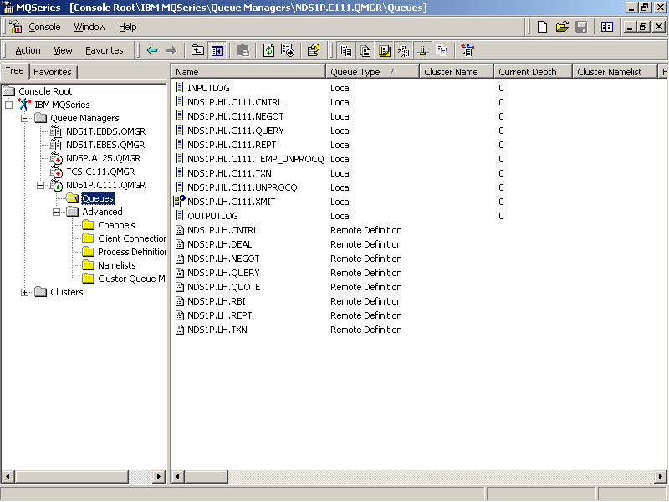
  - If there are any messages in INPUTLOG, OUTPUTLOG and QUERY queues of Q-Manager NDS1P.LudId.QMGR, they can be deleted as follows

- Right Click on the above queues → Select “All Tasks” → Select “Clear Messages”.

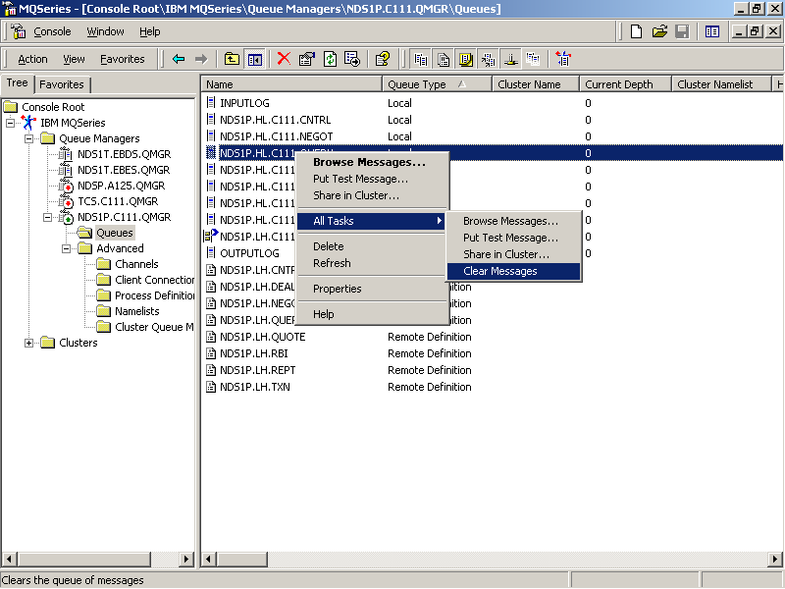

- After clicking on “Clear Messages” the following message will pop up.

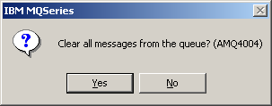

- Click “Yes” to remove all the messages from queue.
- Note: If the Current Depth of any other queue except the above-mentioned three queues (INPUTLOG, OUTPUTLOG, NDS1P.HL.LudId.QUERY) is non-zero then stop and start the processes from ‘NDS Server Administration’ Screen Shot as shown.

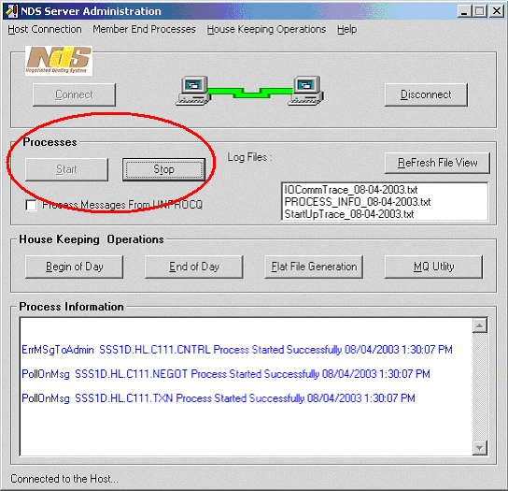

Click Stop to stop the processes. Click Start to start them again.

- If the queues NDS1P.HL.LudId.UNPROCQ and NDS1P.HL.LudId.TEMP_UNPROCQ contain back dated messages then those can be cleared if all the deal transactions of 27/03/2004 are successfully settled. (Refer step 2.5)
- Contact NDS Help Desk on the following numbers, incase of any clarification/problem.
Helpdesk Tel. No.: 2267 5162, 2263 4271, 2266 0500 Ext. 3254

Digital Certificate Change-over Implementation Procedure

Follow the steps given below to implement new digital certificates at the member end. The steps need to be executed on member server only.

  - Rename the C:\Certificates folder to C:\Certificates_27032004.

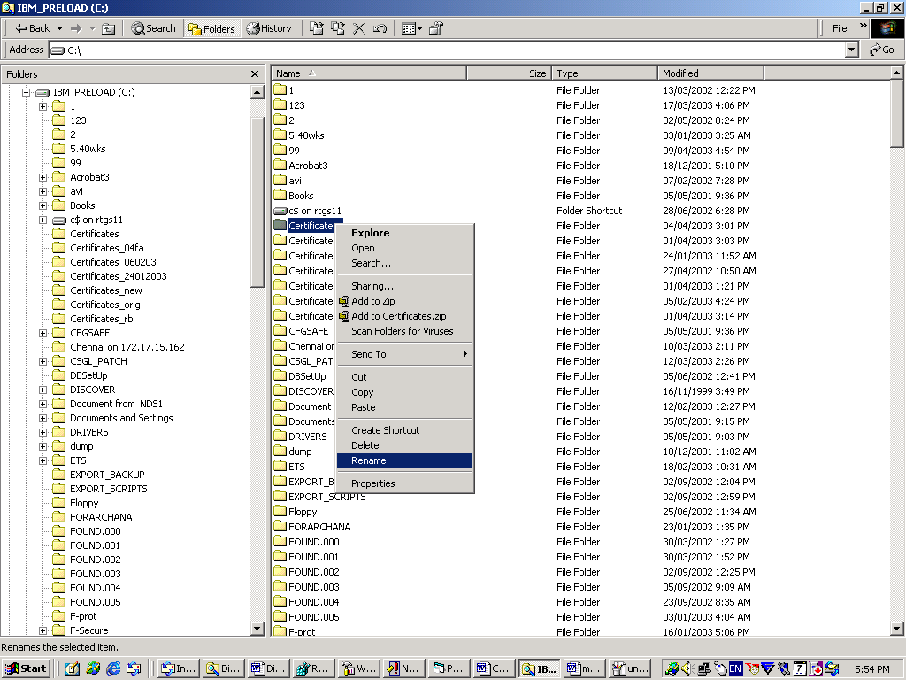

  - Taking the Backup of Registry Entries.

I. Click Start → Run → Type ‘regedit’ and Press OK
(As shown in following Screen Shot)

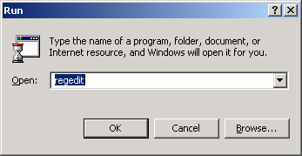

- After opening the registry editor, select the folder
My Computer/HKEY_LOCAL_MACHINE/SOFTWARE/TCS
(As shown in the following Screen Shot)

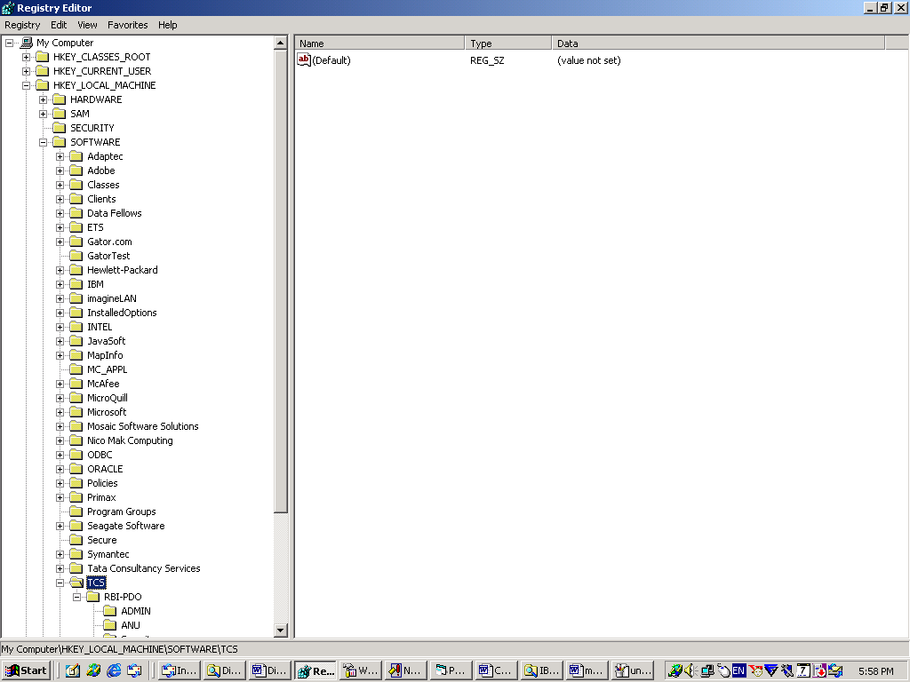

- After selecting the TCS folder click, Registry → Export Registry file option from top menu. (Refer the following Screen Shot)

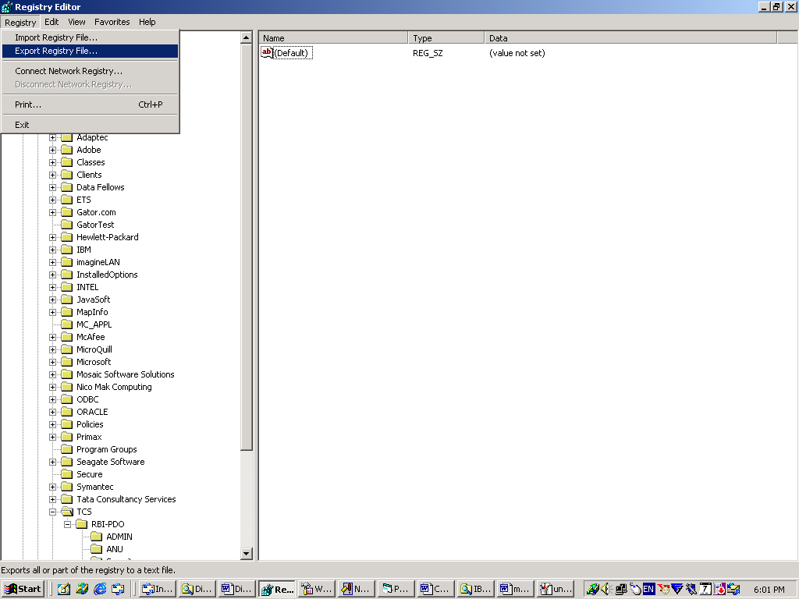

- It will ask for the name of the to be exported registry file. Give the name as
TCS_REG_27032004 and save it to C:\

(Refer the following Screen Shot)
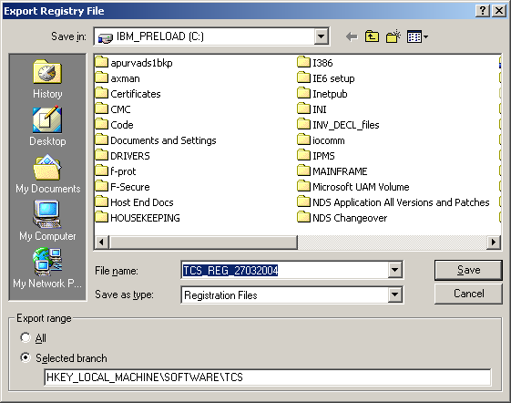

  - Extract the zip file (Certificate_changeover.zip) furnished by RBI to C:\. After extracting the zip file ensure that “Certificates” folder does exist in C:\. The contents of this folder should be as follows:
- cacert.pem
- Receiver.cert
- Crl.pem
- Utility.exe
- RegNewCert.reg

  - Copy your public key (.cer file received from IDRBT) to the “C:\Certificates” folder and rename it to LudIdcert.cert through Command prompt as under:

I. Click Start → Run → Type “cmd” and press OK to go to command prompt.
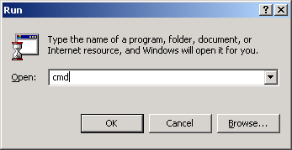

- Type “cd C:\Certificates” and press ENTER to go to Certificate directory.
- Now rename the public key using the REN command as follows.
C:\Certificates \> ren PublicKeyName.cer LudIdcert.cert

(Where LudId is the Member’s LUD Id, also refer the following Screen Shot )

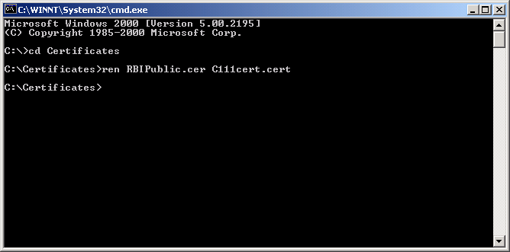

- Similarly, copy the Private key generated by the member(.pem file generated through the Request gen software) to C:\Certificates folder and rename it to LudIdprivate.pem

- Type the command DIR on command prompt and check that the folder “C:\Certificates” contains the following files.
- LudIdcert.cert
- LudIdprivate.pem
- Cacert.pem
- Crl.pem
- Receiver.cert
- Utility.exe
- RegNewCert.reg

(Refer the following Screen Shot)

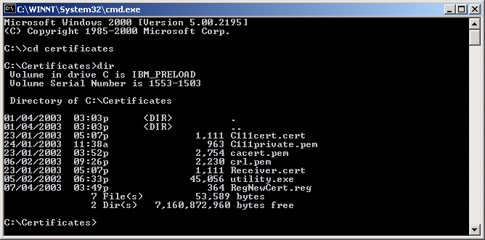

  - Registry Setup:

Double click the file RegNewCert.reg present in C:\Certificates folder.
The following message will pop up.

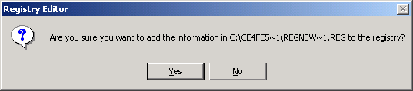

Click “Yes”.

  - Open the Registry Editor and ensure that the value (under column ‘Data’) of following keys is 2707.
(For going to Registry entries, refer step 3.2.I and 3.2.II). Then check as under:
- My Computer/HKEY_LOCAL_MACHINE/SOFTWARE/TCS/RBI-PDO/ SERIAL_NO
- My Computer/HKEY_LOCAL_MACHINE/SOFTWARE/TCS/RBI-PDO/ SECURITY/SERIAL_NO

Verify : The value of the key ‘Serial_ No’ should be 2707 under the field data.

  - Setting the Password Phrase in the registry.

- Run the utility.exe by double clicking it (this will be present in C:\Certificates Folder).
- Now select the Radio Button for “Set Pass phrase” in displayed Screen Shot and type the pass phrase in the textbox labeled as “Own Pass Phrase”. (Refer the following Screen Shot)
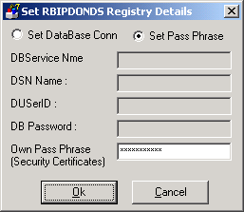

- Press ‘Ok’ button to save it (Please ensure that you enter the exact pass phrase which you had given when your private key and request file was generated. Also ensure that you enter the pass phrase in the correct case as it is case sensitive)

The following message will pop up after pressing OK

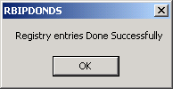

Click OK.

After making the Registry Entries Successfully, Click ‘Cancel’ button to close the
Window.

This will finish the Digital Certificate changeover procedure.

- Contact NDS Help Desk on the following numbers, incase of any clarification/problem.

Helpdesk Tel. No.: 2267 5162, 2263 4271, 2266 0500 Ext. 3254
------------------------------------------------------------------------------------------------------------

