RESERVE BANK OF INDIA


PDO-NDS COMPUTERISATION PROJECT

Revised Broadcast Architecture Release

PDO-NDS Application Version 2.7.5

(Member End)

Manual Version: 1.0

Prepared by



July 2004

Confidential and controlled document.
Unauthorised access or copying is prohibited.

- Introduction

Purpose of the Document

The objective of the document is to provide step-by-step procedure for applying revised broadcast architecture release at member end.

  - Scope of the Document

This document provides guidelines for applying software patch on member server for deployment of the revised format of NDS Trade Data Message Broadcast.

1.3 Objective

The objective is to revise the architecture of message flow from Host end to member-end, segregating flow of messages pertaining to trade watch and market watch from flow of messages pertaining to deals. Henceforth, t
rade messages will flow to member server through a dedicated server at Host end.

- Procedure for applying Patch on the Member Server

This section provides the guidelines for applying the software patch on NDS application at the member end.

It is assumed that NDS application is installed on drive C: of the NDS Server. In case the NDS application is installed on any other drive (e.g. D: or E:), then change the drive name in the UNREG.bat file.
(For changing the drive name in the batch file, select UNREG.bat file->Right click->Select “Edit”->Notepad. The batch file will open. In the batch file, replace drive C: with the desired name of drive at all places. Save the change and close the batch file).

Pre-requisites for NDS Server Application Installation:

  - Log off the NDS Application.
  - Ensure that all the Messages have been processed in MQ Series Queues.
(Current depth of all Queues except Query, input and Output log should be zero)
  - Stop all the Processes.
  - Perform EOD Operation.
  - Close the Host Connection window and Stop the MQ Series Queue Manager.
  - Kill DLLHOST.exe from Task manager.

Renaming and Backup of NDS Registry

On Server:

2.1.1 Create folder ‘NEWSMODLLS’ on C:\.

2.1.2 Copy the NEWSMODLLS.ZIP file to above created folder.

2.1.3

Extract the Zip files on that folder itself.( NEWSMODLLS folder)

2.1.4 Ensure the following 4 files (3 dlls and 1 batch file) should be present in NEWSMODLLS
folder.
MS_SMO.dll,
ComMsg_MS_SMO_dll.dll
MC_Convert.dll
UNREG.bat file.

2.1.5 Goto Start ➔ Settings➔ Control Panel➔ Administrative Tools➔Component Services➔
Computers➔ My Computer➔ COM+ Applications➔RBIPDONDS➔Components .

Following screen will appear

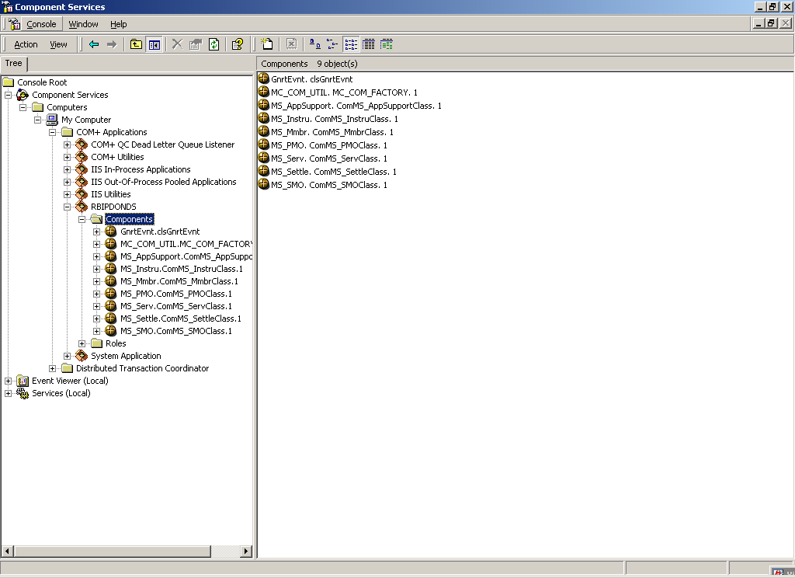

2.1.6 Right click on component MS_SMO.ComMS_SMOClass.1 as shown in figure below and click Delete :

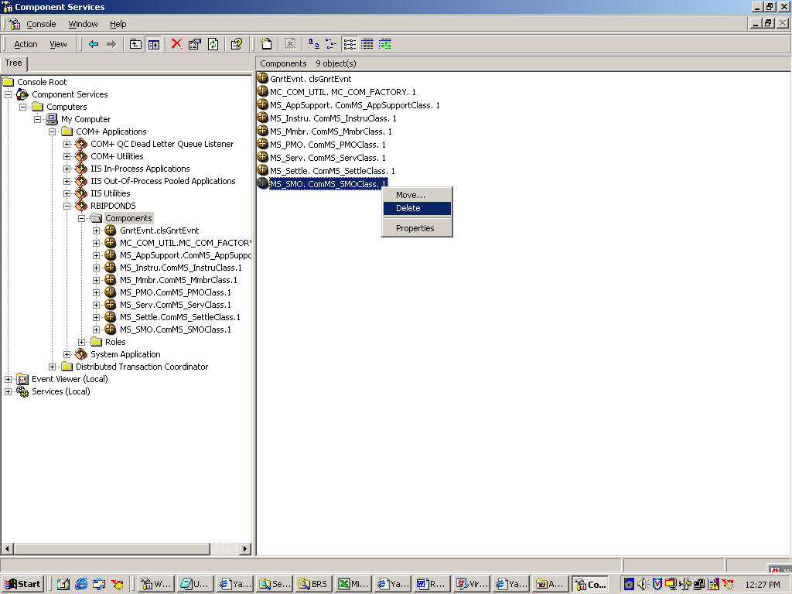

2.1.7 Following dialog box will appear. Confirm delete by pressing Yes.
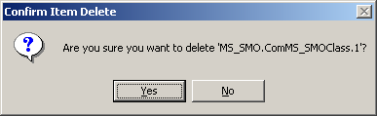

2.1.8 Double click on UNREG batch file from C:\NEWSMODLLS. This batch file will unregister and back up the old dlls and it will register the new SMO dlls.(ComMsg_MS_SMO_dll.DLL & MS_SMO.dll).
Press ‘OK” button in response message box.

2.1.9 Right click on component in left hand side window as shown in figure Below:
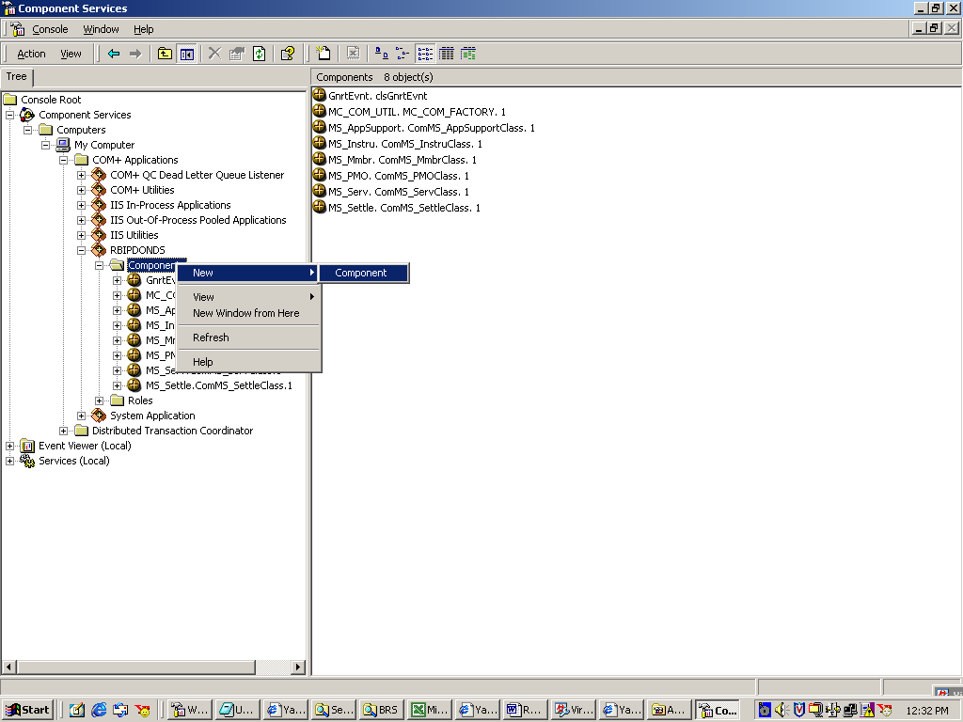

Then click New→Component. Following screen will appear:

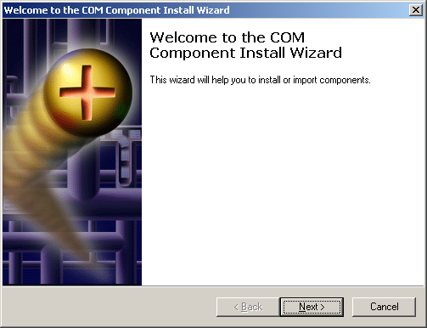

Press “Next” Button.

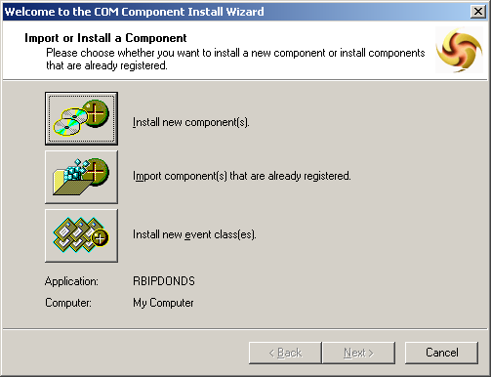

Click on first picture besides “Install New Component”. Then following screen will appear
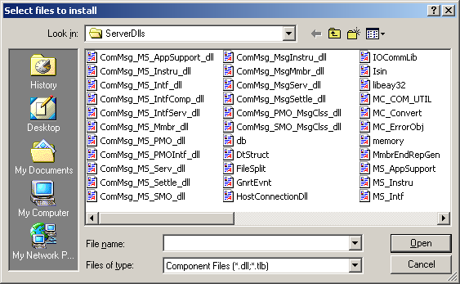

Go to folder “C:\Program Files\RBIPDONDSSetUp\ServerDlls” and select “MS_SMO.Dll” and press Open button. Following screen will appear:

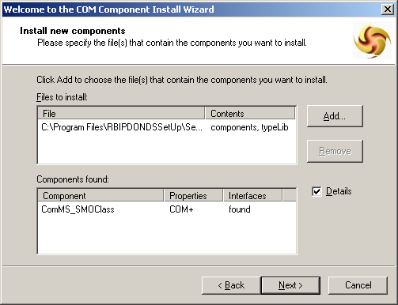

Press Next button. Then following screen will appear:

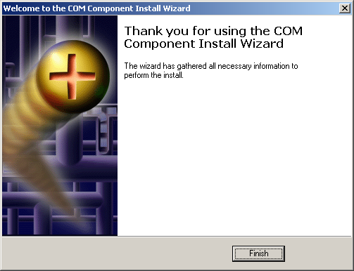

Press “Finish“ button.

  - Install Oracle 8i Enterprise Edition in clustered mode along with with Oracle Fail Safe (version. 3.1.2) installationapplication on both the servers nodes without creating creating a database. The steps for loading oracle in clustered mode

MSMQ Disconnecti

&

xxxxxxxxxxxx END xxxxxxxxxx

