Procedure to ascertain and change the Host (RBI) Server IP address
in the MQ Sender channel at Member-end

The NDS / CFMS / RTGS sender channel at the end of all NDS member’s server contains the IP address of RBI Server (S390 System at RBI, Mumbai) so that it can connect to the live/ operational RBI server. The IP address of RBI Server at the Primary site is 10.21.1.45 and at the On City Disaster Recovery site (backup site) is 10.24.1.45. Any one of the RBI Server will be up i.e., either the primary site or the backup site will be operational. Accordingly, the MQ sender channel at member server should point to the live RBI server. At the time of every Host-end site switch at RBI, the destination IP address in the MQ Sender Channel at member-end will require to change.

The RBI Server IP address change in the Sender channel will take place automatically for all those NDS and CFMS members where the Unicenter MQ Agent is installed and the required services are in running status. The destination IP will be changed centrally by the Helpdesk support team once the S/390 Mainframe system is up at the new live site.

Other member institutions (where either the Unicenter MQ Agent is not installed or the required services are not running) will require to manually change the destination IP address by following the procedure given in this document. (Though the document is prepared for NDS sender channel, same procedure is applicable for CFMS application except for the change in the Port Number used by CFMS application).

The RTGS application has a specific procedure for site switch that needs to be followed by the RTGS members.

Port No. 1414 is being used for the NDS application, Port No. 1416 is used for CFMS application and 1419 is used for RTGS application at both the sites.

The NDS members (including PDOs) may follow the procedure detailed herein below to change the RBI Server IP in the NDS sender channel so that their NDS channels can communicate with RBI Server at the primary site or the On City Disaster Recovery site (backup site), as desired. However, the IP in the NDS sender channel should be altered only on advise from RBI (NDS Helpdesk / CFMS Helpdesk).

Procedure to ascertain and change the IP address in NDS sender channel
Ensure that the Queue Manager NDS1P.LUDID.QMGR is started (LUDID is the member's corresponding LUDID). If it is not started then right click on the Queue Manager and click START.
After the Queue manager is started, then before doing the NDS Begin of Day operations, check the IP address in the NDS sender channel as under:

- Open WebSphere MQ Explorer on the NDS Server :

Click on Start button→Programs→IBMWebSphere MQ→ WebSphere MQ Explorer.

- Within the NDS Queue Manager, Select the folder called Advanced and then the folder called Channels. Then in the right panel, select the NDS sender channel.

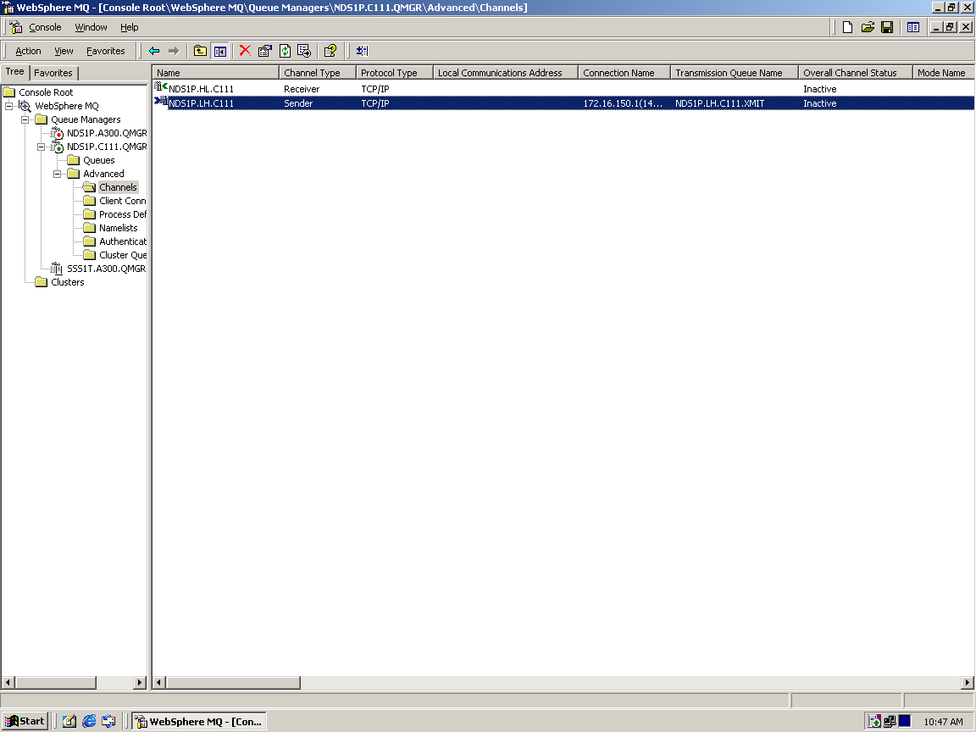

3. Right click on the sender channel and proceed to →Properties →General→Connection Name.
Change the connection name IP address to 10.24.1.45(1414) instead of default IP address 10.21.1.45(1414) for connecting to the On City Disaster Recovery site (backup site).
Similarly, for connecting to the primary site, the connection name IP address should be 10.21.1.45(1414).

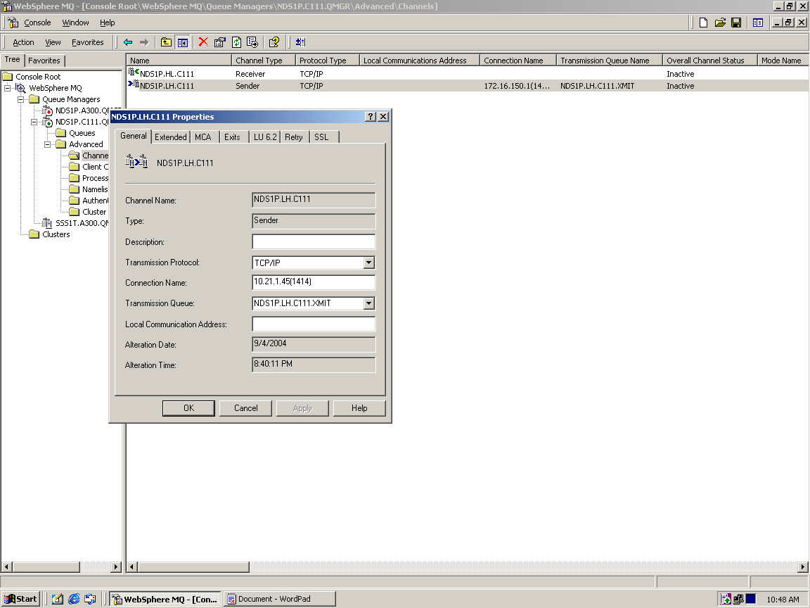

- Click on Apply and then on OK.

With the above activity, the NDS sender channel is ready to connect to the live/ active RBI Server.

After the above activity, you may proceed with the regular NDS operations i.e., Begin of Day/ Connection. In case Begin of day is already done, the system will not allow the Begin of Day again. In that case, start the processes and directly connect to the system.

