User creation and functional/ operational rights assignment to users

In NDS, the individual User needs to be assigned functional rights. The mechanism devised for assigning the functional rights to the User ids is as follows:

- Create the User
- Create Role
- Allocate Operations (functions) to the Role
- Assign Role to the User.

The User creation and the Role creation are independent of each other. They may be created in any sequence.
A set of functions (operations) may be allocated to a Role. Such Roles (one or many) may be assigned to the User/s. Users having specific Role/s will have the operational/ functional rights assigned to that Role/s.

The creation of users/ roles and the assignment of functional/ operational rights to the users can be undertaken as under:

SCREEN SNAPSHOT REPRESENTATION FOR ROLE CREATION:

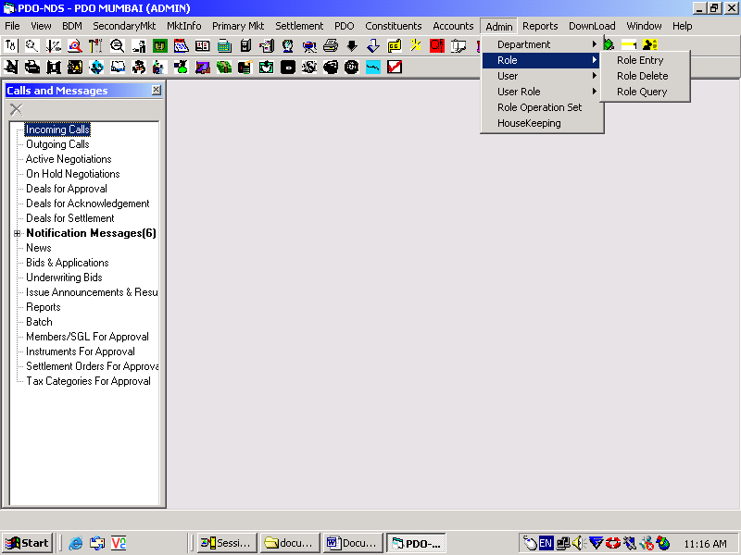
(Fig # 1)
- This operation will need to be performed from the user that is having the ADMIN rights.
- Login as ADMIN (or the user with Admin rights)
- Go to Admin menu in the screen
- From the dropdown select Role>Role Entry
- The Role Entry screen will open as shown below and the role desired can be created.

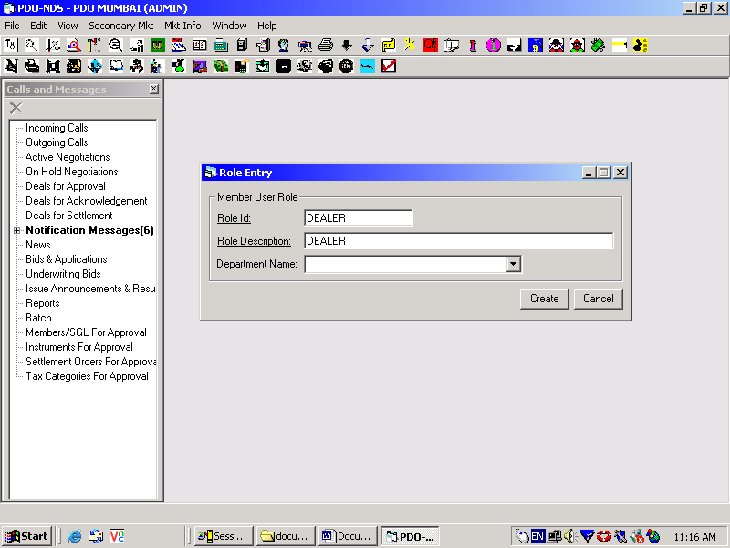
(Fig # 2)

On clicking the Create Button, system will prompt “User Role Created Successfully” as shown below.

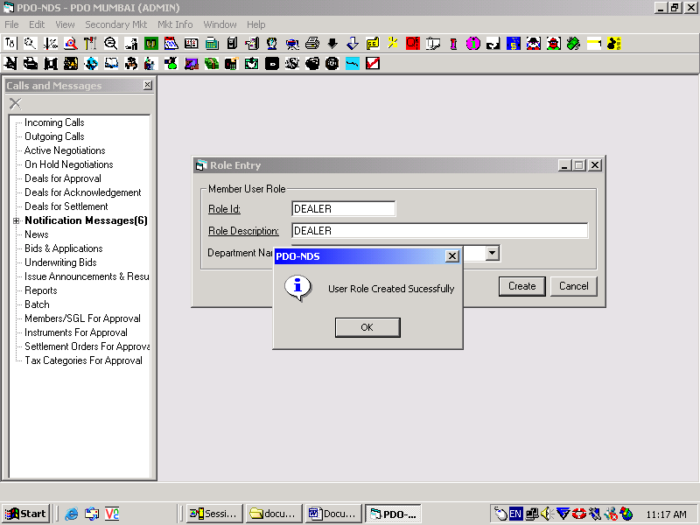
(Fig # 3)

SCREEN SNAPSHOT REPRESENTATION FOR ASSIGNING FUNCTIONS TO ROLE

In the Admin Menu go to Role Operation set menu and the below screen will appear.

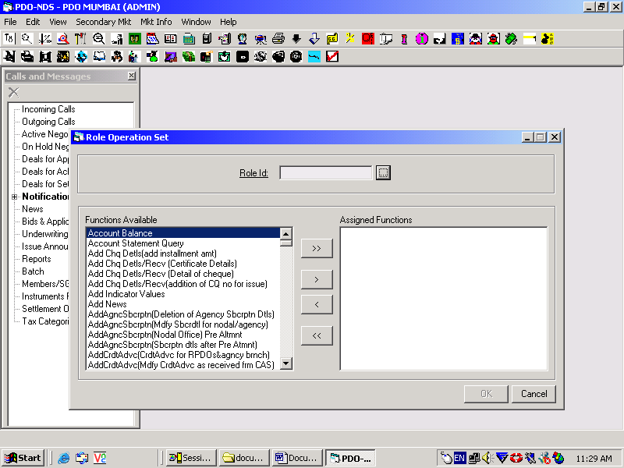
(Fig # 4)

To select the Role click on the 3 dot button next to Role id field and a role query screen will appear as shown below.
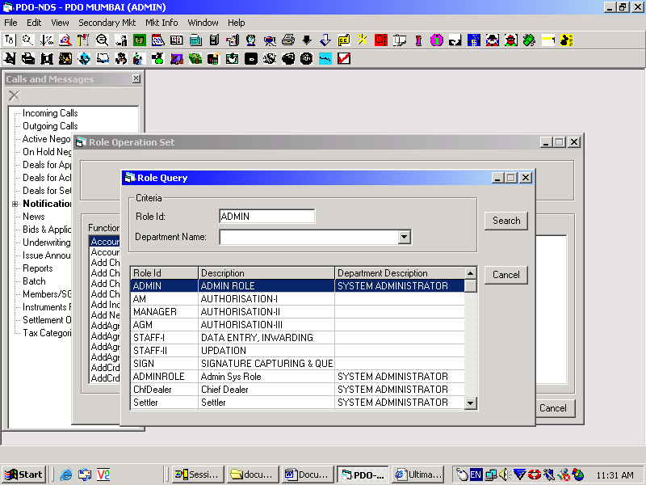
(Fig # 5)
Select the desired role and double click on it. It will get populated on the Role id field as shown below.

The functions desired to be assigned to a role can be so assigned by selecting the same from the available functions. Select the functions and Click on the button with double greater than sign. Incase a single function needs to be assigned select the function and click the single greater than button and it will be populated on the Assigned Functions field

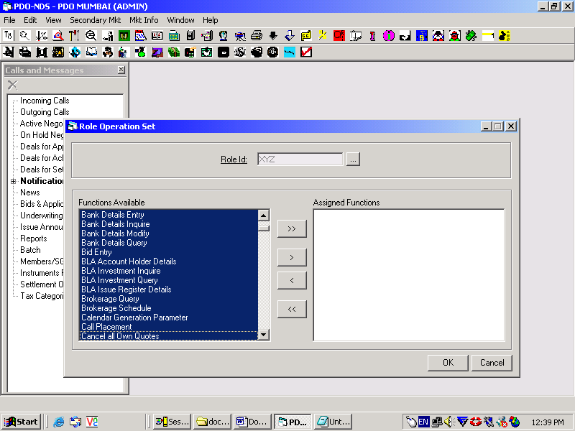
(Fig # 6)

Functions will appear on the Assigned Functions field as shown below.

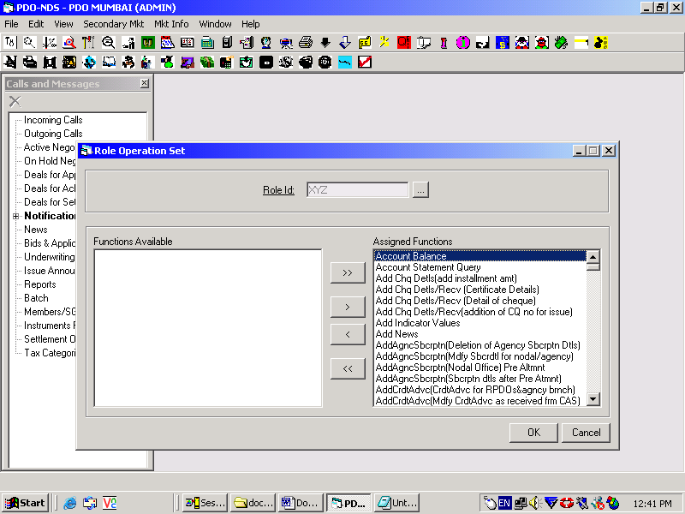
(Fig # 7)

On clicking OK, system will prompt “Operations assigned to the role successfully” as shown below.
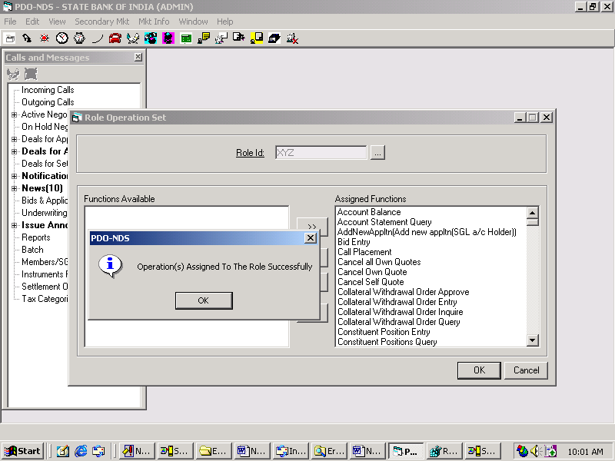
(Fig # 8)

SCREEN SNAPSHOT REPRESENTATION FOR USER CREATION:

In the Admin menu go to User> User Entry.
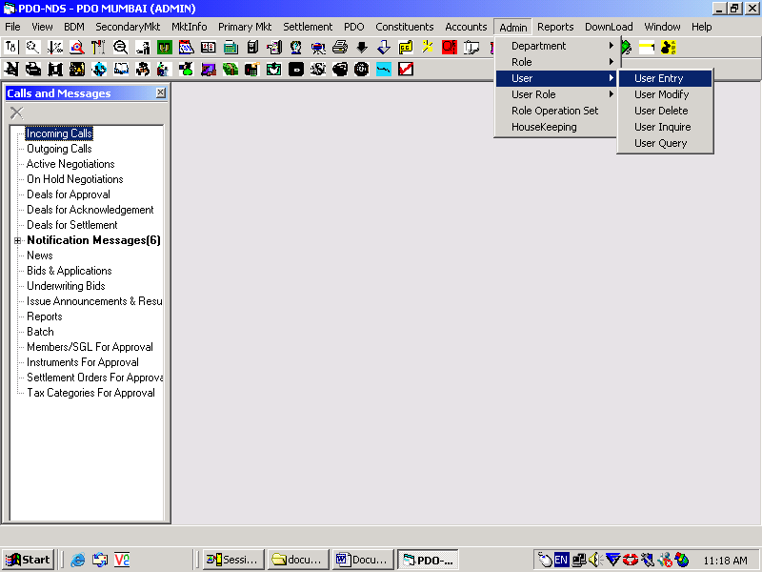
(Fig # 9)

A member User Entry Screen will open as shown below.
Only underlined fields are mandatory. Fill up all the required fields and click password.
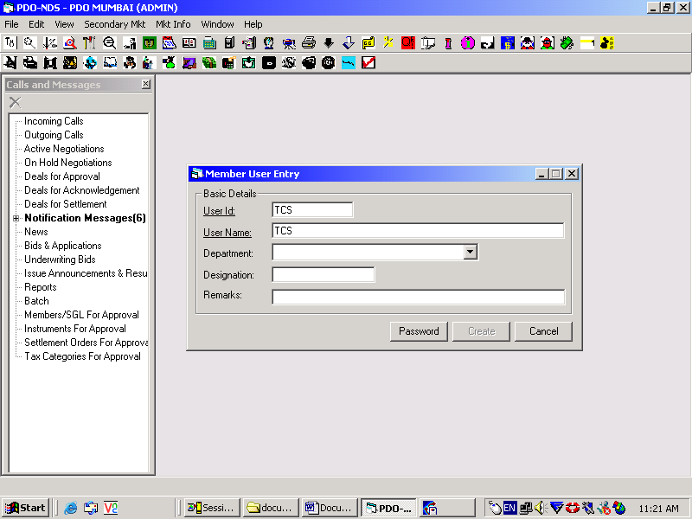
(Fig # 10)

Fill up all the required fields and click password. The password will be required to be given twice(once for confirmation) and then click create .

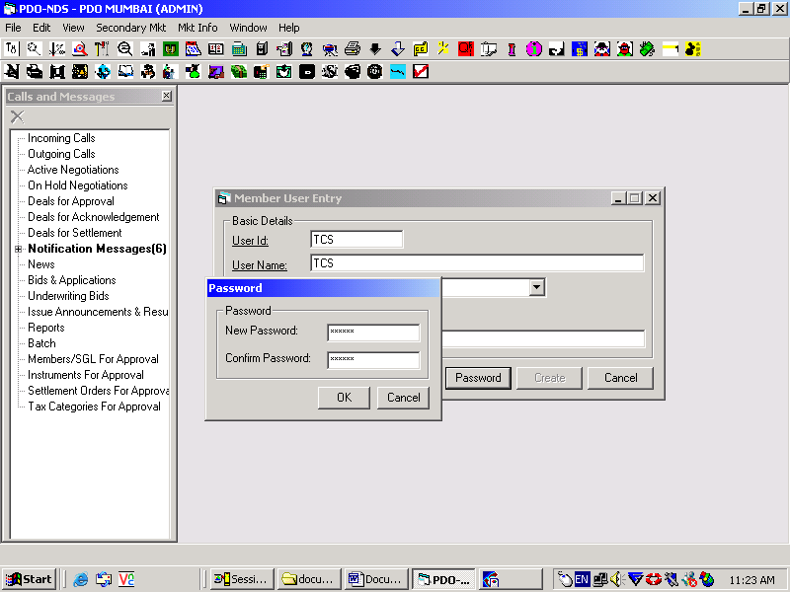
(Fig # 11)

On clicking ‘Create’ it will give the screen shown below.

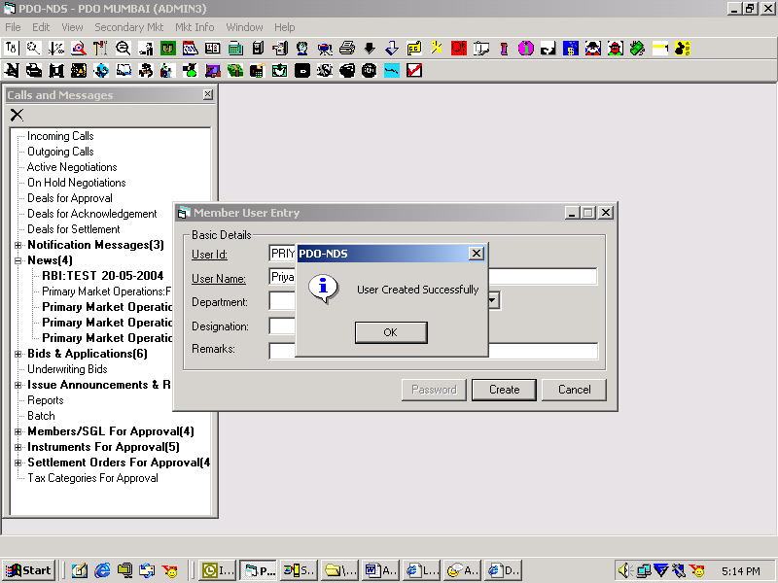
(Fig # 12)

SCREEN SNAPSHOT REPRESENTATION FOR ASSIGNING ROLE TO USER

Once a User has been created a Role needs to be assigned to the User.
For assigning the Role go to Admin Menu>User Role >User Role Set as shown below.

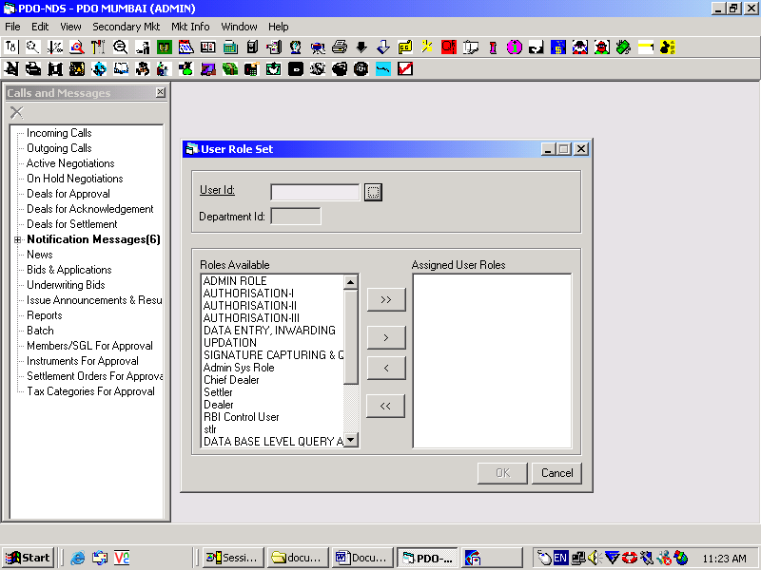
(Fig # 13)

Click on the three-dot button and the User Query screen will open. Select the desired user to whom the role needs to be assigned. Double click on the user and it will be populated in the User Id field of the User Role set Screen as shown below,

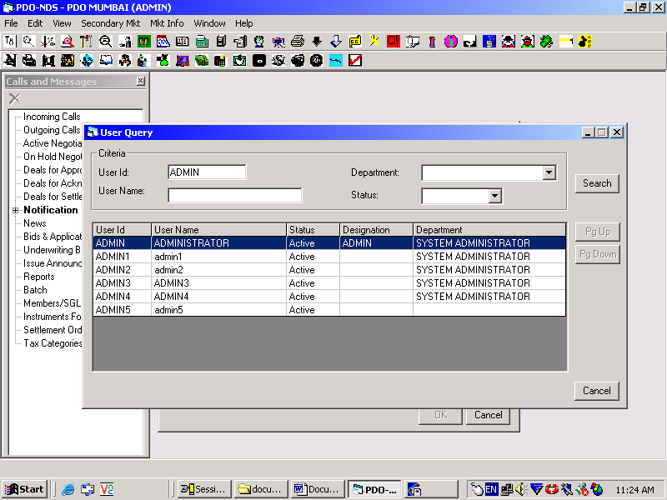
(Fig # 14)

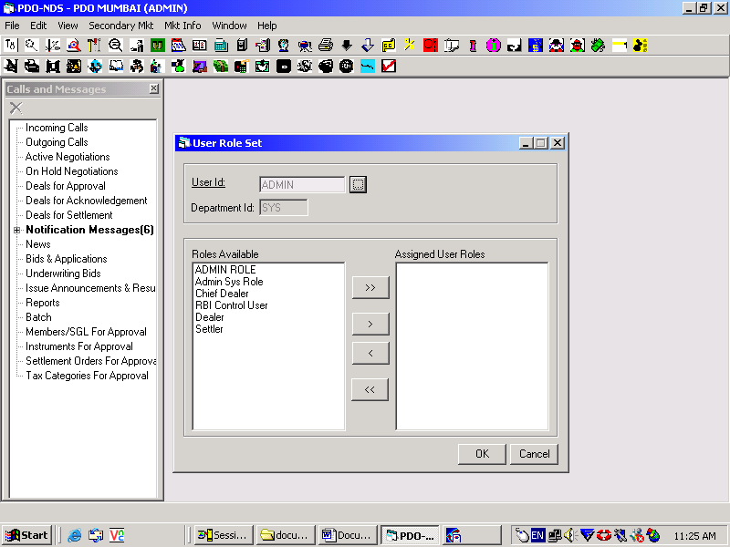
(Fig # 15)

The roles will be displayed on the Roles Available field. The Role/s desired to be assigned to the User may be selected and assigned to the Assigned User Roles Field using the Single/Double Greater than Button. Refer the snap shot below.

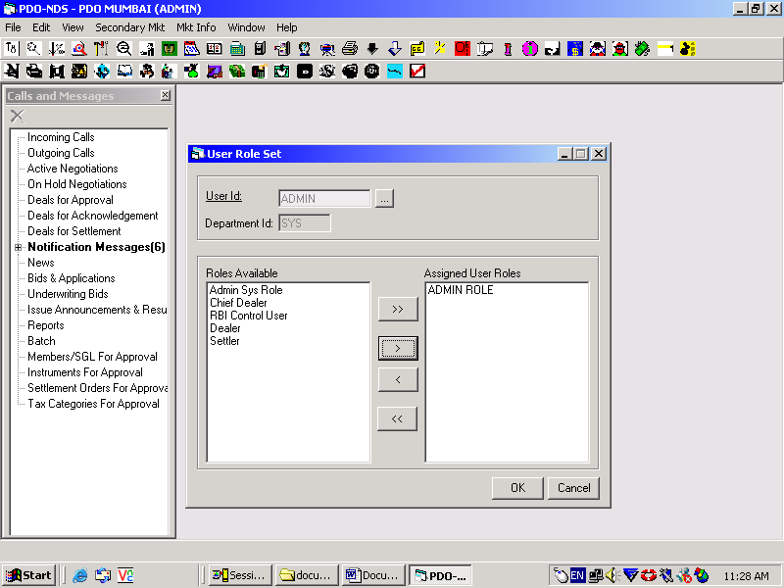
(Fig # 16)

Click ‘OK’ and the system will prompt “ Roles assigned to the User”

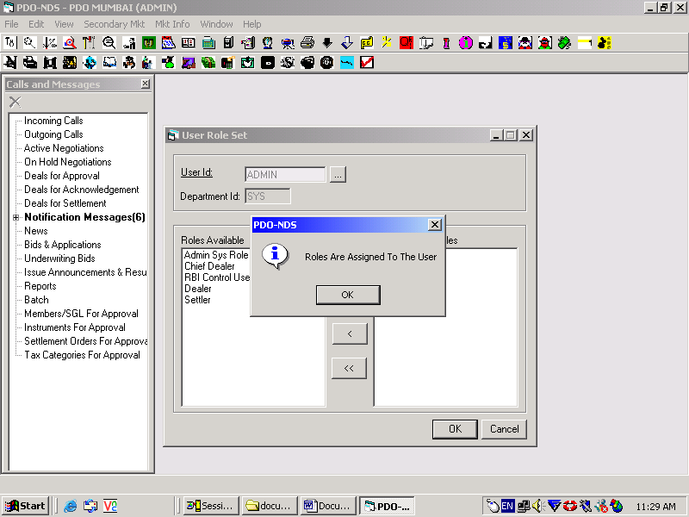
(Fig # 17)

Incase additional functions are being assigned to any role; they can be assigned in the manner as described above (Fig # 4-8).

