Investments of Scheduled Commercial Banks*
(End-March 1998 And 1999)
Reserve Bank of India conducted the annual survey of Investments of Scheduled Commercial Banks as on 31st March of 1998 and 1999. The investments of Regional Rural Banks (RRBs) constitute only 1.9 per cent of All Scheduled Commercial Banks$ and as such RRBs have been excluded from the survey. The types of investments covered in the survey are i) Central and State Government Securities ii) The Securities, other than Central and State Government Securities, approved for the purpose of investments under Indian Trusts Act (1882) iii) Shares, bonds and debentures of Indian Joint Stock Companies (iv) Fixed deposits with banks (v) The domestic securities which are not eligible as trustee securities, such as initial contribution to Unit Trust of India, share capital in Regional Rural Banks vi) Foreign Securities and other foreign investments. The survey covered all Indian Scheduled Commercial Banks (other than RRBs) operating in India and abroad and Foreign Banks operating in India.

2. | A banks' investment decisions depend on a number of factors. It is therefore pertinent to note the developments in the policy framework of banks' investments as cited in the RBI Annual Reports, 1997-98 and 1998-99.

 | i) | Excess provision towards depreciation in investments held under reserves and surplus became eligible for inclusion in Tire II capital.
 | ii) | The ratio of permanent and current investments in approved securities lowered to 40:60 per cent for 1997- 98 from 50:50 per cent for 1996-97.
 | iii) | Banks were allowed to book income on accrual basis on Securities of Corporate bodies/Public Sector Undertakings in respect of which the payment of interest and repayment of principal were guaranteed by the Central Government or State Government. Banks were allowed to book income from dividends on accrual basis provided that the corporate bodies declared dividends on the shares in its Annual General Meeting and the owner's right to receive payments was established.
 | iv) | Banks were required to value the government securities in current category as per market quotations as on the last day of March and to use the yields indicated by Reserve Bank for valuation of government securities where market quotations are not available.
 | v) | With a view of adopting prudent accounting standards and to move towards 'mark to market valuation' of the investment portfolio, banks were required to classify a minimum 70 per cent of their securities as current investments for the year ending March 31, 1999. The proportion of current investments was further raised to 75 per cent for the year ended March 31, 2000 and has been retained unchanged for the year ending March 31, 2001.
 | vi) | The Reserve Bank allowed commercial banks to invest up to 5 per cent of their incremental deposits in the previous year in ordinary shares of corporates including PSUs.
 | vii) | Government / approved securities would have to be provided for a risk weight of 2.5 per cent by the year ending March 31, 2000 on account of market risk. An additional risk weight of 20 per cent for securities of government undertakings, which do not form part of the market-borrowing programme, would be introduced in the financial year 2000-01.
 | viii) | With a view to removing the anomaly of zero risk weight for investments in bonds / securities of some of the Public Financial Institutions (PFIs) due to their status as 'approved securities' and 100 per cent for investments in certain other PFIs, investments in bonds /debentures of PFIs would be given a uniform risk weight of 20 per cent.
 | ix) | Investments by banks in bonds or debentures of a corporate guaranteed by a Public Financial Institution would be treated as an exposure to the Public Financial Institution and not to the corporate. Consequently, the exposure of the bank to Public Financial Institution would be 100 per cent whereas the exposure by the Public Financial Institution to the Corporate would be to the extent of 50 per cent.

Against the backdrop of the policy changes effected during the period April 1997 to March 1999, the investment-deposits ratio maintained steadily decreasing trend from the peak level of 41.2 in the year 1994 to 37.7 in 1997.* The declining trend continued for the year March 1998 and March 1999 as well. It is interesting to note that credit-deposit as well as cash-deposit ratio also maintained a similar declining trend over the period March 1997 to March 1999. (Chart 1)
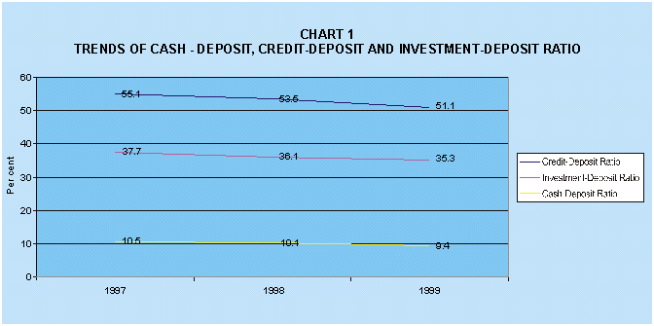

3. | The results of the survey are presented in three sections. Section I presents an analysis of the aggregate investment of Scheduled Commercial Banks according to types of securities. Section II presents the bank group-wise analysis of investments and Section III presents the investments of Scheduled Commercial Banks in State-level securities as at the end of March 1999. Investments in loans floated by the State Governments, contributions in the share capital of Regional Rural Banks, subscribing to the debentures of Cooperative Institutions, subscribing to bonds of State Government guaranteed bodies viz. Municipalities, State Electricity Boards, State Financial Institutions, Road Transport Corporations etc. generally constitute the investment portfolio of the bank in the state level bodies.

SECTION I
Analysis of Aggregate Investments of Scheduled Commercial Banks.
Aggregate investment of Scheduled Commercial Banks as at the end March 1997,1998 and 1999 are presented in statement 1.

4. | The total investment of Scheduled Commercial Banks increased from Rs.2,38,779 crore as at end March 1997 to Rs.2,79,432 crore as at end March 1998 which further increased to Rs.3,32,509 crore as at end March 1999. In the total investment of the Scheduled Commercial Banks, the share of investments by Foreign Offices of Indian Banks remained within a range of 2.0 per cent to 2.9 per cent. However, the share of investments by offices in India was very high in the range of 97 per cent and 98 per cent. The Foreign Offices of Indian Banks as expected did not make any investments in Indian securities. Their investments were generally, in Foreign Government securities and Joint Stock Companies registered abroad. (Chart 2).
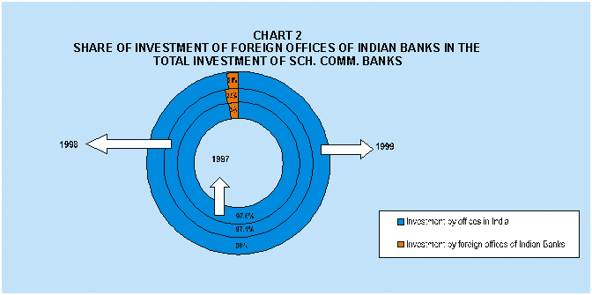
5. | It is observed that there is a clear preference for Indian Government securities in the asset choice of the banks in India. (Chart 3).
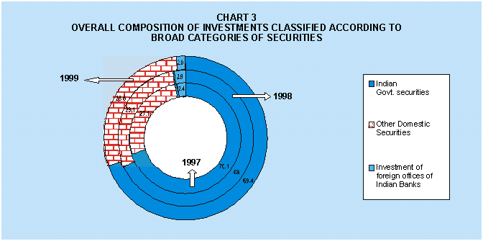

6. | Indian Government Securities consisting of Central Government securities, State Government securities and others (which primarily constitute postal savings certificates and other postal obligations) constituted 68.0 per cent and 69.4 per cent of the investment portfolio of the banks as at the end March 1998 and 1999 respectively. Investments in Central Government securities increased from Rs.1,56,742 crore in 1998 to Rs.1,91,307 crore in 1999, indicating a growth of 22.1 per cent. The net increase of Rs.34,565 crore in outstanding investments in Central Government securities indicate continued investment preference of banks for this category of securities as it constituted 63.2 per cent of the net increase in the outstanding investments portfolio of the banks. The investments in State Government securities grew from Rs.32,923 crore in 1998 to Rs.38,413 crore in 1999. The growth in outstanding investments in State Government securities was lower at 16.7 per cent as compared to the Central Government securities. The net increase of about Rs.5,490 crore in the outstanding investment ranks third in the security preference in the portfolio choice of the banks (Chart 4).
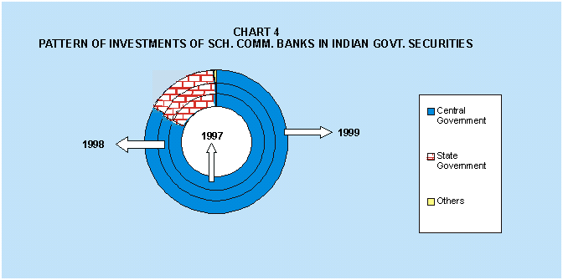
7. | Apart from the Indian Government securities, there was substantial outstanding investment of Rs.81,265 crore in l998 and Rs.95,165 crore in 1999 by the offices of Scheduled Commercial Banks in India in various domestic securities viz. shares and debentures of Joint Stock Companies, trustee securities (other than Central and State government securities), fixed deposits, units of Unit Trust of India, certificate of deposits and commercial papers, Mutual Funds, initial contribution to share capital of Unit Trust of India, bonds and debentures of Quasi-government bodies, venture capital funds etc. Overall pattern of investments of banks in these categories of securities remained similar in both 1998 and 1999.
 | In both the years, while investing in these types of securities, the portfolio choice of the banks remained heavily loaded in favour of shares and debentures of joint stock companies and other trustee securities (i.e. trustee securities other than Central and State government securities). Banks' portfolio of investments constituted an outstanding investment in shares and debentures of Joint Stock Companies of Rs.38,604 crore in 1998 and Rs.52,163 crore in 1999 in terms of market value. Eventhough, other trustee securities continued to be a major portfolio of banks in 1999, there was a reduction in outstanding investments of Rs.31,390 crore in 1998 to Rs.28,327 crore in 1999. Outstanding investments in Certificate of Deposits and Commercial Papers as at end March 1998 and 1999 remained almost stationary at Rs.367 crore and Rs.366 crore respectively. The investment in "Mutual Funds" have however, increased from Rs.148 crore in March 1998 to Rs.199 crore in March 1999. Banks' outstanding investment of Rs.3,296 crore as at the end March 1998 in the bonds and debentures of Quasi-government bodies, venture capital funds etc. had, however, increased to Rs.6,033 crore as at the end March 1999 (Chart 5).

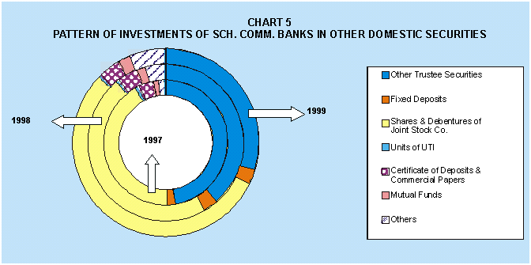
SECTION II
Bank Group-wise Analysis of Investments of Indian Offices
Category-wise outstanding investments of bank groups and their variations in absolute and percentage terms (with regard to previous year) are presented in statement 2.

8. | The total outstanding investment of Scheduled Commercial Banks as at end March 1998 and 1999 were Rs. 2,79,432 crore and Rs. 3,32,509 crore respectively. In the outstanding investments of Scheduled Commercial Banks, Nationalised Banks as a group had a share of 56.8 per cent followed by State Bank of India and Associates 26.5 per cent as at the end of March 1998. Respective shares of Other Indian Scheduled Commercial Banks and Foreign Banks were 10.4 per cent and 6.3 per cent respectively. The shares of State Bank of India and Associates, Other Scheduled Commercial Banks and Foreign Banks in outstanding investments increased as at the end March 1999 as compared to the previous year. Their shares in 1999 were 28.7 per cent, 11.1 per cent and 7.9 per cent respectively. On the other hand, the respective share of Nationalised Banks reduced from 56.8 per cent as at end March 1998 to 52.2 per cent as at end March 1999. (Chart 6).
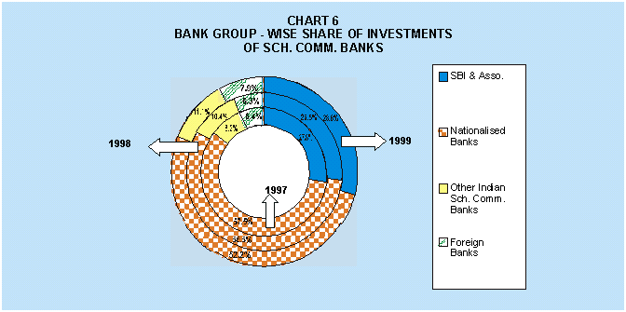
9. | The Central Government securities constituted the major outstanding holdings in the portfolio of State Bank of India and Associates. The share of Central Government securities was 61.6 per cent as at end March 1998 followed by State Government securities (13.7 per cent), other trustee securities (12.9 per cent), shares and debentures of Joint Stock Companies (7.6 per cent), other domestic securities (1.8 per cent) in terms of total outstanding investment. Total investment of State Bank and its Associates increased from Rs. 74,065 crore as at the end March 1998 to Rs. 95,752 crore as at end March 1999 which represented a growth rate of about 29.3 per cent (point to point basis). State Bank and it's Associates increased their investments in Central Government securities from Rs. 45,619 crore in 1998 to Rs. 60,243 crore representing a growth rate of 32.1 per cent (point to point basis). The State Government Securities also grew but at a much lower rate of 15.3 per cent from Rs. 10,119 crore to Rs. 11, 670 crore. There was a net disinvestment of Rs. 468 crore resulting in reduction in the outstanding investment of Rs. 9,549 crore as at end March 1998 to Rs. 9,081 crore as at end March 1999 in the investment category of other trustee securities. Bonds and debentures issued by the All India bodies constitute the majority of the investments in other trustee securities (statement 3). There was a net disinvestment of Rs. 266 crore in terms of outstanding investments of State Bank of India and its Associates in the All India Bodies. Investments in this category came down from Rs. 4,943 crore as at end March 1998 to Rs. 4,677 crore as at end March 1999. Major Investments of State Bank of India and its Associates in the All India bodies were in State Electricity Boards, Industrial Development Bank of India, State Financial Corporations and Industrial Finance Corporation of India. Outstanding investments of SBI and Associates in all the securities of All India bodies have, however, come down as at end March 1999 as compared to that of end March 1998. The exceptions, in this regard were the investments in securities of Unit Trust of India and HUDCO where outstanding investments as at end March 1999 have increased as compared to that of end March 1998. (Chart 7).
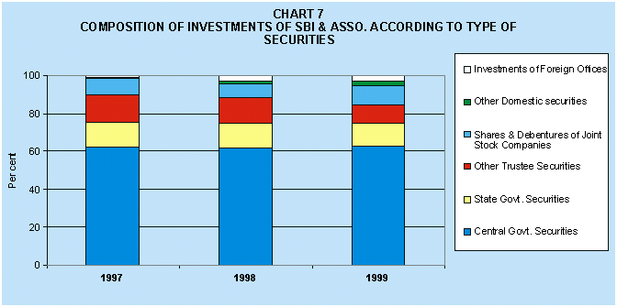
10. | Composition-wise Rs. 1,58,613 crore outstanding investment portfolio of Nationalised Banks as at end March 1998 constituted Central Government Securities (51.6 per cent), State Government Securities (13.2 per cent), Other Trustee Securities (12.2 per cent), shares and debentures of joint stock companies (15.5 per cent) and other domestic securities (3.5 per cent). This portfolio grew at the rate of 9.4 per cent (point to point basis) to an outstanding investment of Rs. 1,73,557 crore as at end March 1999. The outstanding investments of Nationalised Banks as at end March 1999 registered a growth rate of 13.4 per cent (point to point basis) in Central Government securities. The corresponding growth figures for investments on a point to point basis in State Government securities, shares and debentures of joint stock companies and other domestic securities were 18.0 per cent, 11.5 per cent and 36.9 per cent respectively. There were, however, disinvestments of Rs. 2,225 crore in the trustee securities (excluding Central and State Governments) by Nationalised Banks. As regards trustee securities, Nationalised Banks had substantial investments in All India bodies viz. State Financial Corporations, State Electricity Boards, Industrial Development Bank of India & Industrial Credit and Investment Corporation of India etc. The outstanding investments in the All India bodies have individually come down from that of the previous year's outstanding level. (Chart 8).
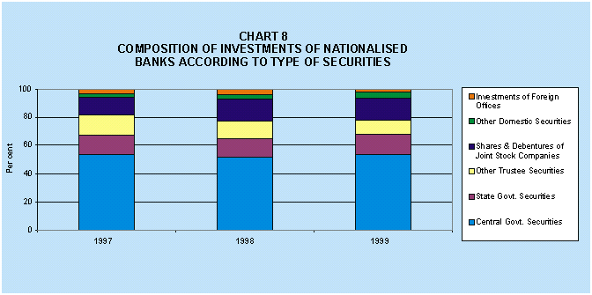

11. | Total outstanding investment of Other Scheduled Commercial Banks increased from Rs. 29,211 crore in 1998 to Rs. 36,935 crore in 1999. This represented a growth rate of 26.4 per cent (point to point basis). The Other Indian Scheduled Commercial Banks registered growth rate of 21.8 per cent in Central Government Securities over the outstanding level of investment as at end March 1998. There was a very substantial growth in outstanding investments (74.9 per cent on a point to point basis) in the shares and debentures of joint stock companies. There was, however, net disinvestment of Rs. 172 crore made by this group of banks in terms of outstanding investments as at end March 1998 and 1999 in the other trustee securities. Out of these disinvestments about Rs. 93 crore were from the bonds portfolio of All India bodies. (Chart 9).
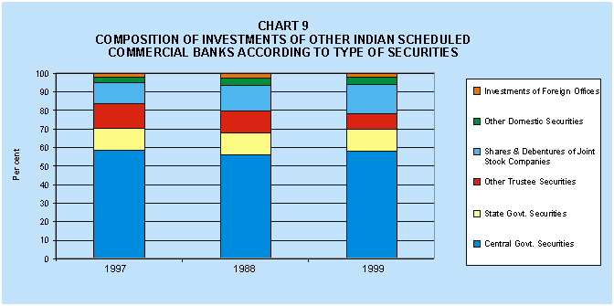
12. | Investment pattern of Foreign Banks indicate that this group of banks invested predominantly in Central Government securities and in the shares and debentures of Joint Stock Companies. The investments of Foreign Banks in Central Government securities were to the extent of 74.0 per cent and 72.6 per cent of the total outstanding investment in 1998 and 1999 respectively. The outstanding investments in shares and debentures in 1998 and 1999 were 18.1 and 23.0 per cent respectively. Foreign Banks participation in other types of securities were negligible. (Chart 10).
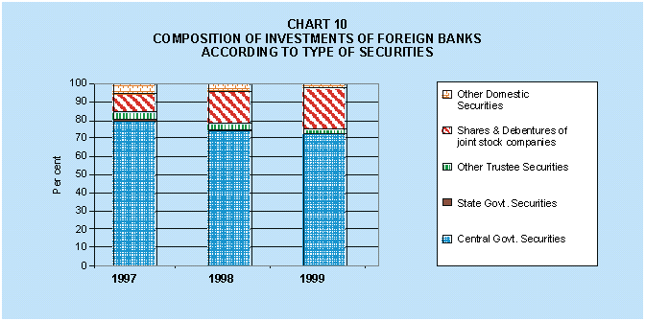
13. | Bank Group-wise Pattern of Investments in Instruments of Capital Market
 | It has been observed that all the bank groups increased their investments in terms of market value in the shares and debentures of Joint Stock Companies. The investments in debentures together with investments in other indirect instruments of capital market viz. Unit Trust of India, Mutual Funds etc. indicate that banks' exposure to capital market had been increasing steadily (statement 4). It has increased from Rs. 22,843 crore in 1996 to Rs. 33,716 crore in 1997 which further increased to Rs. 49,875 crore in 1998 and Rs. 66,838 crore in 1999. (Chart 11).
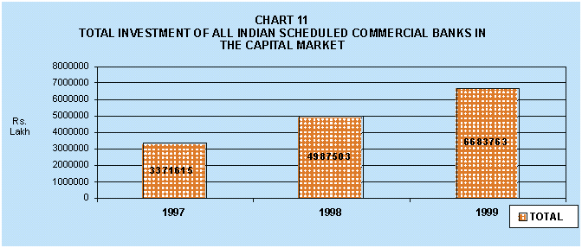
 | The Scheduled Commercial Banks' outstanding investments in the units of Unit Trust of India, Mutual Funds etc. increased from Rs. 6,349 crore in 1997 to Rs. 11,271 crore in 1998 and to Rs. 14,674 crore in 1999. The Scheduled Commercial Banks' investments in shares (face value) had also been increasing but at a slower rate from Rs. 2,165 crore in 1996 to Rs. 2,664 crore in 1997 and to Rs. 2,782 crore in 1998. There was, however, a very significant increase in holdings of banks in outstanding face value of shares in 1999. It has increased from Rs. 2,782 crore in 1998 to Rs. 3,972 crore in 1999.(Chart 12).
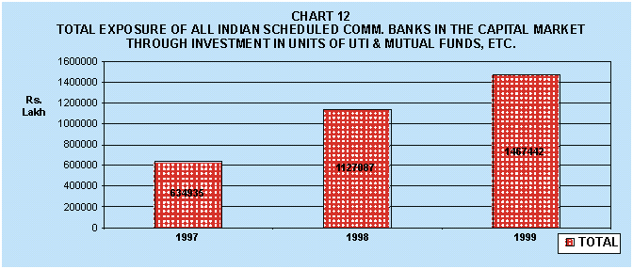
 | Similarly, the face value of holdings in corporate debt instruments in the form of debentures increased steadily from Rs. 16,615 crore in 1996 to Rs. 23,321 crore in 1997 which further increased to Rs. 34,731 crore in 1998. Holdings of debentures by Scheduled Commercial Banks has further increased to Rs. 47,478 crore in 1999. It may be observed that banks have shown clear preference for fixed interest corporate debt instruments over equity shares. (Chart 13).
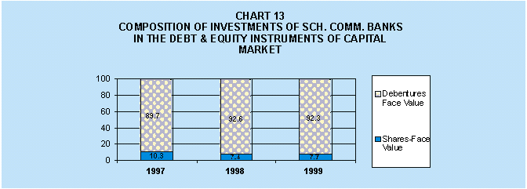
 | The bank group - wise share of investments in the shares and debentures of joint stock companies, units and other securities indicate that majority of this category of investments are held by Nationalised Banks. The other Indian Scheduled Commercial Banks had been steadily increasing investments in this category. These banks had an outstanding investments of Rs.12,662 crore which is even little more than Rs.12,459 crore of outstanding investments of State Bank of India and its Associates (Rs.12,459 crore) as at the end March 1999. (Chart 14).
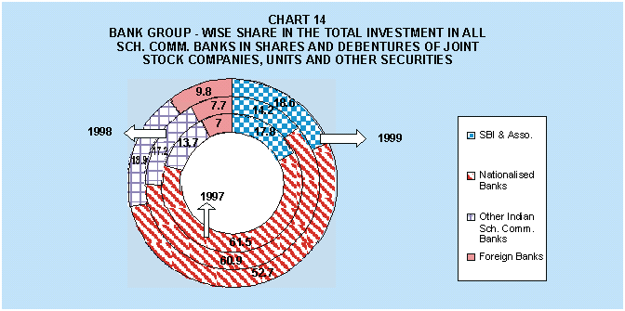
 | The State Bank of India and its Associates over the years end March 1997 to end March 1999 exhibited a clear preference for debentures over shares. The shares to debentures ratio of State Bank of India and its Associates had been coming down during this period. Similar trend could be observed for the Nationalised Banks as well. Foreign Banks have traditionally shown preference for debentures over equity shares. In case of other Indian Scheduled Commercial Banks proportion of investments in shares and debentures has steadily increased from 4.4 per cent in 1997 to 9.5 per cent in 1998 and 11.00 per cent in 1999. Bulk of the investment, however, in this category continues to be in debentures. (Chart 15).
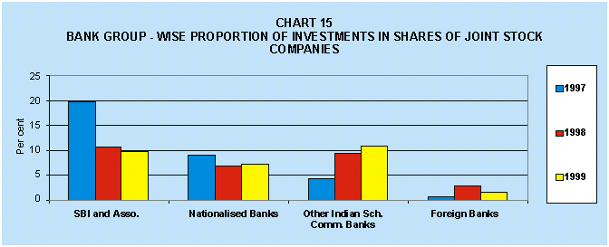
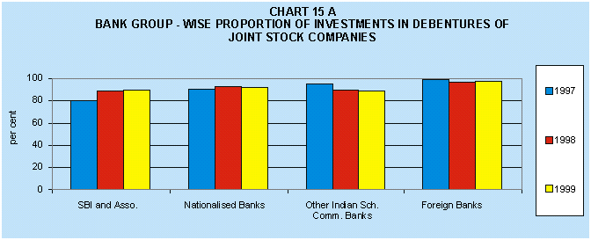
 | It is, however, interesting to note that the devolvement (face value) was only Rs. 54 crore out of total outstanding investment of Rs. 3,972 crore in equity shares as at end March 1999 for All Scheduled Commercial Banks. Bank group-wise share of such devolvements were Rs. 26 crore for State Bank of India and Associates, Rs. 13 crore for Other Indian Scheduled Commercial Banks, Rs. 12 crore for Nationalised Banks and Rs. 3 crore for Foreign Banks. Further, there was no devolvement on account of public sector companies.
14. | Bank Group-wise Maturity Profile of Outstanding Investments
 | Bank group-wise maturity classification of investments in Government securities excluding postal savings and other obligations are presented in statement 6. The investments of State Bank India and its Associates as at end March 1999 indicate that 20.6 per cent of old loans and 6.5 per cent of new loans will be maturing within one year. Another 20.7 per cent of these holdings in old loans and 16.0 per cent in new loans will have maturity upto end March 2002, whereas 31.4 per cent and 60.8 per cent of their old loans and new loans respectively will be maturing during the period April 2002 to March 2007.
 | The investments of Nationalised Banks as at the end March 1999 indicate that 13.6 per cent of old loans and 7.0 per cent of the new loans will be maturing within one year. Another 13.5 per cent of old loans and 7.5 per cent of new loans are having maturity upto end March 2002, whereas 44.9 per cent of old loans and 48.0 per cent of new loans are having maturity between April 2002 to March 2007. There are about 27.9 per cent of old loans and 37.6 per cent of new loans in the holdings of Nationalised Banks, which have maturity period beyond April 2007.
 | The maturity pattern of investments of other Indian Scheduled Commercial Banks indicate that 25.5 per cent of their holdings in Central Government securities and 9.8 per cent in State Government securities were due for maturity by March 2000.Whereas another 31.7 per cent of their holdings held in Central Government securities and 13.9 per cent holdings in State Government securities were due for maturity between April 2000 and March 2002. There was about 33.8 per cent holdings in Central Government securities and 51.8 per cent holdings in State Government securities which had maturity period between April 2000 to March 2007. Maturity period of holdings beyond March 2007 is found to be 9.0 per cent in Central Government securities and 24.7 per cent in State Government securities. (Chart 16).
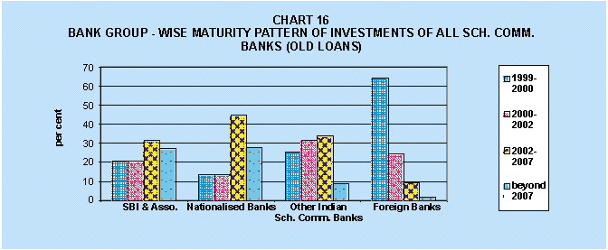
 | It is observed that the maturity profile is very different in case of Foreign Banks. About 64.1 per cent of their holdings in old Central Government loans were to mature by March 2000. The corresponding figures for State Government securities were 23.5 per cent. Nearly 24.4 per cent of their holdings in Central Government securities are having maturity period between April 1, 2000 to March 2002. Whereas 38.1 per cent of holdings in State Government securities were to mature during the same period. There were only 9.5 per cent of Central Government securities in the holdings of Foreign Banks which have maturity period between April 2002 to March 2007. The corresponding figure for State Government securities was 34.9 per cent. The percentage of Central and State Government securities in the holdings of Foreign Banks, which were due for maturity beyond March 2007, was 2.0 per cent and 3.5 per cent respectively. (Chart 17).
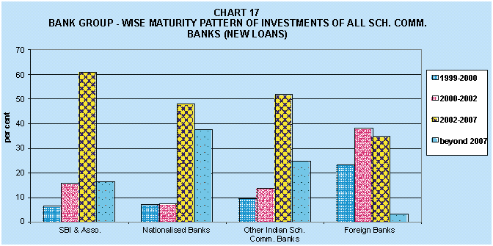
15. | Interest Range-wise Analysis of Investments of Bank Groups in Central and State Government Securities (Excluding Treasury Bills, Postal Obligations, etc.)
 | The Scheduled Commercial Banks' investments in the Central Government & State Government securities were spread over various interest ranges in old and new loans at the end March 1999 (statement 7 ). It may, however, be observed that 77.3 per cent of the holdings of Central Government securities were in interest range of 11 per cent and above. In case of State Government securities, 96.4 per cent of the holdings were in the interest range of 11 per cent and above.(Chart 18).
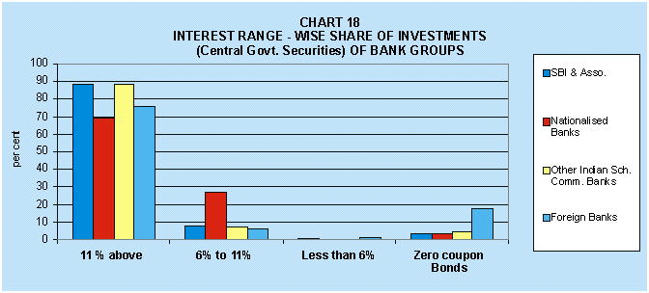
 | The State Bank of India and its Associates held 88.2 per cent of the Central Government Securities in the range of 11 per cent and above, the corresponding figure in respect of State Government securities was 97.5 per cent. The holdings of Nationalised Banks, in this interest range was little lower at 68.7 per cent for Central Government securities and 95.7 per cent in case of State Government securities. Investments of Other Indian Scheduled Commercial Banks also indicate a preference for Central Government securities in the interest range of 11 per cent and above which was about 88.4 per cent. The corresponding figure of total investment in such securities for Foreign Banks was 75.3 per cent. As regards State Government securities, the investments of Other Indian Scheduled Commercial Banks and Foreign Banks were generally in the range of 11 per cent and above. Outstanding investments of State Bank of India and its Associates, Nationalised Banks, Other Indian Scheduled Commercial Banks and Foreign Banks as at end March 1999 in the Central Government securities in the interest range of 6 to 11 per cent were 7.8 per cent, 27.2 per cent, 7.0 per cent and 5.8 per cent respectively. The corresponding figures for State Government securities were 2.5 per cent, 4.3 per cent, 2.6 per cent and zero per cent respectively. (Chart 18 A).
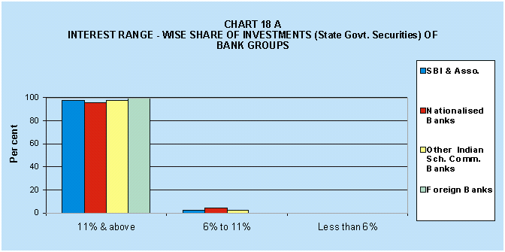
 | Highlights of the investment pattern of banking sector in Government securities during the financial year 1998-99 is presented in Annexure.

SECTION III

16. | Bank Group-wise Investments in State-level Securities
 | Banks invest in various types of state-level securities. viz. securities floated by the State Governments, bonds of state-level bodies guaranteed by the State Governments, share capital of Regional Rural Banks and debentures of co-operative institutions. The state-wise investments of Scheduled Commercial Banks as at end March 1997,1998 and 1999 are presented in statement 8. The outstanding investments of banks in the state level securities as at end March 1999 were mostly in the State Government securities (68.9 per cent) followed by State Electricity Boards (15.3 per cent) and State Financial Corporations (7.2 per cent). Total investment of banks in Government and Quasi-government Bodies are about 4.6 per cent. Investments in other state level bodies viz. Housing Boards, Municipal Corporations and Port Trusts, State Industrial Development Corporations, Regional Rural Banks and Cooperative institutions were 1 per cent or less individually. State-wise outstanding investments of bankers as at end March 1999 in the State loans was highest in Uttar Pradesh (Rs. 6,751 crore) followed by Andhra Pradesh (Rs. 3,940 crore), Bihar (Rs.3,408 crore), Rajasthan (Rs.2,912 crore) and West Bengal (Rs.2,782 crore). Such investments in all other states were less than Rs. 2,500 crore. Outstanding Investments of bankers as at end March 1999 in the bonds of State Electricity Boards was highest in Madhya Pradesh (Rs.1,456 crore) followed by Maharashtra (Rs.990 crore), Bihar (Rs. 820 crore), Uttar Pradesh (Rs.760 crore), Assam (Rs.717 crore), Tamil Nadu (Rs.692 crore) and West Bengal (Rs.596 crore).The outstanding investments in the bonds of State Electricity Boards of all other states were less than Rs.500 crore. Banks Investment in State Financial Corporations was highest in Uttar Pradesh (Rs.486 crore) followed by Andhra Pradesh (Rs.470 crore), Karnataka (Rs.450 crore), Gujarat (Rs.351 crore) Maharashtra (Rs.329 crore) and Orissa (Rs.324 crore). Investments in such securities were below Rs.250 crore in all other states. Investments in the State Industrial Development Corporations were found to be highest in Tamil Nadu (Rs.154 crore) followed by Maharashtra (Rs.114 crore). Investments of banks in such securities of all other states were less than Rs.50 crore. Investments in the bonds of State Housing Boards were less than Rs. 50 crore in all the states. Investments in the bonds of Municipal Corporation, Municipality and Port Trusts was significant for the states of Maharashtra (Rs. 243 crore), Gujarat (Rs.163 crore) and West Bengal (Rs.69 crore). Investments in other states were below Rs. 30 crore.
 | Bank group - wise pattern of investments in the State Government securities for the years 1997, 1998 and 1999 has been prescribed in statement 10. The outstanding investments of "Foreign Banks" in State Government securities as at end March 1999 was highest in Gujarat (Rs.136 crore) followed by Tamil Nadu (Rs.88 crore), Maharashtra (77 crore) and Karnataka (Rs.43 crore). Investment of Foreign Banks in the securities of all other states were below Rs.10 crore. The Foreign Banks' total investment of Rs.367 crore in State level securities is not even one per cent of total investments of the Scheduled Commercial Banks.
 | The Other Indian Scheduled Commercial Banks' outstanding investments as at end March 1999 was to the tune of Rs. 2,824 crore in the state level securities which represents 5.1 per cent of the total investment of the Scheduled Commercial Banks. This group of banks invested Rs.487 crore in Maharashtra, followed by Kerala (Rs. 451 crore), Tamil Nadu (Rs. 390 crore), Karnataka (Rs. 310 crore) and Andhra Pradesh (Rs. 260 crore). Investments in all other states individually were less than Rs. 200 crore.
 | The outstanding investments of Nationalised Banks as at end March 1999 was Rs. 32,695 crore which represents 58.7 per cent of the total investments of all Scheduled Commercial Banks. Investments of Nationalised Banks was highest in Uttar Pradesh (Rs. 5,545 crore) followed by Andhra Pradesh (Rs. 3,233 crore), West Bengal (Rs. 2,713 crore), Maharashtra (Rs. 2,613 crore) and Bihar (Rs. 2,485 crore). Nationalised Banks' investment in the state-level securities for all other states were below Rs. 2,000 crore.
 | The investment of State Bank of India and Associates as at end March 1999 stood at Rs. 19,813 crore in the state-level securities which constituted 35.6 per cent of the total investments of Scheduled Commercial Banks in the state level securities. The State Bank of India and Associates had investments of Rs. 2,468 crore in the state level securities of Uttar Pradesh whereas there were nine other states viz. Andhra Pradesh, Bihar, Kerala, Madhya Pradesh, Maharashtra, Orissa, Rajasthan, Tamil Nadu, and West Bengal in which State Bank group had an outstanding investment of Rs. 1,000 crore or more in state level securities.
The Scheduled Commercial Banks' investments in the interest bearing state loans was 62.5 per cent of the total outstanding amount of state loans as at the end March 1999
(statement 9). In the total outstanding state loans the share of Uttar Pradesh was highest at 17.0 per cent followed by Andhra Pradesh (9.8 per cent), Bihar (8.7 per cent), West Bengal (7.1 per cent). Shares of other states individually were below 7 per cent. The absorption rates of banks were above 65 per cent in 5 states viz. Andhra Pradesh (65.3 per cent), Himachal Pradesh (65.4 per cent), Kerala (66.4 per cent), Orissa (66.5 per cent) and Rajasthan ( 68.9 per cent). The absorption rate was between 60 per cent to 65 per cent for Assam (61.9 per cent), Bihar (63.5 per cent), Harayana (63.3 per cent), Jammu and Kashmir (62.4 per cent), Karnataka (61.9 per cent), Madhya Pradesh (62.6 per cent), Punjab (62.5 per cent), Uttar Pradesh (64.7 per cent) and West Bengal (63.8 per cent). Absorption rate of the banks in the interest bearing state loans of all other states remained below 60 per cent for eleven other states.

* | Prepared in the Banking Statistics Division of the Department of Statistical Analysis and Computer Services.The previous article as on end March 1997 was published in the May 1999 issue of the Reserve Bank of India Bulletin.
$ | As per reported figures of investments of Regional Rural Banks in form –A returns under section 42 (2) of RBI Act 1934 as on 26th March 1999.
* | Source : Statistical Tables Relating to Banks in India 1998-99.

Annexure
The Investment Pattern of Banking Sector in Government Securities Market in 1998-99*
The salient features of investment of banking sector in primary issues of Government of India dated securities and also net sales/ purchases through secondary market transactions reported at PDO Mumbai for the financial year 1998-99 are set out below:

I) | Investment by banking sector in primary issues of Government of India dated securities

 | (i) | The gross market borrowing through issues of Government of India dated securities during the year 1998-99 was at Rs. 83,753 crore as compared to Rs. 42,686 crore during 1997-98. The investment of banking sector in primary issues was at Rs.19,376 crore accounting for 23.1 per cent in 1998-99 compared to their investments at Rs.10,290 crore (24.1 per cent) in the preceding year (Table 1).
 | (ii) | The weighted average yield relating to cut-off coupon in primary issues through dated securities during 1998-99 declined to 11.86 per cent from 12.01 per cent in the preceding year. On the other hand, the weighted average maturity moved up marginally from 6.6 years in 1997-98 to 7.7 years in 1998-99. This was on account of longer maturity issues (20 years) in the later half of 1998-99 as compared to the longest maturity issues of 10 years in 1997-98.
 | (iii) | The weighted average yield of banking sector for their investments in 1998-99 was at 11.67 per cent compared to 11.75 per cent in the previous year which were comparatively lower than the yields on gross amount raised in respective years. Lower weighted average yields of banking sector compared to yield on gross amount raised reflected in their preference for investments of low maturing securities. This was mainly on account of securities of comparatively longer maturities being privately placed with RBI.
 | (iv) | The investment pattern of various bank groups, in terms of weighted average maturity, in primary issues of government dated securities did not reveal consistency in the years being reviewed. The trend of average maturity of investments among banking groups in 1998-99 was reversed as compared to the trend observed in 1997-98. During 1998-99, average maturity of investments in government securities of Foreign Banks was the lowest at 3.93 years compared to 4.79 years of Other Scheduled Commercial Banks, 5.23 years of SBI and its Associates and 6.17 years of Nationalised Banks. In contrast, the average maturity of investment of Foreign Banks and Other Scheduled Commercial Banks worked out 6.48 years each in 1997-98 whereas average maturity of investments of Nationalised Banks was at the lowest at 5.68 years followed by State Bank of India and its Associates (5.87 years).

II) | SGL Secondary Market Transactions of Banking Sector

 | i) | Total volume (Face Value) of outright transactions in Central Government dated securities increased by 20.6% in 1998-99 (Rs. 1,43,087 crore) over 1997-98 (Rs. 1,18,694 crore) whereas in treasury bills, the increase was marginal at 4.2% from Rs.41,180 crore to Rs.42,890 crore. (Table 2).
 |  | During 1998-99, sale transactions relating to banking sector accounted for 52.0 per cent of total transactions in government dated securities while the share of purchase transactions was at 74.8 per cent. The corresponding figures of banking sector were 65.6 per cent and 75.2 per cent respectively in 1997-98. This showed slowdown in sales activities of banking sector in secondary market in 1998-99. The banking sector was net purchaser of securities worth Rs.32,658 crore in 1998-99 compared to Rs.11,436 crore in 1997-98 in secondary market.
 | ii) | Within the banking sector, Foreign Banks were most active with sales and purchase transactions of dated securities amounting to Rs.25,487 crore and Rs.32,366 crore respectively (turnover of Rs.57,853 crore) in 1998-99, thus resulting in net purchase of Rs.6,789 crore. The net purchases of Nationalised Banks (Rs.12,108 crore) and State Bank of India and its Associates (Rs.10,073 crore) were higher than the Foreign Banks. However, trading activities in terms of turnover (total amount of sale and purchase) of Nationalised Banks ( Rs.44,789 crore) and State Bank of India and Associates (Rs.33,399 crore) were of lower volume as compared to other bank groups.
 | iii) | During 1998-99, in Treasury Bills secondary market transactions (14/ 91/364 day auction), net purchase by State Bank of India and its Associates was at the highest level (Rs.7,441 crore), followed by Nationalised Banks (Rs.2,229 crore), Foreign Banks (Rs.2,107 crore) and Other Scheduled Commercial Banks (Rs.1,266 crore). Similar trend was observed in 1997-98.
 | iv) | Month-end term structure of interest rates based on secondary market transactions in government securities for the years 1997-98 and 1998-99 are given in Table 3. During 1997-98, the yield on 10 year residual maturity paper softened from 12.86 per cent in April 1997 to 11.18 per cent in December 1997 and then moved up to 13.35 per cent in January 1998 primarily on account of various monetary measures announced to stabilise the volatile forex market. At end March 1998, the yield on this paper settled at 12.12 per cent. The yield marginally came down at the level of 12.03 per cent by end March 1999. The yields in maturity segment of 1-5 years at end March 1999 were higher by 7 to 22 basis points compared to yields at the end March 1998. In contrast, yields in 6-10 years maturity segment declined by 8 to 25 basis points in March 1999 over March 1998. The comparative position of month end movements in yields of 3, 9 and 10 years residual maturity segment for 1997-98 and 1998-99 is depicted in the enclosed Chart 19.
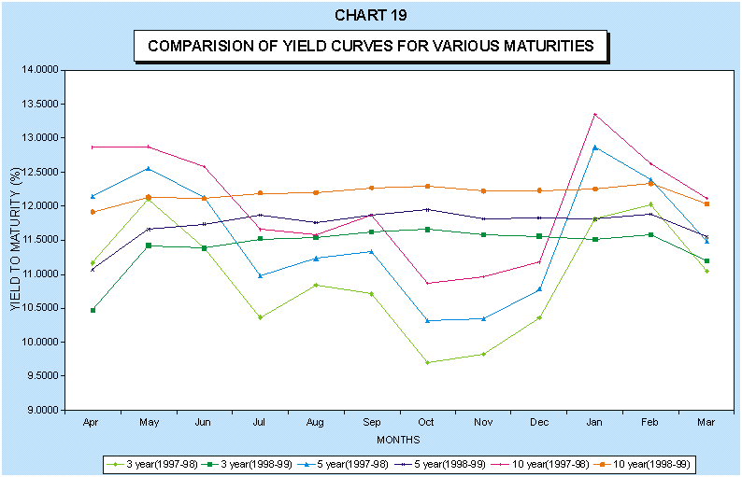

* | Prepared in the Internal Debt Management Cell, Reserve Bank of India, Mumbai.

