Monthly Seasonal Factors of Selected Economic Time Series*

Monthly seasonal factors for selected economic and financial time series are being regularly published in the Reserve Bank of India Bulletin from 1980** onwards. This article presents the estimated seasonal factors of 62 economic time series classified into five major groups, namely,

(A) Monetary and Banking Indicators (22 series);

(B) Wholesale Price Index (WPI) with base 1993-94=100 (17 series);

(C) Consumer Price Index for Industrial Workers (CPI-IW) (1 series);

(D) Index of Industrial Production (IIP) with base 1993-94=100 (18 series); and

(E) External Trade (4 series).

The estimation of seasonal factors has been carried out by using X-12-ARIMA method developed by the US Bureau of the Census, a technical note on which appeared in the previous year’s article. The present article considers a uniform data length of 10 years ranging from April 1990 to March 2000 with respect to each series for estimation of seasonal factors.

For WPI and IIP series, the seasonal factors are calculated based on the new base (base 1993-94=100). The data prior to April 1994 (i.e., 1990-91 to 1993-94) have been obtained by using linking factor between old and new series.

Monthly seasonal factors for the year 1999-00, the average monthly seasonal factors for the period 1990-91 to 1999-00 (10 years) and forecasts of monthly seasonal factors for the year 2000-01 are presented in Table 1. The peak and trough values of the seasonal factors, which contain information regarding the cyclical behaviour of these series, are also presented in Table 1 along with their respective months. Based on the seasonal factors for last 10 years, ranges of seasonal factors, averages of these ranges along with their standard deviation are presented in Table 2. Figures 1 to 11 present the bar diagrams of monthly seasonal factors for 1999-00 (Actual) and 2000-01 (Forecasts) for 11 important series. The monthly seasonal factors for these 11 series for the last 10 years are presented in Statement I. The salient features of the variation in seasonal factors of some selected series during the last ten years in general, and 1999-00 in particular, are briefly discussed in the subsequent paragraphs.

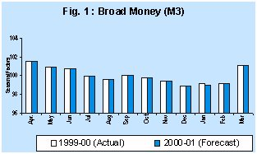
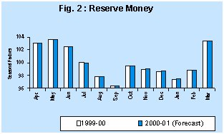

A. Monetary and Banking Indicators
There was no change in the seasonal variation of Broad Money (M3) during 1999-00 as compared to 1998-99 as its monthly seasonal factors during these two years continued to be the same.

During 1999-00, M3 displayed much lower seasonal variation than Narrow Money (M1). These results could be attributable to lesser seasonal fluctuations in Time Deposits - the additional component, which forms almost two-third of M3. The average and standard deviation of the range of variation of seasonal factors for the period 1990-91 to 1999-00 for M3 were 2.4 and 0.2, respectively, while those for M1 were 6.3 and 0.9, respectively. There were differences in the peak and trough occurrences of M3 and M1 during 1999-00. During 1999-00, the peak had occurred in April for M3, whereas peak for M1 was in May. Similarly, the trough for M3 and M1 were in December and August, respectively. Peak for Currency with the Public (CWP) occurred in May in resonance with the seasonal trough for WPI-Foodgrains, which also occurred in May, corresponding to harvesting season. During 1999-00, Reserve Money (RM) and CWP exhibited similar seasonal pattern since the latter forms a major component of the former.

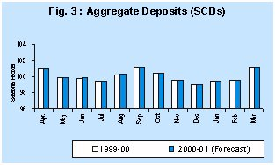

Aggregate Deposits (AD) of Scheduled Commercial Banks (SCBs) had seasonal peak in September, whereas seasonal trough occurred in December. Two components of AD, viz., Demand Deposit (DD) and Time Deposit (TD) had different seasonal behaviour. Peak and trough for DD were in March and November respectively, while those for TD were in September and December, respectively. The average range and standard deviation of seasonal factors of TD were 1.4 and 0.1, respectively, while those for DD were much higher at 9.8 and 2.5, respectively.

The seasonal behaviour of Bank Credit was similar to that observed in Demand Deposits and the two series had same ten years average peak and trough months —March and August, respectively. The average range and range of variations of these two series were 6.1 and 0.2, and 9.8 and 2.5, respectively. The seasonal peak and trough for Investments by Scheduled Commercial Banks (SCBs) occurred in August and March, respectively. Food Credit (SCBs), a component of the Bank Credit, had its peak seasonal factor in June and trough in March for 1999-00. Though the seasonal variations of Food Credit declined steadily over the 10 years, however, it still remained high at 20.9 in 1999-00 due to seasonal nature of agricultural operations.

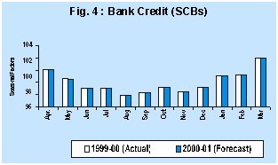

B. Wholesale Price Index

The seasonal factors for the wholesale price index series are based on the new series (base 1993-94=100). One of the important findings of the analysis is that over the period (from 1990-91 to 1999-00) there has been a general moderation in the seasonal price variation of many of the price series since ranges (differences of peak and trough) for many of them narrowed down.

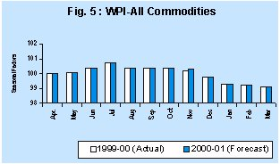

During 1999-00, WPI-All Commodities registered its peak seasonal factors in July and trough in March. The average range and the range of variation for the General Index had been observed as 1.9 and 0.2, respectively. Overall, there was similar pattern of the seasonal movement of WPI-All Commodities and of WPI-Manufacturing since the latter covered 63.7 per cent of the former. For WPI-Manufacturing and IIP-Manufacturing, the range of variation in seasonal factors has been decreasing over time with the decrease being more pronounced in case of IIP-Manufacturing. The seasonality in production of manufactured goods had a visible impact on their prices since the seasonal movements of the two were nearly opposite with the peak of one being the trough of the other and vice-versa. During 1999-00, the seasonal peak for WPI-Primary Articles occured in August and seasonal trough occurred in March, which coincided with the ten years average.

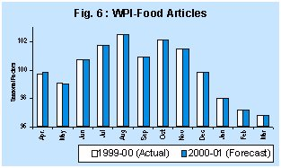

Seasonal factors of WPI-Food Articles have been stable for the last ten years with peak in August and trough in March. During 1999-00, seasonal peak of WPI-Cereals, a sub-subgroup of WPI-Food Articles, occurred in February with a seasonal trough in May. The two items under WPI-Cereals, viz., WPI-Rice & WPI- Wheat had distinctly different seasonal patterns. This was largely because Rice is mainly a Kharif crop and Wheat is a Rabi crop and their prices had seasonal peaks in August and February, respectively, month before their harvesting seasons. Among the WPI series, WPI-Fruits and Vegetables revealed the maximum range of seasonal price variation.

C. Consumer Price Index for Industrial Workers

Seasonal variation in CPI-IW had remained stable over the years with average range 2.8 and standard deviation 0.2. During 1999-00, the CPI-IW series attained its seasonal peak in October and trough in April.

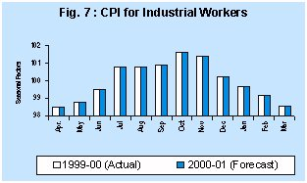

A comparative analysis between the seasonal price variability in case of WPI-All Commodities and CPI-Industrial Workers reflected that price variability in case of CPI-IW continued to be higher than WPI-All Commodities.

D. Index of Industrial Production

The seasonal variation in IIP - General Index, although reflected a significant decline over the period (Table 2), it continued to be on the higher side. The range between peak and trough values of the seasonal factors declined from 21.6 in 1990-91 to 13.4 in 1999-00. These results reflected the undergoing structural shifts in the seasonal factors.

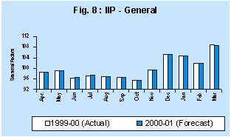

The existing high level of seasonality in IIP-General Index was also reflected in most of the IIP subgroups considered here and these strong seasonal patterns were closely related to busy and slack seasons of the economy. The seasonal peaks for all the IIP series generally occurred in March, but the troughs occurred in different months for different series. The seasonality in IIP-Food Products could be seen in contrast to the seasonal behaviour in WPI-Food Articles reflecting its input prices. Similarly, the seasonality in IIP-Food Products could be seen in contrast to the seasonal behaviour in WPI-Food Products.

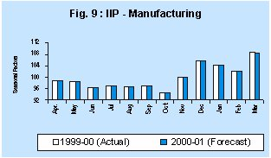

Among the Use-based classified groups, IIP-Capital Goods Industries showed the maximum range of seasonal variation although it had been consistently decreasing over time. IIP-Consumer Durables had the peak in March but troughs occurred in April whereas, IIP-Consumer Non-Durables had the peak in January but troughs occurred in October, respectively. The range of variation for both these Consumer Goods groups remained high; however, the range of seasonal variation for both the series had been decreasing over the years. In line with expectations, the seasonal pattern of IIP-Manufacturing was similar to that of IIP-General and both were decreasing over the years. Most interestingly, the seasonal variations for all other sub-groups had been decreasing over the years.

E. External Trade (Based on data from DGCI & S)

Seasonal factors in respect of external trade series including exports, imports, oil imports and non-oil imports (all in US $ terms) exhibited a mixed pattern.

At the overall level, exports were more pronounced to seasonal variations and these seasonal variations were moderately increasing over the period. The average range of seasonal factors for Exports was very high at 29.6 with a standard deviation of 1.0 while the corresponding figures for Imports were 14.1 and 2.1, respectively. The peak month for both Exports (US Dollar terms) and Imports (US Dollar terms) occurred in March during 1999-00. The seasonal trough for Exports occurred in June. Non-Oil Imports, the largest share in Imports, exhibited same peak and trough period as that of Imports.

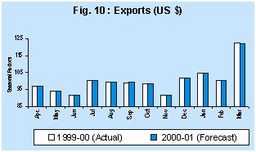
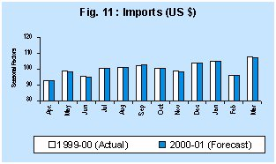

* | Prepared in the Forecasting Division of the Department of Statistical Analysis and Computer Services.
** | The previous study in this series was published in December 1999 issue of the Reserve Bank of India Bulletin.

