Monthly Seasonal Factors of Selected Economic Time Series*
Considering the importance of study of seasonal pattern of various macroeconomic variables, monthly seasonal factors for selected economic and financial time series are being regularly published in the Reserve Bank of India Bulletin from 1980¶ onwards. This article presents the estimated@ seasonal factors of 62 economic time series classified into five major groups, namely,
(A) Monetary and Banking Indicators (22 series);
(B) Wholesale Price Index (WPI) with base 1993-94=100 (17 series);
(C) Consumer Price Index for Industrial Workers (CPI-IW) with base 1982=100 (1 series);
(D) Index of Industrial Production (IIP) with base 1993-94=100 (18 series); and
(E) External Trade (4 series).
The present article considers a uniform data length of 10 years ranging from April 1991 to March 2001 with respect to each series for estimation of seasonal factors.
For WPI and IIP series and their respective subgroup series, the seasonal factors are calculated based on the new base (base 1993-94=100). The data prior to April 1994 (i.e., 1991-92 to1993-94) have been obtained by adopting the usual linking factor mechanism.
Monthly seasonal factors for the year 2000-01, the average monthly seasonal factors for the period 1991-92 to 2000-01 (10 years) and forecasts of monthly seasonal factors for the year 2001-02 are presented in Table 1. The peak and trough values of the seasonal factors, which contain information regarding the cyclical behaviour of these series, are also presented in Table 1 along with their respective months. Based on the seasonal factors for last 10 years, ranges of seasonal factors, averages of these ranges along with their standard deviation are presented in Table 2. Figures 1 to 7 present the comparison of seasonal factors of various important variables for the period 2000-01. The monthly seasonal factors for selected 11 series for the last 10 years are presented in Statement I. The salient features of variation in seasonal factors of some selected series during the last ten years in general, and 2000-01 in particular, are briefly discussed in the subsequent paragraphs.
A. Monetary and Banking Indicators
Over the last ten years, the seasonal pattern for the is very stable with Broad Money (M₃) an average range of 2.3 with standard deviation 0.1. Here range is the difference between maximum seasonal factor and minimum seasonal factor. There was almost no change in the seasonal variation of during 2000-01 as M₃ compared to 1999-00, as its monthly seasonal factors during these two years essentially remain the same. The peak period for the Broad Money supply had occurred in April whereas trough is in December-January.
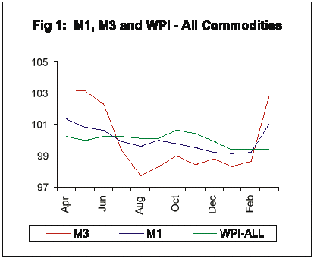
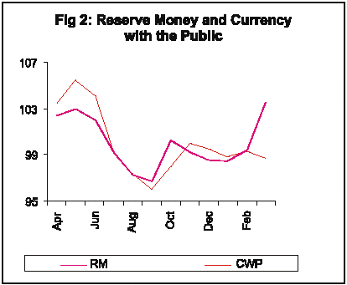
It can be observed that is more stable M₃ than the as it is evidenced Narrow Money (M₁ ) from the comparison of the range of variation of these two series. This behaviour is attributable to lesser seasonal fluctuations in Time Deposits - the additional component, forming almost two-third of M3. The average and standard deviation of the range of seasonal factors for the period 1991-92 to 2000-01 for were 6.2 and 0.9, M₁ respectively.
Peak for Currency with the Public (CWP) occurred in May in resonance with the seasonal trough for WPI- Foodgrains, which also occurred in May, corresponding to harvesting season.
As it is expected, Reserve Money and the Currency with the Public witnessed the same peak and trough period for the year 2000-01.
Over the last ten years Aggregate Deposits (AD) of Scheduled Commercial Banks (SCBs) and its major constituent, Time Deposits (TD) have been having very low level of seasonality as evidenced from the average range of 1.9 and 1.5, respectively.
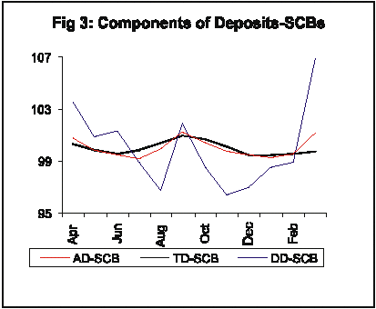
However the other component of AD, i.e., Demand Deposits (DD) exhibited relatively higher level of seasonality as compared to AD or TD, the 10 years average range for DD being 9.7 with a standard deviation of 1.5. AD had seasonal peak in September, whereas seasonal trough occurred in July. Two components of AD, viz., DD and TD had different seasonal behaviour. Peak and trough for DD were in March and November respectively, while those for TD were in September and December, respectively.
There had been a close link between the seasonal behaviour of the Bank Credit (SCBs) and the Demand Deposits and the two series had same ten years average peak and trough months -- March and August, respectively. The average range and the standard deviation of these two series were 5.7 and 0.4, and 9.7 and 1.5, respectively. The seasonal peak and trough for Investments by SCBs occurred in August and March, respectively. Food Credit (SCBs), a component of the Bank Credit (SCBs), had its peak seasonal factor in June and trough in March for 2000-01. Though the seasonal variations of Food Credit declined steadily over the 10 years, it still remained high at 22.0 in 2000-01 due to seasonal nature of agricultural operations.
B. Wholesale Price Index
The seasonal factors for the Wholesale Price Index (WPI) series are based on the new series (base 1993-94=100). The data prior to 1993-94 (i.e., 1991-92 to 1993-94) have been obtained by using linking factor between the old and new series. One of the important findings of the analysis is that over the period (from 1991-92 to 2000-01) there had been a general moderation in the seasonal price variation of many of the price series since ranges of many of them narrowed down.
During 2000-01, WPI-All Commodities registered its peak seasonal factors in October and trough in January. The average range and standard deviation of the range of variation for this series had been observed as 1.6 and 0.3, respectively. The WPI-Manufacturing, the major component of WPI-All Commodities had relatively low level of seasonality as compared to other subgroups. The average ranges for the major three subgroups, viz,
WPI-Primary articles , WPI-Manufactured Products and WPI-Fuel, Light, Petroleum and Lubricant are 4.8, 1.0 and 2.7 respectively. For WPI-Manufactured Products and IIP-Manufacturing, the range of variation in seasonal factors was decreasing over time; decrease being more pronounced in case of IIP-Manufacturing. From its economic behaviour, seasonal peak of WPI-Manufactured Products should coincide with the seasonal trough of IIP - Manufacturing. However, data do not reflect this as evidenced from the Fig 5. During 2000-01, the seasonal peak for WPI-Primary Articles occured in October and seasonal trough occurred in February.
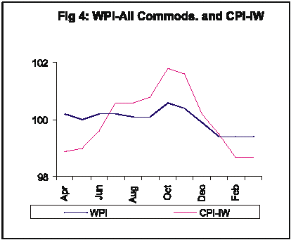
Seasonal factors of WPI-Food Articles have been stable for the last ten years with an average range of 6.0 and with standard deviation of 0.1. During 2000-01, WPI-Food Articles have witnessed the seasonal peak in October and seasonal trough in February whereas seasonal peak of WPI-Cereals, a sub-subgroup of WPI-Food Articles, occurred in August with a seasonal trough in October. The two items under WPI-Cereals, viz., WPI-Rice & WPI - Wheat had distinctly different seasonal patterns. This was largely because Rice is mainly a Kharif crop and Wheat is a Rabi crop and their prices had seasonal peaks in August and February, respectively, month before their harvesting seasons. Among the WPI series, WPI-Fruits and Vegetables revealed the maximum range of seasonal price variation. This feature may be indicative of problems in preservation of this perishable commodity group.
C. Consumer Price Index for Industrial Workers
Seasonal variation in CPI-IW had remained stable over the years with average range 2.8 and standard deviation 0.2. During 2000-01, the CPI-IW series attained its seasonal peak in October and trough in February.
A comparative analysis (Fig 4) between the seasonal price variability in case of WPI-All Commodities and CPI-Industrial Workers reflected that price variability in case of CPI-IW continued to be higher than WPI-All Commodities.
D. Index of Industrial Production
The seasonal variation in IIP - General Index though declined significantly over the period (Table 2), continued to be on the higher side. The range between peak and trough values of the seasonal factors declined from 16.4 in 1991-92 to 13.1 in 2000-01. These reflect the structural shifts in the seasonal factors.
The existing high level of seasonality in IIP-General Index was also reflected in most of the IIP subgroups considered here and these strong seasonal patterns were closely related to busy and slack seasons of the economy. The seasonal peaks for all the IIP series generally occurred in March, but the troughs occurred in different months for different series. The seasonality in IIP-Food Products could be seen in contrast to the seasonal behaviour in WPI-Food Articles (Fig 5) and the seasonality in IIP-Food Products could be seen in contrast to the seasonal behaviour in WPI-Food Products (Fig 6).
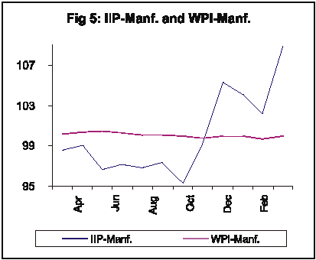
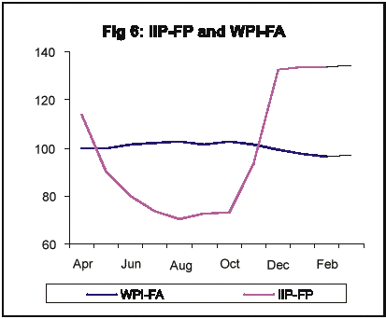
Among the Use-based classified groups, IIP-Capital Goods Industries showed the maximum range of seasonal variation although it had been consistently decreasing over time. During 2000-01, IIP-Consumer Durables had the peak in March but troughs occurred in April whereas, IIP-Consumer Non-Durables had the peak in January but troughs occurred in October, respectively. The range of variation for both these Consumer Goods groups remained high; however, the range of seasonal variation for both the series had been decreasing over the years.
On the line of expectations, the seasonal pattern of IIP-Manufacturing was similar to that of IIP-General and both were decreasing over the years. Interestingly, the seasonal variations for all other sub-groups had been decreasing over the years.
E. External Trade (Based on data from DGCI & S)
Seasonal factors in respect of external trade series including Exports, Imports, Oil Imports and Non-oil Imports (all in US $ terms) exhibited a mixed pattern.
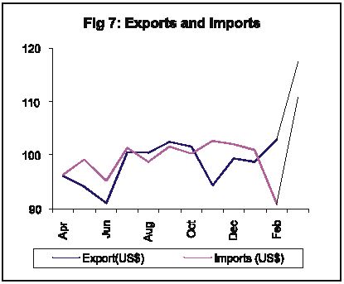
At the overall level, exports were more pronounced to seasonal variations as compared to Imports. The average range of seasonal factors for Exports was very high at 27.5 with a standard deviation of 1.6 while the corresponding figures for Imports were 18.0 and 1.2, respectively. The peak month for both Exports (US Dollar terms) and Imports (US Dollar terms) occurred in March during 2000-01. The seasonal trough for Exports occurred in June while that for Imports is in February. Non-Oil Imports, the largest share in Total Imports exhibited same peak and trough period with that of Imports.
Trends in seasonality from 1991-92 to 2000-01
The seasonal behaviour in the series Net RBI Credit to Government is showing a downward trend from 1996-97. The range of seasonal factors was 10.0 in 1996-97, which declined to 7.6 in 2000-01. In contrast, the seasonality in the case of Investment of Scheduled Commercial Banks (Investment (SCBs)), whose major component is investment in government securities, is showing an increasing trend. The range between the seasonal factors was 2.7 in 1996-97, which increased to 3.3 in 2000-01.
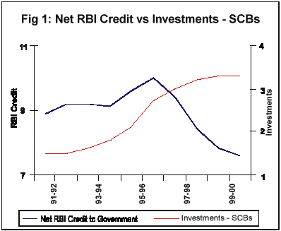
Among various groups in WPI basket, it is being observed that, the seasonality in WPI-Rice is showing an increasing trend from 1992-93 while the seasonality of WPI - Wheat has been declining. In the case of WPI - Rice, the range of the seasonal factors was 3.8 in 1992-93 which increased steadily to 5.1 in 2000-01 whereas the range of the seasonal factors in the case of WPI - Wheat has declined to 7.9 in 2000-01 whereas the range of the seasonal factors of various sub-groups such as Primary Articles, Oil Seeds, Food Products and Sugar have also been declining over the years. WPI - Fruits and Vegetables has exhibted an increasing seasonal behaviour over the years with range increasing form 18.8 in 1991-92 to 26.0 in 2000-01.
During the last ten years, the seasonality pattern of IIP - Capital Goods Industries has declined drastically. The range of the seasonal factors of IIP - Capital Goods Industries was 69.8 in 1991-92, which declined to 21.8 in 2000-01. However, in the case of IIP - Consumer Goods industries, the seasonality pattern in showing an increasing trend from 1992-93. The range between the seasonal factors of the series was 19.1 in 1992-93, which increased to 23.4 in 2000-01. Among major IIP groups, Mining as well as Manufacturing sector have also shown declining trend for the last ten years.
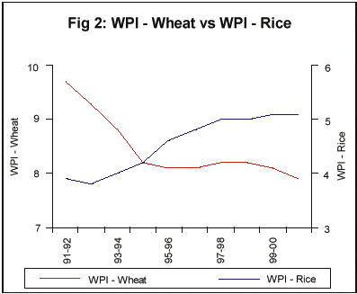
The seasonal behaviour of some of the series remained stable during the last ten years. The range of the seasonal factors of Narrow Money (M₁) remained around 5.5 from 1996-97 onwards, which that of Time Deposits of SCBs remained near 1.5 during the last ten years.
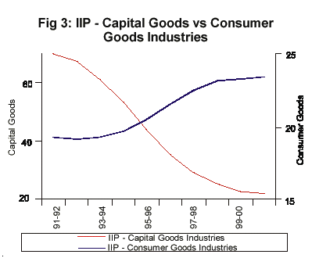

* Prepared in the Forecasting Division of the Department of Statistical Analysis and Computer Services.
¶ The previous study in this series was published in October 2000 issue of the Reserve Bank of India Bulletin.
@ The estimation of seasonal factors had been carried out by using the X-12-ARIMA method developed by the US Bureau of Census, a technical note on which appeared in the December 1999 issue of the Reserve Bank of India Bulletin.

