Invisibles in India's Balance of Payments: 2000-01 and 2001-02*

Introduction

At present balance of payments (BoP) statistics relating to invisibles are published in two formats viz., standard presentation with broad heads and detailed presentation with break-up of broad heads. The standard presentation with broad heads is compiled in accordance with the methodology set out in the IMF Balance of Payments Manual, 5 ^{th} edition (BPM5) and is published every quarter with a lag of three months as per IMF's Special Data Dissemination Standards (SDDS) requirements. The disaggregated data are finalised and published once the firm data on the components are available. Invisibles chiefly encompass services, transfers and income. Services, on the other hand, comprise travel, transportation, insurance, government not included elsewhere (GNIE) and miscellaneous (i.e. other services); transfers constitute private transfers and official transfers; income includes investment income and compensation of employees.

Sources of Data

Data on invisibles are compiled primarily on the basis of information made available by authorised dealers (ADs), supplemented by information furnished by various Indian embassies, National Association of Software Service Companies (NASSCOM), the Government of India (GoI), financial institutions and the Reserve Bank's own records. ADs report all receipts transactions to Reserve Bank with purpose-wise classification over a threshold transactions limit equivalent to US $ 10,000 or Rs 5,00,000 (approximately) since January 2001. For small value transactions of under Rs.5,00,000/- (approx.) the Reserve Bank conducts a quarterly survey for apportioning these receipts under various purposes.

Highlights

- During 2001-02, growth rate of invisible receipts decelerated to 3.4 per cent (to US $ 35.6 billion) from 13.6 per cent (US $ 34.4 billion) during 2000-01.
- Miscellaneous services and private transfers were major contributors to the invisible receipts during 2001-02. The share of miscellaneous service receipts in invisible receipts increased to 41.2 per cent in 2001-02 from 37.4 per cent in 2000-01, while the share of private transfer receipts in invisible receipts fell to 34.2 per cent in 2001-02 from 37.4 per cent in 2000-01.
- Major components of miscellaneous service receipts viz., software services, management services and communication services, contributed to the extent of 49 per cent, 6.5 per cent and 6.3 per cent, respectively, during 2001-02.
- Software exports recorded a growth of 13.2 per cent to reach US $ 7.2 billion during 2001-02 over and above an increase of 57.9 per cent in 2000-01.
- Miscellaneous service payments, investment income payments, transportation service payments and travel service payments dominated the invisible payments during 2001-02.
- Major components of miscellaneous service payments viz., financial services, management services and software services contributed to the extent of 21.4 per cent, 16.1 per cent and 6.2 per cent, respectively, during 2001-02.
- Investment income payments showed a reduction to US $ 5.4 billion in 2001-02 from US $ 6.2 billion in 2000-01 reflecting the softening of interest rates.

Review of Developments during 2000-01 and 2001-02

The statistics on India's invisibles, both receipts and payments, during 1999-2000 to 2001-02 under broad aggregates are presented in Table 1.

During 2000-01, invisible receipts increased by 13.6 per cent to US $ 34.4 billion from US $ 30.3 billion during 1999-2000. The growth rate of invisible receipts decelerated to 3.4 per cent during 2001-02. Invisible payments which were US $ 17.2 billion during 1999-2000 increased by 32 per cent to US $ 22.7 billion in 2000-01 before declining to US $ 21.6 billion during 2001-02.

Table 1 : Invisibles by Category
 |  |  | (Rs.Crore) |  |  | (US $ mn.)
 |  |  | 1999-00PR | 2000-01 | 2001-02 | 1999-00PR | 2000-01 | 2001-02
A. | Receipts |  | 131449 | 157748 | 169841 | 30312 | 34447 | 35612
 | 1. | Services | 68137 | 86613 | 96739 | 15709 | 18870 | 20286
 |  | Travel | 13166 | 14505 | 13880 | 3036 | 3168 | 2910
 |  | Transportation | 7400 | 8750 | 9410 | 1707 | 1913 | 1969
 |  | Insurance | 1004 | 1176 | 1279 | 231 | 257 | 267
 |  | GNIE | 2523 | 3012 | 2235 | 582 | 657 | 469
 |  | Miscellaneous | 44044 | 59170 | 69935 | 10153 | 12875 | 14671
 | 2. | Transfers | 54939 | 60312 | 59987 | 12672 | 13211 | 12577
 |  | OfficialTransfers | 1659 | 1556 | 1851 | 382 | 338 | 385
 |  | PrivateTransfers | 53280 | 58756 | 58136 | 12290 | 12873 | 12192
 | 3. | Income | 8373 | 10823 | 13115 | 1931 | 2366 | 2749
 |  | Investment Income | 7727 | 10336 | 12711 | 1783 | 2259 | 2663
 |  | Compensation of Employees | 646 | 487 | 404 | 148 | 107 | 86
B. | Payments |  | 74421 | 103803 | 102695 | 17169 | 22656 | 21558
 | 1. | Services | 50467 | 75212 | 76598 | 11645 | 16392 | 16087
 |  | Travel | 9268 | 13136 | 10869 | 2139 | 2874 | 2282
 |  | Transportation | 10450 | 14461 | 11346 | 2410 | 3170 | 2382
 |  | Insurance | 525 | 562 | 1208 | 122 | 122 | 254
 |  | GNIE | 1167 | 1557 | 1293 | 270 | 341 | 272
 |  | Miscellaneous | 29057 | 45496 | 51882 | 6704 | 9885 | 10897
 | 2. | Transfers | 150 | 354 | 319 | 34 | 77 | 68
 |  | OfficialTransfers | 2 | 10 | 4 | 0 | 2 | 1
 |  | PrivateTransfers | 148 | 344 | 315 | 34 | 75 | 67
 | 3. | Income | 23804 | 28237 | 25778 | 5490 | 6187 | 5403
 |  | Investment Income | 23747 | 28192 | 25724 | 5478 | 6177 | 5391
 |  | Compensation of Employees | 57 | 45 | 54 | 12 | 10 | 12
C. | Net (A-B) |  | 57028 | 53944 | 67146 | 13143 | 11791 | 14054
 |  | PR : Partially revised.

The ratio of invisibles balance to GDP, which along with the ratio of trade balance to GDP determines the ratio of current account to GDP. This is presented in Chart 1.

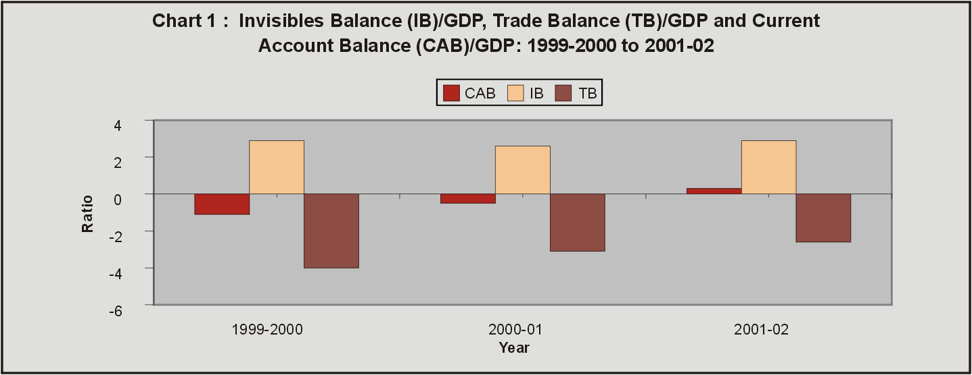

Continuing the past trend, private transfers and miscellaneous services were major contributors to invisible receipts (Chart 2).

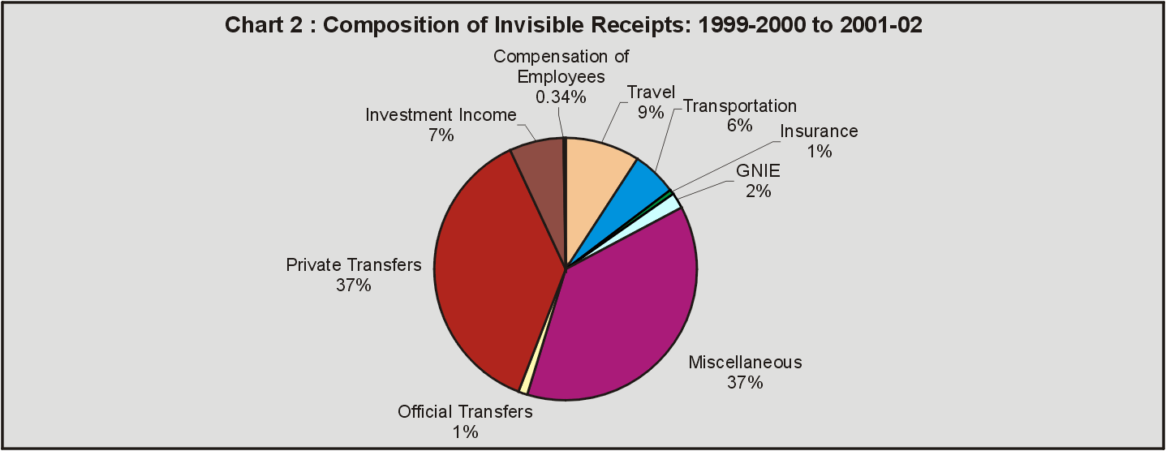

Miscellaneous service payments, investment income payments, transportation service payments and travel service payments dominated the invisibles payments (Chart 3).

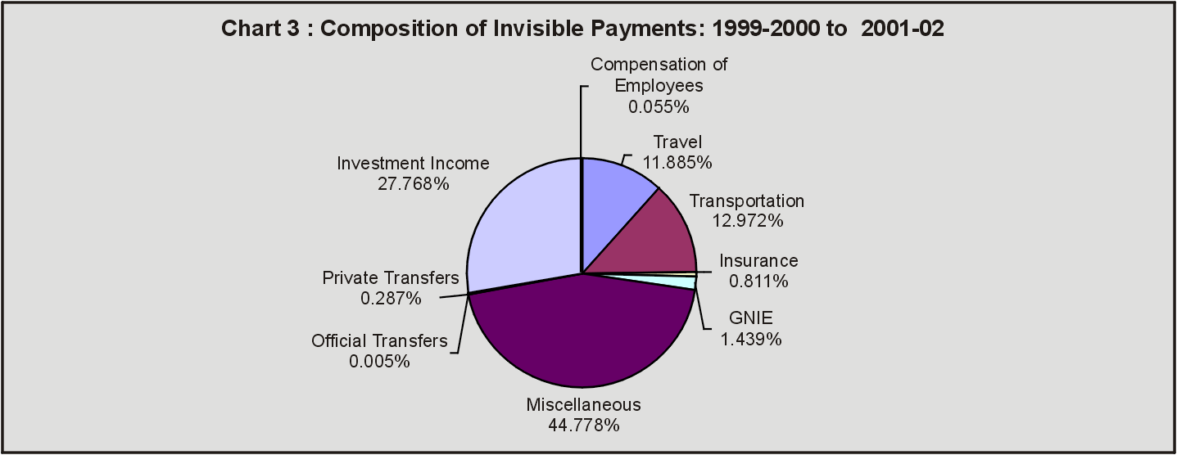

As regards the composition, the share of services in gross invisible receipts increased to 57 per cent in 2001-02 from 54.8 per cent in 2000-01 and 51.8 per cent in 1999-2000. This is mainly on account of increase in miscellaneous receipts which include receipts from software services.

Services

Travel represents all expenditure by foreign tourists in India on the receipts side and all expenditure by Indian tourists abroad on payments side. Travel receipts constituted the second largest share in services receipts. In recent years, there has been a deceleration in travel earnings on account of highly uncertain climate for international tourism vitiated by the terrorist attacks in the US. Travel receipts largely depend on the arrival of foreign tourists in India during a given period. Among travel payments, business related and basic travel quota (BTQ) payments were major constituents (Table 2). The lower proportion of travel by Indians could be attributed to the adverse international environment.

Table 2 : Travel
 |  | (Rs Crore) |  |  | (US $ mn)
 |  | 1999-00PR | 2000-01 | 2001-02 | 1999-00PR | 2000-01 | 2001-02
A | Receipts
 | Tourist Expenses in India | 13166 | 14505 | 13880 | 3036 | 3168 | 2910
 | TOTAL-A | 13166 | 14505 | 13880 | 3036 | 3168 | 2910
B | Payments
 | Business | 5490 | 7177 | 6098 | 1268 | 1570 | 1281
 | Health Related | 13 | 15 | 9 | 3 | 3 | 2
 | EducationRelated | 263 | 378 | 582 | 61 | 83 | 122
 | Basic travel quota ( BTQ) | 1638 | 2977 | 2293 | 379 | 652 | 483
 | Pilgrimage | 602 | 819 | 333 | 137 | 179 | 69
 | Others (includes settlements of | 1262 | 1770 | 1554 | 291 | 387 | 325
 | international credit cards)
 | TOTAL-B | 9268 | 13136 | 10869 | 2139 | 2874 | 2282
C. | Travel Net (A-B) | 3898 | 1369 | 3011 | 897 | 294 | 628
PR : Partially revised.

Transportation records receipts and payments on account of the carriage of goods and natural persons as well as other distributive services (like port charges, bunker fuel, stevedoring, cabotage, warehousing etc.) performed on merchandise trade (Table 3). The share of freight on exports in total transportation receipts has

Table 3 : Transportation
 |  |  | (Rs.Crore) |  |  | (US $ mn)
 |  |  | 1999-  00PR | 2000-  01 | 2001-  02 | 1999-  00PR | 2000-  01 | 2001-  02
A. | Receipts
 | a. | Sea Transport
 |  | Surplus remitted by Indian
 |  | companies operating abroad | 262 | 250 | 322 | 61 | 55 | 68
 |  | Operating expenses of foreign
 |  | companies in India. | 696 | 539 | 665 | 161 | 118 | 137
 |  | Charter hire charges | 181 | 214 | 250 | 42 | 47 | 52
 | b. | Air Transport
 |  | Surplus remitted by Indian
 |  | companies operating abroad | 781 | 804 | 835 | 180 | 176 | 175
 |  | Operating expenses of foreign
 |  | companies in India. | 87 | 89 | 41 | 20 | 20 | 9
 |  | Charter hire charges | 103 | 19 | 76 | 24 | 4 | 16
 | c. | Freight on exports | 4617 | 6177 | 6498 | 1065 | 1350 | 1361
 | d. | Others (includes port charges, bunker, | 673 | 658 | 723 | 155 | 143 | 152
 |  | Stevedoring, demurrage and other port facilities)
 |  | TOTAL-A | 7400 | 8750 | 9410 | 1707 | 1913 | 1969
B. | Payments
 | a. | Sea Transport
 |  | Surplus remitted by Foreign
 |  | companies operating in India | 1681 | 1841 | 1464 | 387 | 404 | 308
 |  | Operating expenses of Indian
 |  | companies abroad | 1757 | 2058 | 1506 | 406 | 450 | 315
 |  | Charter hire charges | 501 | 720 | 826 | 116 | 161 | 175
 | b. | Air Transport
 |  | Surplus remitted by Foreign
 |  | companies operating in India | 3561 | 5936 | 4074 | 821 | 1299 | 854
 |  | Operating expenses of Indian
 |  | companies abroad | 580 | 435 | 346 | 134 | 95 | 73
 |  | Charter hire charges | 324 | 307 | 234 | 75 | 67 | 49
 | c. | Freight on imports | 1317 | 2807 | 2369 | 304 | 615 | 497
 | d. | Remittance of passage booking abroad. | 104 | 34 | 94 | 24 | 7 | 20
 | e. | Others (includes port charges, bunker, | 625 | 324 | 433 | 144 | 72 | 91
 |  | Stevedoring, demurrage and other port facilities)
 |  | TOTAL - B | 10450 | 14461 | 11346 | 2410 | 3170 | 2382
C. | Transportation Net (A - B) |  | -3050 | -5711 | -1936 | -703 | -1257 | -413
 |  | PR : Partially revised.

averaged at 69. 8 per cent, during 2000-02, followed by sea transport (12.3 per cent) and air transport (10.3 per cent). As regards transportation payments, air transport accounted for 43.9 per cent followed by sea transport (32.6 per cent) and freight on imports (20.0 per cent) during 2000-02.

Insurance receipts consist of insurance on exports, premium on life and non-life polices and reinsurance premium from foreign insurance companies. Insurance on exports is directly linked to total exports from India. During 2001-02, insurance receipts on account of exports remained at US $ 232 million, i.e. almost the similar level obtained during the previous year (Table 4). Insurance payments more than doubled to US $ 254 million during 2001-02 as compared with US $ 122 million reported during both 1999-2000 and 2000-01.

Government not included elsewhere (GNIE) receipts represent inward remittance towards maintenance of foreign embassies, diplomatic missions and international/ regional institutions in India, while GNIE payments record the remittances on account of maintenance of Indian embassies and diplomatic missions abroad and remittances by foreign embassies on their account (Table 5). Receipts and payments of GNIE transactions declined on 2001-02 over those recorded in 2000-01 as also the net receipts.

Table 4 : Insurance
 |  |  | (Rs.Crore) |  |  | (US $ mn)
 |  |  | 1999-  00PR | 2000-  01 | 2001-  02 | 1999-  00PR | 2000-  01 | 2001-  02
A. |  | Receipts
 | a. | Insurance on export | 832 | 1056 | 1110 | 192 | 231 | 232
 | b. | Premium
 |  | Life | 3 | 5 | 25 | 1 | 1 | 5
 |  | Non-life | 31 | 22 | 26 | 7 | 5 | 5
 |  | Reinsurance from foreign
 |  | Companies | 43 | 18 | 36 | 10 | 4 | 8
 | c. | Commission on Business
 |  | received from foreign companies | 2 | 7 | 14 | 0 | 2 | 3
 | d. | Others (includes settlement of claims on | 93 | 68 | 68 | 21 | 15 | 14
 |  | account of insurance & reinsurance)
 |  | TOTAL-A | 1004 | 1176 | 1279 | 231 | 257 | 267
B. |  | Payments
 | a. | Premium
 |  | Life | 3 | 1 | 3 | 1 | 0 | 1
 |  | Non-life | 45 | 43 | 123 | 10 | 9 | 26
 |  | Reinsurance | 328 | 344 | 780 | 76 | 75 | 163
 | b. | Commission on Business | 24 | 1 | 11 | 6 | 0 | 2
 | c. | Others (includes settlement of claims on | 125 | 173 | 291 | 29 | 38 | 62
 |  | Account of insurance & reinsurance)
 |  | TOTAL-B | 525 | 562 | 1208 | 122 | 122 | 254
C. |  | Insurance Net (A-B) | 479 | 614 | 71 | 109 | 135 | 13
 |  | PR : Partially revised.

Table 5 : Government Not Included Elsewhere
 |  |  | (Rs Crore) |  |  | (US $ mn)
 |  |  | 1999-  00PR | 2000-  01 | 2001-  02 | 1999-  00PR | 2000-  01 | 2001-  02
A. |  | Receipts
 | a. | Maintenance of foreign embassies and
 |  | diplomatic missions in India | 887 | 1016 | 853 | 205 | 222 | 178
 | b. | Maintenance of international and regional
 |  | institutions in India | 1636 | 1996 | 1382 | 377 | 435 | 291
 |  | TOTAL-A | 2523 | 3012 | 2235 | 582 | 657 | 469
B. |  | Payments
 | a. | Maintenance of Indian embassies and
 |  | diplomatic missions abroad | 1023 | 1232 | 956 | 237 | 270 | 201
 | b. | Remittances by foreign embassies and
 |  | missions in India | 144 | 325 | 337 | 33 | 71 | 71
 |  | TOTAL-B | 1167 | 1557 | 1293 | 270 | 341 | 272
C. |  | GNIE Net (A-B) | 1356 | 1455 | 942 | 312 | 316 | 197
 |  | PR : Partially revised.

Miscellaneous services comprise of a host of business services. Miscellaneous services encompass communication services, construction services, financial services, software services, news agency services, royalties, copyright and license fees, management services and others (Table 6). Under miscellaneous receipts, software services have the largest share (Chart 4).

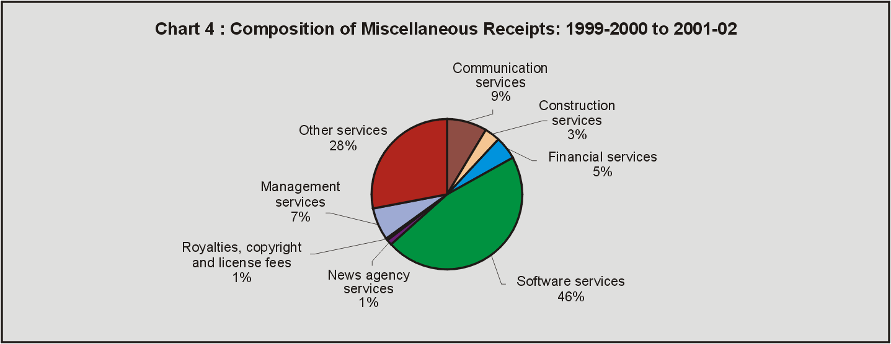

Software services, which had earlier recorded a significant growth of around 58 per cent in 2000-01 decelerated to 13.2 per cent during 2001-02 to reach US $ 7.2 billion. Financial services, management services, software services constituted 41 per cent of miscellaneous payments, while other services accounted for 45 per cent (Chart 5).

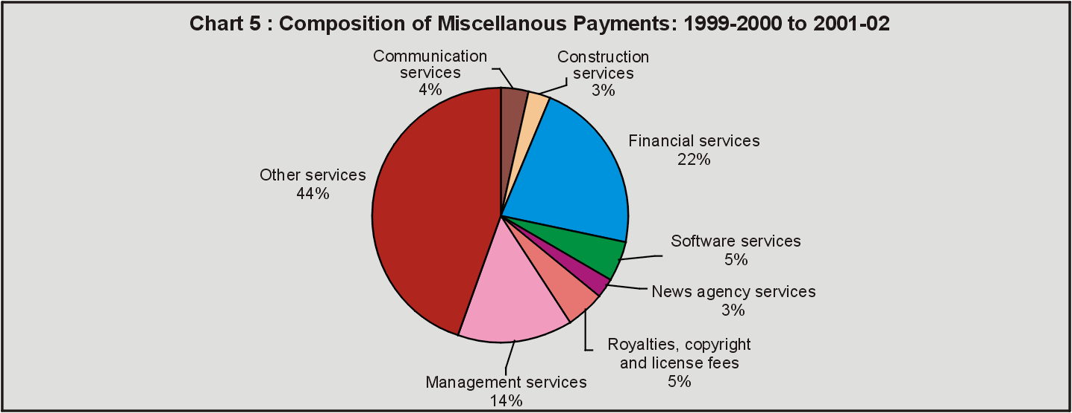

Table 6 : Miscellaneous Services
 |  | ( Rs Crore ) |  |  | (US $ mn)
 |  | 1999-  00PR | 2000-  01 | 2001-  02 | 1999-  00PR | 2000-  01 | 2001-  02
A. | Receipts
 | Communication services | 4601 | 5949 | 4377 | 1064 | 1288 | 921
 | Constructionservices | 1691 | 3081 | 803 | 389 | 671 | 167
 | Financial services | 1569 | 3193 | 3719 | 361 | 696 | 780
 | Software services | 17412 | 29014 | 34216 | 4016 | 6341 | 7175
 | News agency services | 1485 | 511 | 35 | 342 | 114 | 7
 | Royalties, copyright and license fees | 237 | 280 | 400 | 54 | 62 | 84
 | Management services | 2790 | 4471 | 4546 | 643 | 970 | 951
 | Other services (Advertising, rentals, office | 14259 | 12671 | 21839 | 3284 | 2733 | 4586
 | maintenance, prizes, exhibitions & other services
 | not enumerated elsewhere)
 | TOTAL-A | 44044 | 59170 | 69935 | 10153 | 12875 | 14671
B. | Payments
 | Communication services | 826 | 1138 | 2719 | 190 | 247 | 571
 | Constructionservices | 220 | 996 | 2462 | 51 | 216 | 517
 | Financial services | 5785 | 9221 | 11117 | 1632 | 2003 | 2335
 | Software services | 1600 | 2706 | 3202 | 138 | 590 | 672
 | News agency services | 693 | 1378 | 1509 | 90 | 299 | 317
 | Royalties, copyright and license fees | 1351 | 2367 | 2671 | 311 | 514 | 561
 | Management services | 3456 | 6376 | 8341 | 795 | 1385 | 1752
 | Other services (Advertising, rentals, office | 15126 | 21314 | 19861 | 3497 | 4631 | 4172
 | maintenance, prizes, exhibitions & other services
 | not enumerated elsewhere)
 | TOTAL-B | 29057 | 45496 | 51882 | 6704 | 9885 | 10897
 | C. Miscellaneous Net (A-B) | 14987 | 13674 | 18053 | 3449 | 2990 | 3774
 | PR : Partially revised.

Transfers

Transfers represent one-sided transactions, i.e., transactions which do not have any quid pro quo, such as grants, gifts, remittances for family maintenance, repatriation of savings and migrant transfer (financial and real resources transferred as a result of the migration from one economy to another). Official transfer receipts record grants and donations from non-residents to the Government and other assistance received by the Government from bilateral and multilateral institutions. Similarly, payments by India to other countries are recorded under official transfer payments (Table 7).

Private transfers from expatriate Indians is traditionally a major source of invisible receipts. In recent years, however, the share of private transfers in gross invisible receipts has declined from 40.5 per cent in 1999-2000 to 34.2 per cent in 2001-02. Among the various components of private transfer receipts, inward remittances constituted the largest part of transfer receipts
(Chart 6) (Table 8 ).

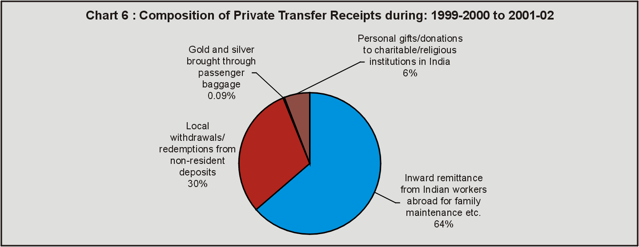

Table 7 : Official Transfers
 |  | (Rs.Crore) |  |  | (US $ mn)
 |  | 1999-  00PR | 2000-  01 | 2001-  02 | 1999-  00PR | 2000-  01 | 2001-  02
A. | Receipts
 | Donations received from Non- residents | 174 | 489 | 29 | 40 | 107 | 6
 | Grant under PL 480 II | 414 | 439 | 279 | 96 | 95 | 58
 | Grants from other Governments | 1071 | 628 | 1543 | 246 | 136 | 321
 | TOTAL-A | 1659 | 1556 | 1851 | 382 | 338 | 385
B. | Payments
 | Grants/donations from official sector | 2 | 10 | 4 | 0 | 2 | 1
 | TOTAL-B | 2 | 10 | 4 | 0 | 2 | 1
C. | Official Transfers Net (A-B) | 1657 | 1546 | 1847 | 382 | 336 | 384
 | PR : Partially revised.

Table 8 : Private Transfers
 |  | (Rs.Crore) |  |  | (US $ mn)
 |  | 1999-  00PR | 2000-  01 | 2001-  02 | 1999-  00PR | 2000-  01 | 2001-  02
A. | RECEIPTS
 | Inward remittance from Indian workers
 | abroad for family maintenance etc. | 32192 | 37681 | 38514 | 7423 | 8255 | 8076
 | Local withdrawals/redemptions from
 | Non-resident deposits | 17849 | 17305 | 16422 | 4120 | 3791 | 3444
 | Gold and silver brought through passenger baggage | 57 | 41 | 62 | 13 | 9 | 13
 | Personal gifts/donations to charitable/
 | Religious institutions in India. | 3182 | 3729 | 3138 | 734 | 818 | 659
 | TOTAL –A | 53280 | 58756 | 58136 | 12290 | 12873 | 12192
B. | PAYMENTS
 | Remittance by foreign workers
 | for family maintenance etc. | 125 | 201 | 172 | 29 | 44 | 37
 | Personal gifts/donations to charitable/
 | religious institutions in India. | 23 | 143 | 143 | 5 | 31 | 30
 | TOTAL –B | 148 | 344 | 315 | 34 | 75 | 67
 | C. PRIVATE TRANSFERS NET (A-B) | 53132 | 58412 | 57821 | 12256 | 12798 | 12125
 | PR : Partially revised.

Investment income

Investment income transactions represent the servicing of capital transactions (both debt and non-debt). Investment income transactions are in the form of interest, dividend, profit and others for servicing of capital transactions. Interest payments represent servicing of debt liabilities, while the dividend and profit payments reflect the servicing of non-debt (foreign direct investment and portfolio investment) liabilities. Investment income payments move in tandem with India's external liabilities. Total investment income payments rose from US $ 5.5 billion in 1999-2000 to US $ 6.2 billion during 2000-01. However, it has declined to US $ 5.4 billion during 2001-02 (Table 9). Investment income payments declined by 12.7 per cent from US $ 6.2 billion in 2000-01 to US $ 5.4 billion during 2001-02, mainly due to softening of interest rates in international markets.

Table 9 : Income
 |  | (Rs. Crore) |  |  | (US $ mn)
 |  | 1999-  00PR | 2000-  01 | 2001-  02 | 1999-  00PR | 2000-  01 | 2001-  02
Receipts (I+II) |  | 8373 | 10823 | 13115 | 1931 | 2366 | 2749
Payments (I+II) |  | 23804 | 23237 | 25778 | 5490 | 6187 | 5403
Net |  | -15431 | -17414 | -12663 | -3559 | -3821 | -2654
I. | Compensation of Employees
 | A. Receipts
 | Wages received by Indians working on
 | foreign contracts or the foreigners working in
 | India on foreign contracts. | 646 | 487 | 404 | 148 | 107 | 86
 | B. Payments
 | Payment of wages/salary to Non-residents | 57 | 45 | 54 | 12 | 10 | 12
 | working in India or Indians working on projects abroad
 | Compensation of Employees Net (A-B) | 589 | 442 | 350 | 136 | 97 | 74
II. | Investment Income
 | A. Receipts
 | Interest received on loans to non-residents | 688 | 741 | 2041 | 159 | 163 | 428
 | Dividend/profit received by
 | Indians on foreign investment | 68 | 113 | 230 | 16 | 16 | 48
 | Interest received on debentures,FRNs,CPs, fixed
 | deposits and funds held abroad by ADs out of
 | foreign currency loans/export proceeds | 50 | 10 | 61 | 11 | 3 | 13
 | Interest received on overdraft of VOSTRO accounts
 | of foreign correspondents / branches by the ADs | 38 | 21 | 52 | 10 | 6 | 11
 | Payment of taxes by the non-residents/refund of
 | taxes by foreign governments to Indians | 854 | 456 | 691 | 195 | 104 | 145
 | Interest/discount etc. earnings on RBI investment | 5992 | 8926 | 9597 | 1383 | 1951 | 2010
 | Interest/remuneration on SDR holdings | 37 | 69 | 39 | 9 | 16 | 8
TOTAL-A |  | 7727 | 10336 | 12711 | 1783 | 2259 | 2663
 | B. Payments
 | Payment of interest on non-resident deposits | 7549 | 7803 | 7613 | 1742 | 1710 | 1596
 | Payment of interest on loans from non-residents | 13167 | 15048 | 13401 | 3037 | 3297 | 2808
 | Payment of dividend/profit to non-resident share holders | 2333 | 4395 | 3756 | 537 | 963 | 787
 | Payment of interest on debentures, FRNs, CPs,
 | fixed deposits, Government securities etc | 512 | 571 | 468 | 119 | 125 | 98
 | Charges on SDRs | 132 | 183 | 243 | 30 | 40 | 51
 | Interest paid on overdraft on NOSTRO Account | 2 | 0 | 0 | 0 | 0 | 0
 | Payment of taxes by the Indians/refund of taxes by
 | government to non-residents | 52 | 192 | 243 | 13 | 42 | 51
TOTAL-B |  | 23747 | 28192 | 25724 | 5478 | 6177 | 5391
C. | Investment Income Net (A-B) | -16020 | -17856 | -13013 | -3695 | -3918 | -2728
PR : Partially revised.

* Prepared in the Division of International Finance (DIF), Department of Economic Analysis and Policy (DEAP). Such data for the period 1997-98 to 1999-2000 were published in RBI Bulletin, January 2001 in an article entitled “Invisibles in India’s Balance of Payments: 1997-98 to 1999-2000”and for the period 1989–90 to 1996-97 in RBI Bulletin, April 1999. Data for the period 1956-57 to 1989-90 were published in July 1993 in the “Monograph on India’s Balance of Payments”.

