Finances of The Government of India: 2003 - 04*

Introduction

The Union budget for 2003-04, presented to the Parliament on February 28, 2003, was formulated against the backdrop of a stable macroeconomic environment at home and uncertainities in the international arena arising out of geo-political stress in the Gulf region coupled with continuing sluggishness in global economic recovery. Domestic macroeconomic stability was facilitated by low inflation, a strong balance of payment position and comfortable foreign exchange reserves. Despite the decline in agricultural GDP to the extent of 3.1 per cent, caused entirely by a large decline in crop output, the rebound in growth observed since 2001-02 gained momentum in the industry and service sectors. Exports also exhibited healthy recovery. A major area of concern, however, remains. Gross fiscal deficit in the revised estimates for 2002-03 at 5.9 per cent of GDP has again exceeded the budget estimates of 5.3 per cent by a substantial margin. As observed by the pre-budget Economic Survey, the rising fiscal deficit continues to complicate the task of conducting counter-cyclical fiscal policies when required and augmenting outlays on the much needed social and physical infrastructure, and poverty alleviation programmes¹.

The budget, while recognising the above issues, essentially addresses five basic objectives
(“Panch Priorities”):

- Poverty eradication; addressing the ‘life time concerns’ of citizens covering health, housing, education and employment;
- Infrastructure development;
- Fiscal consolidation through tax reforms and progressive elimination of budgetary drags, including reform of the additional excise duty, introduction of service tax, and introduction of Value Added Tax (VAT) at the State level;
- Agriculture and related aspects including irrigation; and
- Enhancing manufacturing sector efficiency, including promotion of exports and further acceleration of the reform process.

Fiscal consolidation and debt restructuring has been accorded highest priority in the budget as it is essential for sustainable growth. Accordingly, the fiscal policy measures proposed in the budget underscore the Government’s commitment to eliminating budgetary drags and fiscal consolidation through revenue enhancement under a modern tax administration, and expenditure rationalisation. An important element of tax reforms envisaged in the budget is the step towards States switching over to a Value Added Tax (VAT) with effect from April 1, 2003² , strengthening of tax administration through greater application of IT and rationalisation of tax structure with a view to improving the competitiveness of Indian industry in international markets. Expenditure management envisaged in the budget focuses mainly on better cash management and debt restructuring, both in respect of external debt and domestic debt, taking advantage of comfortable foreign exchange reserves and lower domestic interest rates. As part of domestic debt restructuring, buy-back of a proportion of banks’ holding of Central Government domestic debt that was contracted under the high interest regime and is illiquid, is proposed. This will also help in improving banks’ balance sheets. The Government’s objective to achieve fiscal consolidation is to be done through expenditure reprioritisation and revenue augmentation. The budgetary announcements for 2003-04 aim at the promotion of infrastructure by leveraging public money through additional initiatives such as mobilising public-private partnership.

This article focuses on major policy initiatives contained in the budget, revenue and expenditure estimates for the year 2003-04, and the revised estimates for 2002-03. The article is organised into four Sections. Section-I outlines the major policy initiatives in specific areas proposed in the budget. Section-II presents the revised budgetary outcome vis-à-vis budget estimates for 2002-03. Section-III sets out the budget estimates of receipts, expenditure and deficit position for 2003-04. Issues and perspectives are presented in Section-IV.

Section I

Major Policy Initiatives

The broad objectives of the budget for 2003-04 are to address the issues relating to eradication of poverty, development of infrastructure and fiscal consolidation. The budget, keeping these objectives in view, has proposed the following major sector-specific policy initiatives.

I. Agriculture

The policy proposals in the agriculture sector are mainly in response to second generation issues and centre around diversification in horticulture, water management and irrigation, and flow of credit. To ensure that horticulture would contribute significantly to both GDP and food and nutritional security, the budget proposed to introduce a new Central Sector Scheme on Hi-tech Horticulture and Precision Farming. Major components of the scheme include the use of hi-tech interventions like fertigation, use of biotechnological tools, green food production, and hi-tech green houses. Initially, a sum of Rs.50 crore has been proposed under this scheme.

Timely availability of adequate credit is of utmost importance for the development of the rural economy. In order to pass on the benefits of lower rates of interest to agriculture and the SSI sector, the State Bank of India has already announced an interest rate band of 2 per cent above and below its prime lending rate (PLR) for secured advances. The Indian Banks Association (IBA) has advised its member banks to adopt a similar interest rate band. In order to make timely availability of adequate credit, the budget has announced, that subject to the Reserve Bank of India’s prudential norms and approvals, private banks would, hereafter, be further encouraged to open branches in rural areas, to service both farm and non-farm sectors there. The Government would also examine afresh the whole question of franchising agricultural credit, including through Post Offices. With a view to providing stability in terms of income for the small growers in the plantation sector, a Price Stabilisation Fund of Rs.500 crore will be operationalised during 2003-04 for the benefit of tea, coffee, and natural rubber growers. SHG-Bank Linkage Programme has now been recognised as the largest and fastest growing micro-finance programme in the world and, accordingly, all States have been urged to make the programme widespread success.

To facilitate better water management, a special programme, Maru Gochar Yojana, is proposed to be taken up for the desert districts of Rajasthan for rehabilitation of traditional pastures – ‘Oran’ or ‘Gauchar’ – by developing at least one large pasturage nursery in each of the identified districts, as a Central scheme, for restoration of traditional water courses, and other measures so as to provide effective drought proofing. A Task Force will be established for working out modalities for its implementation. Over a period of three years, Rs. 100 crore will be provided for this purpose, with only a quarter of the contribution coming from the State Government. For 2003-04, Rs.50 crore is provided in the budget for this purpose. Further, in the light of the recent drought, the budget has proposed to expand the coverage of drip and sprinkler irrigation. A bipartisan Task Force, headed by the Chief Minister of Andhra Pradesh, and a Minister of Agriculture from another State as one of the members, would be constituted to recommend measures, firstly, to expand the coverage of drip and sprinkler irrigation and, thereafter, to suggest safeguards so that the intended benefits actually reach the target groups.

The budget announced measures to provide relief to the sugar industry and the farmers associated with this industry. The Reserve Bank of India had earlier issued instructions to cooperative banks for the conversion of shortfall in margins into medium-term working capital loans, subject to their furnishing adequate security or State Government guarantees. Necessary instructions have also been issued to extend the repayment period of medium-term loans to nine years. The Ministry of Food and the Ministry of Finance would be proposing a comprehensive scheme for sugar industry.

The budget proposed to raise issue prices of fertilisers by a modest amount of Rs.12 for urea³ , and Rs.10 for DAP and MOP, per 50 kg bag. This was in view of the likely increase in naptha and gas feed stock and the consequent need for containing fertilisers subsidy.

II. Social and Welfare Measures

The core objective of economic development is eradication of poverty and total well being of the citizens. Towards these objectives, the budget focuses on some key areas, viz., Antyodaya Anna Yojana, public health, housing and social security. Following are the major policy announcements in these areas.

Antyodaya Anna Yojana : With the objective of eliminating poverty, given our comfortable food stocks, the budget speech proposed that the Antyodaya Anna Yojana would be expanded from April 1, 2003. During 2003-04, an additional 50 lakh families are targeted to be covered so that the total coverage will be raised to more than a quarter of all families below the poverty line (BPL) during the year. The budget provided additional budgetary allocation of Rs.507 crore for this purpose. Further, to rationalise various schemes in different ministries, a Committee headed by the Deputy Chairman, Planning Commission is proposed to examine all schemes having a bearing on poverty alleviation and rural development and recommend their practical convergence.

Housing : The budget announced the continuation of tax deductibility of interest on housing loans up to Rs.1,50,000, for construction or purchase of a self-occupied house property. This would help to maintain the present momentum of growth in this sector. In addition, income from housing projects for construction of residential units, of prescribed specification, approved by the local authorities up to March 31, 2005, would be exempt from income tax. Furthermore, the Government is examining the feasibility of additional incentives providing basic infrastructural developments in aid of slum upgradation, laying sewerage systems and green-field housing projects.

Health : A number of additional measures have been proposed in the budget to enable easier access to health facilities. These, inter alia, include encouragement to private hospitals for establishing new medical facilities or expanding existing ones through extension of the benefit of Section 10(23 G) of IT Act to them; increase in the rate of depreciation from the present 25 per cent to 40 per cent in respect of life saving medical equipments; and reduction in customs and excise duties on specified life saving equipments, life saving drugs, etc.

Insurance and Pension : The public sector general insurance companies have been encouraged to design a community-based universal health insurance scheme during 2003-04. Under this scheme, a premium equivalent to Re.1 per day (or Rs.365 per year) for an individual, Rs.1.50 per day for a family of five, and Rs.2 per day for a family of seven, will provide eligibility to get reimbursement of medical expenses up to Rs.30,000 towards hospitalisation, a cover for death due to accident for Rs.25,000, and compensation due to loss of earning at the rate of Rs.50 per day up to a maximum of 15 days. To make the scheme affordable to BPL families, the Government has decided to contribute Rs.100 per year towards their annual premium. In the first phase, at least an additional 50 lakh BPL families will be covered during 2003-04.

In order to provide relief to senior citizens and others, the Life Insurance Corporation of India (LIC) will launch a special pension policy, guaranteeing an annual return of 9 per cent, in the form of a monthly pension scheme called: Varishtha Pension Bima Yojana. Any citizen above the age of 55 years of age will qualify, and will get a monthly return in the form of a pension for life. The difference between the actual yield earned by the LIC on the funds invested under the scheme, and the assured return of 9 per cent, will be reimbursed to the LIC annually, by the Government.

A restructured pension scheme was announced in 2001 for new Central Government employees and a scheme for the general public has been finalised by the Government. The restructured scheme will offer a basket of pension choices, on a voluntary basis, to all employers for their employees, as well as to the self-employed. The new pension system, when introduced, will be based on defined contribution, shared equally between the Government and the employees in the case of Government employees. There will be no contribution from the Government in respect of individuals who are not Government employees. The new pension scheme will be portable, allowing transfer of the benefits in case of change of employment, and will go into ‘individual pension accounts’ with Pension Funds. The Ministry of Finance will oversee and supervise the Pension Funds through a new and independent Pension Fund Regulatory and Development Authority.

III. Industry

The budget proposed fresh measures to promote investment in the industrial sector; to maintain and encourage growth in information technology; to facilitate R&D in bio-technology; and to provide new incentives to the tourism industry. The proposals are, by and large, in the form of sector specific tax incentives.

Textile Sector: The proposals for the textile sector are intended to ensure a moderate rate structure to complete the CENVAT chain, to promote compliance, to encourage modernisation, and to eliminate evasion. Keeping these objectives in view, a package of incentives has been proposed, which, inter alia, includes reduction in excise duty on polyester filament yarn (from 32 per cent to 24 per cent); reduction in excise duty on all spun and other filament yarns (16 per cent to 12 per cent); reduction in excise duty on all knitted cotton fabrics and garments (12 per cent to 8 per cent); reduction in excise duty on all woven fabrics and other knitted fabrics (12 per cent to 10 per cent); reduction in excise duty on garments (12 per cent to 10 per cent); and to remove the scheme of deemed credit so as to complete the CENVAT chain. To encourage modernisation of the textile industry, the customs duty on a large number of textile machinery and their parts was reduced (25 per cent to 5 per cent). For the power-looms sector, it is proposed to strengthen the existing programme for Induction of Technology in the Weaving Sector further by offering a ‘Power-loom Package for Modernisation’ with three features- Technology Up-gradation Fund Scheme, a new Power-loom Workshed Scheme, and a Special Insurance Scheme for power loom workers.

Information Technology: The concessions extended to the IT sector under Sections 10A and 10B of the Income Tax Act will continue and the benefit of such tax exemptions will remain even in the case of amalgamation or de-merger. The value of pre-loaded software will be excluded for the purpose of charging excise duty on computers.

Tourism: The tourism industry being a high employment generating sector has been given special attention in this budget. New initiatives for this industry include: withdrawal of expenditure tax; extension of benefits under Section 10(23G) of the Income Tax Act to financial institutions that advance long-term capital to hotels in three-star and above categories; the availability of the benefit of set-off of unabsorbed loss and depreciation on amalgamation to hotels under Section 72A of the Income Tax Act; continuation of the exemption for the hotel industry from the levy of service tax; and reduction in basic customs duty on imported equipment for ropeway projects to 5 per cent without payment of CVD and SAD. The leave travel concession (LTC) facility to the Government employees has been restored which will give further boost to tourism industry.

Gems and Jewellery Industry: With a view to nurturing gems and jewellery industry, the budget has proposed to reduce the customs duty on rough and coloured gem stones from 5 per cent, and on semi-processed, half-cut or broken diamonds from 15 per cent, to nil. Customs duty on cut and polished diamonds and gem stones will also be reduced from the present 15 per cent to 5 per cent. The proposals also include reduction in the customs duty on imported gold to Rs.100 per 10 grams from the present level of Rs.250 per 10 grams. This will be applicable only to gold that is brought in the form of serially numbered bars, or in the form of gold coins, not as ‘tola’ bars. The budget also proposed to extend the benefits under Sections 10A and 10B of the Income Tax Act to cutting and polishing of diamonds and gems activities.

Small Scale Industry: For small-scale industry, the recent announcement by the State Bank of India and the decision by the Indian Banks Association about an interest rate band of 2 per cent above and below PLR for secured advances will help the SSI sector in obtaining bank finance at moderate rates of interest. The budget proposed to withdraw SSI reservations from another 75 items of laboratory chemicals and reagents, leather and leather products, plastic products, chemicals and chemical products and paper products. To help further investment in the SSI sector, the Government will examine the question of a limited partnership act. To avoid the misuse of Small Scale Exemption Scheme, the budget proposed to withdraw this facility in case of a few items and rationalise the eligibility limit of Rs.3 crore under the general SSI scheme.

Bio-Technology: In order to facilitate units engaged in R&D in bio-technology and the pharmaceuticals sector, the budget has proposed to remove the existing restriction of the minimum export obligation of Rs.20 crore for availing exemption from customs duty for specified equipments. Further, in respect of R&D units with manufacturing facilities, the benefit of full customs duty exemption for specified equipment will also be available for their manufacturing activity to the extent of 25 per cent of the previous year’s export turn over.

India Development Initiatives: With a view to promoting India as both a production centre and an investment destination, a new initiative called ‘India Development Initiative’ is proposed to be established in the Ministry of Finance. The budget has provided an allocation of Rs.200 crore for 2003-04 towards this initiative.

IV Physical Infrastructure

It is well recognised that neither agriculture nor industry would be able to grow rapidly unless infrastructure, both physical and social, is rapidly and efficiently developed. The budget, therefore, proposed to enhance investment in infrastructure by encouraging public-private partnerships mainly through the process of leasing of major airports, modernisation of sea-ports and strengthening the legal framework of power sector reforms. Innovative funding mechanisms have been proposed in the budget principally for financing roads, railways, airports, and seaports to encourage public-private partnership. The three critical components of the scheme are: release of public funds only when linked to specific and well-defined milestones in completion of the project in physical terms; a sharing of the risks with the private promoters and financiers; and no open-ended Government guarantees at any stage.

The comprehensive initiative proposed in the budget will cover 48 new road projects at an estimated cost of around Rs.40,000 crore, National Rail Vikas Yojana projects worth Rs.8,000 crore, renovation/modernisation of two airports, and two seaports at an estimated cost of Rs.11,000 crore, and establishing two global standard international convention centres at an estimated cost of Rs.1,000 crore. The total estimated cost of the above projects is about Rs.60,000 crore. To augment the resources for rural roads, apart from allocating the anticipated Rs.2,325 crore from the existing cess on diesel for 2003-04, additional funds will be made available from the proposed additional cess on diesel of 50 paise per litre.

The Electricity Bill 2001, which provides a legal framework for reforms and restructuring of the power sector is under consideration of the Government. For capacity addition, the Government proposes to further liberalise the mega power project policy by extending all these benefits to any power project that fulfills the conditions already prescribed for mega power projects. Given the importance of transmission in the power sector, the budget proposed to reduce customs duty on specific equipments for high voltage transmission projects from 25 per cent to 5 per cent.

The budget intends to provide more fiscal concessions for investment in safe drinking water, being an essential component of infrastructure development. Plant, machinery and buildings associated with water supply projects have been granted depreciation at the rate of 100 per cent. Capital goods and machinery required for water supply projects are now totally exempt, both from customs and excise duties as part of infrastructure development. In addition, pipes have been exempted from excise duty for bringing raw water from the source to the treatment plant and for conveying treated water to the storage place.

V. Banking and Financial Sector

Banking : The important measures proposed in the banking sector are:

- FDI limit has been proposed to be raised to 74 per cent from the existing cap of 49 per cent for facilitating the setting up of subsidiaries by foreign banks, as well as for inviting investment in private banks;
- The voting rights of any person holding shares of a banking company are now restricted to 10 per cent irrespective of his/her shareholding. The Banking Regulation Act, 1949 will be amended to remove this limitation;
- The benefit of Section 72 A of the I.T. Act will be extended to nationalised banks, so that any banking company can now merge with the nationalised banks with consequential tax benefit;
- Necessary legislative support will be provided to Credit Information Bureau, which has already been established to help the development of an efficient credit market.

Capital Market: In order to enable stock exchanges to attain a corporate structure, necessary amendments to the Securities Control and Regulation Act were proposed to be introduced in the Parliament. As a one time measure, capital gains arising at the time of corporatisation or demutualisation of the stock exchanges shall be fully exempt from capital gains tax, in accordance with a scheme approved by the SEBI. To improve the equity market, from April 1, 2003, dividends will be tax free in the hands of the shareholders; correspondingly, there will be a 12.5 per cent dividend distribution tax on domestic companies. While mutual funds, including UTI-II, will have to pay dividend distribution tax, equity oriented schemes will be exempted from the purview of the tax for one year. UTI-I, however, will be exempt from the dividend distribution tax. Further, all listed equities that are acquired on or after March 1, 2003, and sold after the lapse of a year, or more, will be exempted from the incidence of capital gains tax. Long term capital gains tax will, therefore, not hereafter apply to such transactions.

Interest Rates: In a low inflation regime, high rates of interest, particularly in respect of small savings and contractual savings, clearly act as a disincentive to investment. The budget, therefore, proposed to reduce rates of interest on public provident funds and small savings schemes, by 1 percentage point with effect from March 1, 2003. Interest on relief and savings bonds would also be reset accordingly⁴ . The basic premise on which the rate reduction proposed was that the real returns adjusted for inflation, offered on these instruments at 6.3 per cent per year, are still higher than they were between 1991-92 and 1995-96.

VI. External Sector

Capital Account: The budget proposed further measures to ease restrictions on capital account. First, to enable diversification, overseas investment under the automatic route will be permitted to corporates with proven track record, even where the investment is not in the same core activity. Further, the current restriction limiting such investment to 50 per cent of the net worth of the Indian company will now be raised to 100 per cent. Second, prepayment of ECB dues under the automatic route will be facilitated by removing the current ceiling of US $100 million⁵ . Third, in order to facilitate easy entry into the stock markets for Foreign Institutional Investors, the process of their registration will be further streamlined. Fourth, in order to enable ECGC to provide adequate underwriting support to project exports, its share capital has been increased to Rs.80 crore.

External Aid: The budget has proposed the following measures on the external aid front after carefully weighing the aspects such as, India’s dependence on external donors, extension of support to the national efforts of other developing countries and line of credit route of international assistance to developing countries.

- The Government would now prefer to provide relief to certain bilateral partners with smaller assistance packages, so that their resources can be transferred to specified nongovernmental organisations (NGOs) in greater need of official development assistance. The current agreed programmes would, however, continue until their completion. Further, there would be no more extension of ‘tied aid’ assistance.
- For the Heavily Indebted Poor Countries (HIPCs), owing overdue payments of substantial sums to India, a debt relief package is being considered.
- The Government proposed to generally discontinue the practice of extending loans or credit lines to fellow developing countries. Instead, in future, the ‘India Development Initiative’ would be utilised, for providing grants or project assistance to developing countries in Africa, South Asia and other parts of the developing world.

VII. Fiscal Consolidation and Debt Restructuring

The budget underscores the Government’s commitment to completely eliminate budgetary drags and go forward with fiscal consolidation through revenue enhancement under a modern tax administration and expenditure rationalisation. The budget focuses on better cash management, debt restructuring, tax reforms focussing on efficiency in tax administration, and State level reforms to sustain the fiscal consolidation.

Cash Management: As part of expenditure management, the Government proposed to initiate cash management, on a pilot basis, in some major spending ministries. This would facilitate releasing budgetary allocations in a time-sliced manner to permit convergence with available resources within the year. Under this, based on the actual requirement, monthly or quarterly cash limits for various ministries will be prescribed. The improved cash management would avoid both the mis-matches between receipts and expenditure and rush of expenditure and the associated possible waste of resources in the last quarter.

Debt Restructuring: The Government has initiated debt restructuring process on three fronts, viz., pre-payment of external debt, buy-back of loans from banks contracted under high interest rate regime and debt-swapping scheme with the State Governments. These steps initiated are keeping pace with the softening interest rate regime⁶ . With regard to external debt repayment, the Government has effected premature repayment of ‘high-cost’ currency pool loans of the World Bank, and of the Asian Development Bank totalling around $ 3 billion taking advantage of comfortable foreign exchange reserves and lower domestic interest rates. The budget reaffirmed the intention to continue with the policy of prudently managing the external liabilities and of proactively liquidating relatively higher cost component of external debt portfolio.

As regards domestic debt, the measures are initiated in the context of large proportion of the banks’ holding of Central Government domestic debt contracted under the high interest regime, which is thinly traded. With the softening of interest rates, such loans command a premium over their face value. Under the proposed scheme, Government would offer to buy-back high interest loans from banks on an entirely voluntary basis. The buy-back scheme would enable the banks to improve their liquidity position by encashing the premium for making provisions for their NPAs. Furthermore, in case the banks declare the premium received as business income, for income tax purpose, they will be allowed additional deduction to the extent such income is used for provisioning of their NPAs for improving their balance sheet.

Under the debt-swap scheme between the Central Government and the States, all State loans to the Government of India bearing coupons in excess of 13 per cent would be swapped⁷ over a three-year period ending in 2004-05. The States are expected to save an estimated Rs 81,000 crore in interest, and deferred loan repayments, over the residual maturity period of the loans. The scheme would also help to restrain the debt build-up in States through the small savings scheme.

Tax Reform: Tax reforms proposed in the budget emphasise six important aspects: States switching over to a Value Added Tax (VAT); integrate services into the tax net in a comprehensive manner through a constitutional amendment; improvements in tax administration through greater application of IT; further rationalisation of excise duties; reduction in customs duty to improve the competitiveness of Indian industry in international markets; and fiscal consolidation through revenue augmentation (the details of tax proposals are given in Box-I). Under direct taxes, the major proposals include raising of standard deduction for salaried employees; relief to employees by exempting VRS payments from income tax up to Rs.5 lakh; elimination of dividend tax in the hands of the recipient; general deductions under section 80L on income from dividends and interest etc. has been enhanced for individual taxpayers; rebate to senior citizens; and rebate for education expenses. Corporate tax structure is left unchanged except that the 5 per cent surcharge is halved. For individuals, the surcharge is removed entirely. However, for those earning an income above Rs.8.5 lakhs, a 10 per cent surcharge on the tax has been imposed.

Box I : Major Changes proposed in Tax Structure

Direct Taxes

- No change in income tax rates but surcharge of 5 per cent is imposed on all categories of taxpayers except income up to Rs. 60,000, while the 2 per cent surcharge for the Gujarat Earthquake relief is withdrawn.
- No change in rate structure of personal income tax and corporate tax. The 5 per cent surcharge is halved in the case of corporate assessees. The surcharge is removed entirely, in the case of individuals/HUF while for assessees with earnings above 8.5 lakh, a surcharge of 10 per cent on tax is imposed.
- The standard deduction for salaried employees raised to 40 per cent of salary, or Rs.30,000, whichever is less, for salary income up to Rs.5 lakh; and allowed a deduction of Rs.20,000 for salary income above Rs.5 lakh.
- Education expenses up to Rs.12,000 per child for two children is made eligible for rebate under Section 88 of the Income Tax Act.
- VRS payments up to Rs.5 lakh, even when taken in installments, exempted from income tax.
- The tax rebate for senior citizens is increased to Rs.20,000. Their income up to 1.53 lakh will, therefore, become fully exempt from income tax. On pension, the effective exemption limit becomes Rs.1.83 lakh, because of standard deduction by availing tax rebate available under Section 88.
- Physically handicapped or persons with such dependents will be entitled to a deduction for income tax purpose for permanent physical disability of Rs.50,000, and an enhanced deduction of Rs.75,000 in case of severe disability.
- Dividend income made tax free in the hands of the shareholders; however, 12.5 per cent dividend distribution tax is imposed on domestic companies.
- General deduction for individual taxpayers having income from dividends, interest, etc. increased to Rs.12,000 from Rs. 9,000. An additional deduction of Rs.3,000 is allowable in respect of interest from Government securities.
- All listed equities that are acquired on or after March 1, 2003, and sold after the lapse of a year, or more, exempt from the incidence of capital gains tax.
- Tax holiday to R&D companies established up to March 31, 2004 to encourage R&D.

Indirect Taxes

- Peak rate of customs duty is reduced to 25 per cent from 30 per cent.
- Customs duty on specific equipment for high voltage transmission projects reduced from 25 per cent to 5 per cent.
- The customs duty on specified life saving equipment reduced from 25 per cent to 5 per cent, and also exempt them from CVD (additional duty of customs).
- Water supply projects are totally exempted in regard to capital goods and machinery, both from customs and excise duties.
- Customs duty on a large number of textile machinery and their parts reduced from 25 per cent to 5 per cent
- Three-tier excise duty structure of 8 per cent, 16 per cent and 24 per cent proposed with certain exception.
- Excise duty on tyres, aerated soft drinks, polyester filament yarn, air-conditioners and motor cars reduced from 32 per cent to 24 per cent.
- Garments and fabrics manufactured by non-profit charitable institutions exempted from excise duty.
- Additional cess of 50 paise per liter of diesel and motor spirit was levied to fund road development.
- A 1 per cent National Calamity Contingent Duty is imposed on polyester filament yarn, motor cars, multi utility vehicles and two-wheelers. Crude, domestic or imported, also subjected to a duty of Rs.50 per metric tonne for this purpose. These new levies will be limited to one year only.
- The general service tax enhanced from 5 per cent to 8 per cent.

Rationalisation of excise rate structure and reduction of the multiplicity of rates are the main planks of tax reform measures proposed on the indirect tax front. The peak rate of customs duty has been reduced from 30 per cent to 25 per cent, excluding agriculture and dairy products as a part of improving the competitiveness process. In the case of excise duties, a 3-tier excise duty structure, viz., 8 per cent, 16 per cent and 24 per cent has been proposed except for petroleum and tobacco products, pan masala, and items attracting specific duty rates. Excise duty on tyres, aerated soft drinks, polyester filament yarn, air-conditioners and motor cars reduced to 24 per cent from 32 per cent. To widen the tax base, fresh excise levy of 8 per cent with the CENVAT credit facility has been proposed on certain items such as branded refined edible oil and vanaspati packed in sealed containers for retail sale, lay flat tubing, chemical reagents, etc.

Tax administration has been accorded priority in the reforms, drawing mainly on the recommendations of the Kelkar Committee. Some of the principal measures announced in the budget are: outsourcing of non-core activities of Income Tax Department; immediate abolition of present discretion-based system for selection of returns for scrutiny; expanding the scope of taxpayer services; direct crediting of all refunds to the bank account of the taxpayer through electronic clearance system; reduce the compliance cost of the taxpayer - the Income Tax Act is being amended to enable electronic filing of returns; abolition of tax-clearance certificates for certain categories; and simplifying the procedure and methods employed during search and seizure, and during survey by the Income Tax department.

The tax proposals made in the budget on the direct taxes would result in a revenue loss of Rs.2,955 crore, while the proposals relating to indirect taxes envisage a gain of Rs.3,294 crore.

State-level Reform: A major initiative in the budget towards fiscal reforms at the State level relates to the implementation of VAT. The Conference of State Chief Ministers, 2002 confirmed the final decision that all States and Union Territories would introduce VAT from April 2003. The Empowered Committee of State Finance Ministers 2003, has endorsed the suggestion that all State legislations on VAT should have a minimum set of common features. The introduction of VAT, besides avoiding cascading effects of taxes, is also expected to increase revenue flow to the Government. However, in view of possible revenue loss, in the initial years of VAT, the Central Government has agreed to compensate 100 per cent of the loss in the first year, 75 per cent of the loss in the second year and 50 per cent of the loss in the third year of the introduction of VAT; the loss being computed on the basis of an agreed formula. The Additional Duties of Excise (Goods of Special Importance) Act, 1957 is being amended from a date to be notified to allow the States to levy sales tax on textiles, sugar and tobacco products at a rate not exceeding 4 per cent. To enable levy of tax on services as a specific and important source of revenue, an amendment to the Constitution is proposed. This Constitutional amendment, and the consequent legislation would give the Central Government the power to levy the tax and both the Central and the State Governments sufficient powers to collect the proceeds. With the introduction of VAT, there is need to phase out the CST, and move to a completely destination-based system. Therefore, in the first instance, the ceiling rate of CST for interState sale between registered dealers will be reduced to 2 per cent during 2003-04, with effect from a date to be notified.

The budget, inter alia, proposed certain policy measures, which have larger bearing on further strengthening of the financial sector reforms. The important measures, which have already been described, are summarised in Box 2.

Box 2 : Important Budget Proposals relevant to Financial Sector

- The Banking Regulation Act, 1949 will be amended to remove restriction of voting rights to 10 per cent irrespective of the subjects shareholding in a banking company.
- For facilitating the setting up of subsidiaries by foreign banks, as well as for inviting investment in private banks, the FDI limit will be raised to at least 74 per cent from the existing 49 per cent.
- The benefit of Section 72A of Income Tax Act has been extended to nationalised banks. Any banking company can now merge with a nationalised bank with consequential tax benefit.
- A large proportion of the banks’ holding of Central Government domestic debt, contracted under the high interest regime of the past, is thinly traded. With the softening of interest rates, Government proposed to offer a buy back of high cost loans from banks to improve their liquidity or provisions for their non-performing assets (NPAs).
- To contain the problem of non-performing assets (NPA) and to ensure a credit market that functions efficiently, necessary legislative support to Credit Information Bureau would be provided.
- Subject to the Reserve Bank of India’s prudential norms and approvals, private banks will hereafter be encouraged to open branches in rural areas to service both farm and non-farm sectors.
- Taking advantage of comfortable foreign exchange reserves and lower domestic interest rates, the Government has effected premature repayment of ‘high-cost’ currency pool loans of the World Bank, and of the Asian Development Bank totalling around $ 3 billion. Government intends to continue with this policy of prudently managing the external liabilities and of proactively liquidating relatively higher cost component of our external debt portfolio.
- The debt swap scheme introduced by the Government of India will enable States to prepay high cost debt and substitute them by current, low-coupon-bearing small savings and Open Market Loans. Twenty-six of the twenty-eight States have consented to participate in the scheme from 2002-03, while the remaining two States will join from 2003-04. Over a three-year period ending in 2004-05, all State loans to the Government of India bearing coupons in excess of 13 per cent would be swapped.
- Interest on relief and savings bonds will be reset following the reduction in interest rates on public provident funds, and small savings schemes, etc. by one percentage point with effect from March 1, 2003.
- To enable diversification, overseas investment under the automatic route will be permitted to corporates with a proven track record, even where the investment is not in the same core activity. Further, the current restriction, limiting such investment to 50 per cent of the net worth of the Indian company, will now be raised to 100 per cent.
- Prepayment of ECB dues under the automatic route will be permitted by removing the current ceiling of US $100 million.
- In order to facilitate easy entry by Foreign Institutional Investors into the stock markets, the process of their registration will be further streamlined.
- In order to enable ECGC to provide adequate underwriting support to exports project from India, the Government has decided to increase its share capital to Rs.80 crore.

Section II

Revised Estimates : 2002-03

The revised estimates for 2002-03 indicated deterioration in the fiscal situation with all the key deficit indicators turning out higher than their budgeted levels. Despite a decline in the overall expenditure, the deterioration was mainly due to the larger shortfall in the realisation of revenue receipts and disinvestment proceeds. The revenue deficit in the revised estimates at Rs.1,04,712 crore (Table 1) exceeded the budget estimates by Rs. 9,335 crore (9.8 per cent) and constituted 4.3 per cent of GDP as against the budgeted level of 3.8 per cent. Gross fiscal deficit (GFD) at Rs.1,45,466 crore surpassed the budget estimates by Rs.9,942 crore (7.3 per cent). In terms of GDP, GFD constituted 5.9 per cent, an increase of 0.6 percentage point over the budgeted target of 5.3 per cent. Primary deficit at Rs.29,803 crore (1.2 per cent of GDP) in the revised estimates was higher by 64.3 per cent than the budget estimates of Rs.18,134 crore ( 0.7 per cent of GDP ). The movements in deficit indicators since 1990-91 may be seen from Chart 1.

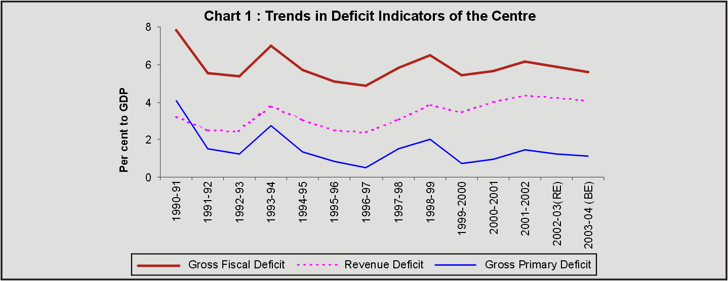

Revenue receipts in the revised estimates for 2002-03 at Rs. 2,36,936 crore were lower by Rs. 8,169 crore (3.3 per cent) than the budgeted level solely due to shortfall in tax collection by 5.1 per cent, even though non-tax revenue registered a marginal increase (0.9 per cent). The gross tax collections at Rs.2,21,918 crore were lower by Rs. 13,882 crore (5.9 per cent) than the budget estimates. Barring customs duties, all the major taxes suffered decline over the budget estimates - income tax by Rs. 5,224 crore, Union excise duties by Rs.4,050 crore, corporation tax by Rs. 3,916 crore and service tax by Rs. 1,026 crore. Collection from custom duties showed a marginal increase of Rs. 307 crore (Table 2). Capital receipts at Rs. 1,67,077 crore were higher by 1.1 per cent over the budget estimates. The non-debt components of capital receipts showed a decline over the budgeted level due to shortfall in disinvesment receipts. The disinvestment receipts at Rs. 3,360 crore in the revised estimates were lower by Rs. 8,640 crore from the budgeted target of Rs.12,000 crore (Table 3). The non-debt components contributed 12.9 per cent of the capital receipts, while the rest was contributed by debt components.

Aggregate expenditure in the revised estimates for 2002-03 at Rs. 4,04,013 crore was lower by Rs. 6,296 crore or 1.5 per cent from the budget estimates. The reduction in expenditure was effected both in revenue and capital accounts. However, in the aggregate, the expenditure compression in the revised estimates was solely in non-Plan expenditure to the extent of Rs.6,885 crore, while Plan expenditure showed a marginal rise of Rs.589 crore. The reduction in non-Plan expenditure was on account of reduced grants and loans to States and UTs due to non-utilisation of funds under ‘Fiscal Incentive Fund’ (Rs.2,184 crore), defence (Rs 9,000 crore) on account of lower capital expenditure, interest payments (Rs.1,727 crore) due to reduction in interest rate in Government securities, and pensions (Rs.804 crore). The expenditure on subsidies, on the other hand, increased by Rs. 4,817 crore over the budget estimates and almost 83 per cent of the rise was accounted for by food and indigenous fertiliser subsidies. The Central Plan outlay at Rs. 1,36,867 crore was, however, lower than the budgeted level of Rs. 1,44,038 crore. The budgetary support to Central Plan outlay at Rs. 68,219 crore was kept higher by 2.0 per cent than the budgeted level of Rs. 66,871 crore. The fall in Plan outlay was on account of lower internal and extra budgetary resources of public enterprises (IEBR) by Rs.8,519 crore than the budgeted level (Table 4).

The fiscal deterioration, as reflected in the revised estimates for 2002-03, was thus, the outcome of revenue short-fall, despite the fact that expenditure was maintained below the budget estimates. With both revenue collection and the disinvestment receipts falling below the targets, the borrowing requirements (GFD) amounted to Rs.1,45,466 crore exceeding the budgeted level of Rs.1,35,524 crore by Rs.9,942 crore in the revised estimates. Revenue deficit pre-empted 72 per cent of GFD in the revised estimates as against 70.4 per cent projected in the budget estimates. Market borrowings alone financed 77.6 per cent of GFD and the balance was financed through other liabilities (provident funds, deposits, reserve funds etc.). The net market borrowings increased substantially by Rs.17,006 crore, partly due to non-availment of Rs. 8,000 crore budgeted under small savings. Net external financing turned out to be negative at Rs.13,496 crore as against Rs.770 crore in the budget estimates⁸ . The Centre also took recourse to drawing down of cash balances to the extent of Rs.5,298 crore to meet the resource gap (Table 5).

Section III

Budget Estimates: 2003-04

The budget for 2003-04 projects moderate growth rates of 7.2 per cent in revenue receipts and 8.6 per cent in aggregate expenditure. With relatively higher growth in expenditure, all the major deficit indicators would show increase in absolute terms during 2003-04 from the levels in the revised estimates for 2002-03 (Table 1). However, in terms of GDP, all the deficit indicators would be lower during 2003-04, than the levels in the revised estimates for 2002-03, due to the anticipation of higher GDP growth. Gross fiscal deficit at Rs.1,53,637 crore is budgeted to be higher by Rs.8,171 crore (5.6 per cent) than the revised estimates of Rs.1,45,466 crore for 2002-03. As proportion of GDP, gross fiscal deficit for 2003-04 is placed lower at 5.6 per cent than 5.9 per cent in the revised estimates for 2002-03, but higher than the budget estimates for 2002-03 at 5.3 per cent. Revenue deficit is placed at Rs.1,12,292 crore, higher by Rs.7,580 crore (7.2 per cent) over Rs. 1,04,712 crore in 2002-03. Revenue deficit to GDP ratio is estimated lower at 4.1 per cent as against 4.3 per cent in the revised estimates for 2002-03. Primary deficit is projected at Rs.30,414 crore, which translates to 1.1 per cent of GDP - lower than 1.2 per cent in 2002-03.

Pattern of Receipts

Revenue receipts for 2003-04 at Rs.2,53,935 crore are budgeted to rise by 7.2 per cent (Rs. 16,999 crore) over the revised estimates for 2002-03. The entire incremental revenue receipts projected during 2003-04 is expected from tax receipts. The net tax revenue is projected to increase by Rs. 19,992 crore (12.2 per cent). Non-tax revenue is budgeted to register a decline of Rs. 2,993 crore (4.1 per cent). The negative growth in non-tax revenue is expected on account of decrease of Rs.1,411 crore in interest receipts and decline in dividends and profits to the extent of Rs.2,333 crore (Table 2).

The gross tax collection is estimated to grow from Rs.2,21,918 crore in 2002-03 to Rs.2,51,527 crore in 2003-04; with the result, the tax-GDP ratio of the Central Government would show a modest rise to 9.2 per cent during 2003-04 from 9.0 per cent in the revised estimates for 2002-03. Major portion of the increase in tax revenue is estimated to be obtained from Union excise duties (Rs.9,408 crore), corporation tax (Rs.6,799 crore), income tax (Rs.6,770 crore), custom duties (Rs.3,850 crore), and service tax (Rs. 3,000 crore). Of the gross tax collection, the share of States works out to 25.3 per cent.

Capital receipts at Rs.1,84,860 crore are budgeted to show a rise of Rs.17,783 crore (10.6 per cent) from the revised estimates for 2002-03 (Rs.1,67,077 crore). Receipts from disinvestment are projected at Rs.13,200 crore as against Rs.3,360 crore in the revised estimates for 2002-03. Recovery of loans at Rs.18,023 crore shows 1.2 per cent decrease over the previous year. The non-debt capital receipts (disinvestment and recovery of loans) are estimated to contribute 16.9 per cent of the capital receipts, while the debt components would constitute the balance 83.1 per cent. Net market borrowings are budgeted lower at Rs.1,07,194 crore than Rs.1,12,865 crore in 2002-03, whereas receipts from other liabilities are estimated higher at Rs.42,861 crore as compared to Rs.40,799 crore in the revised estimates for 2002-03.

Pattern of Expenditure

The aggregate expenditure budgeted at Rs.4,38,795 crore during 2003-04 would be higher by Rs. 34,782 crore (8.6 per cent) than the revised estimates for 2002-03. Revenue expenditure budgeted at Rs.3,66,227 crore would show a growth of 7.2 per cent, and would account for 70.7 per cent of the growth in overall expenditure. Non-Plan revenue expenditure estimated at Rs.2,89,384 crore would be higher by 7.6 per cent and would constitute 79.0 per cent of the revenue expenditure. Among the major non-Plan revenue expenditure items, interest payments (Rs.1,23,223 crore), defence expenditure (Rs.44,347 crore), and subsidies (Rs.49,907 crore) taken together would form 75.2 per cent of non-Plan revenue expenditure and would absorb 85.6 per cent of revenue receipts. Interest payments alone would pre-empt 48.5 per cent of the revenue receipts during 2003-04. Capital disbursements budgeted at Rs. 72,568 crore would be higher by 16.4 per cent from Rs.62,365 crore in the revised estimates for 2002-03. Non-Plan capital expenditure is budgeted to rise by 35.8 per cent and would account for 39.2 per cent of the total capital expenditure. Plan Capital expenditure is budgeted to show a moderate rise of 6.5 per cent during 2003-04.

During 2003-04, net market borrowings would finance 69.8 per cent of GFD as against 77.6 per cent in the revised estimates for 2002-03. At the same time, financing through other domestic liabilities would decline to 27.9 per cent from 28.0 per cent. External finance would, however, contribute 2.3 per cent of the total as against a negative share of 9.3 per cent in the previous year (Table 5 and Chart 2). To meet the net market borrowings requirement and repayments, the gross market borrowings for 2003-04 are placed at Rs. 1,66,230 crore⁹ which are higher by 10.0 per cent than that in 2002-03 (Rs. 1,51,126 crore). The outstanding liabilities of the Centre are estimated to grow from Rs. 15,61,876 crore in 2002-03 to Rs. 17,80,064 crore in 2003-04. With the result, the debt-GDP ratio of the Centre is estimated to rise to 64.9 per cent in fiscal year 2003-04 from 63.3 per cent in 2002-03 (revised estimates).

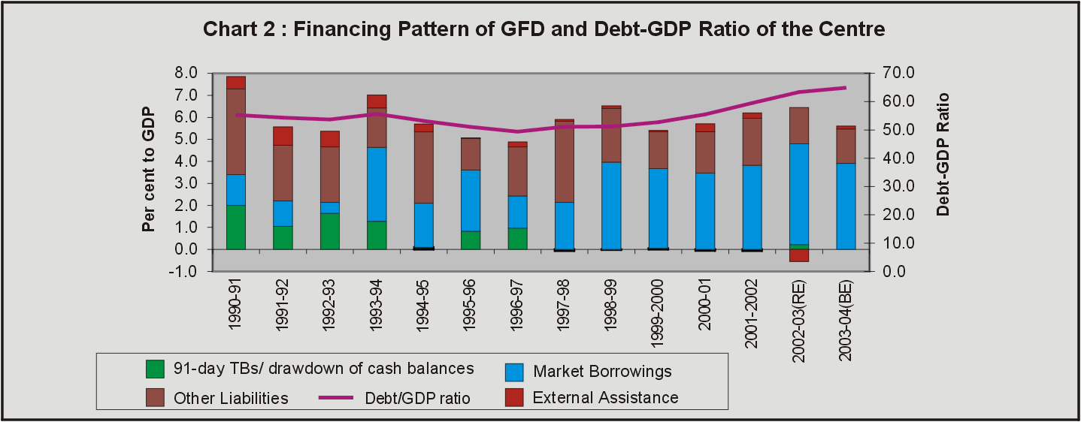

Central Plan Outlay

The Central Plan outlay for 2003-04 has been budgeted at Rs.1,47,893 crore, showing a rise of 8.1 per cent over the revised estimates for 2002-03 (Rs.1,36,867 crore) (Table 4). On the financing side, budgetary support at Rs.72,152 crore (higher by 5.8 per cent) would contribute 48.8 per cent of the Plan outlay(49.8 per cent in the previous year) and internal and extra budgetary resources (IEBR) of public sector enterprises at Rs.75,741 crore (10.3 per cent rise) would contribute the remaining 51.2 per cent (50.2 per cent in 2002-03). Sector-wise allocations indicate that major shares are earmarked for energy (29.3 per cent), transport (19.5 per cent), and social services (21.4 per cent). The sectoral growth of Plan outlay shows that outlay on energy would increase by 17.8 per cent, agriculture by 20.1 per cent, science and technology by 16.8 per cent, and irrigation and flood control by 16.3 per cent.

Transfer of Resources to State and Union Territory Governments

The gross resource transfer from the Centre to the States and Union Territories (UTs), comprising shareable tax revenue, grants and loans are budgeted at Rs.1,40,111 crore during 2003-04 - an increase of 11.2 per cent over Rs.1,25,993 crore in 2002-03 (Table 6). The net resource transfers, after adjusting for recovery of loans and advances to States and UTs, are budgeted at Rs.1,26,623 crore - higher by Rs.12,009 crore (10.5 per cent) from the revised estimates for 2002-03 (Rs. 1,14,614 crore). The States' share in Central taxes and duties would increase by Rs.7,617 crore (13.6 per cent) to Rs.63,758 crore during 2003-04. Total grants to States and the Union Territories are budgeted to increase by 15.9 per cent. The budgetary support to States and UTs Plans estimated at Rs.48,822 crore in 2003-04 would show a rise of 6.4 per cent over 2002-03. The small savings collection accrued to States (i.e. investments made from National Small Savings Fund in State Government securities) is budgeted at Rs.60,000 crore in 2003-04 as compared to Rs.52,200 crore in the revised estimates for 2002-03.

Section IV

Issues and Perspectives

The drag in Central finances is the manifestation of structural weakness on both the resources and expenditure fronts. This phenomenon often leads to significant deviation between budget projections and the actual outcome. During the 1990s, fiscal deficit, on an average, exceeded the budget estimates by more than 19 per cent and revenue deficit by 24 per cent (Table A). The deviation between the budget estimates and actual out-turn was more pronounced in the case of expenditure in the 1990s, while in the recent periods, the deviation is more in the revenue realisation. The shortfall in revenue from the budget estimates was to the extent of 2.6 per cent, on an average, in the 1990s and it increased to 5.4 per cent in 2001-02 and 3.3 per cent in 2002-03. On the other hand, the deviation in aggregate expenditure was 4.0 per cent during the 1990s. The recent trends, however, reveal that expenditure turns out to be lower than budget estimates, a reversal from the earlier trend of actual expenditure far exceeding the budget estimates. This could be attributed to a possible outcome of expenditure compression aimed at containing fiscal deficit when revenue realisation failed to show adequate buoyancy.

Table A : Deviations Between Accounts and Budget Estimates-Select Fiscal Variables
 |  |  |  |  |  | (Per cent)
 | 1990-95(Avg) | 1996-00(Avg) | 1990s Avg | 2000-01 | 2001-02 | 2002-03
Gross Fiscal Deficit | 20.1 | 18.0 | 19.1 | 31.0 | 6.8 | 7.3
Revenue Deficit | 29.6 | 20.1 | 23.9 | 24.8 | 10.1 | 9.8
RevenueReceipts | -1.6 | -3.5 | -2.6 | -0.7 | -5.4 | -3.3
Net Tax Revenue | -3.1 | -4.2 | -3.8 | -3.1 | -6.5 | -5.1
Non -Tax Revenue | 3.1 | 0.2 | 2.0 | 5.4 | 0.4 | 0.9
Total Expenditure | 4.2 | 4.4 | 4.0 | 5.0 | 0.0 | -1.5
Revenue Expenditure | 3.5 | 0.7 | 2.3 | 5.1 | -1.9 | 0.3
Capital Expenditure | 9.3 | 4.6 | 4.8 | 4.4 | -16.8 | -10.7
Note: Data on deviations are actual over budget estimates. For the year 2002-03, deviation is revised over budget estimates.

The tax-GDP ratio of the Centre has suffered steady deterioration from more than 10 per cent in the late 1980s to just about 9 per cent by the end of the 1990s. The drag on revenue collection is also reflected in the deceleration in tax buoyancy. Between the Eighth and Ninth Plan periods, the buoyancy of Central taxes deteriorated from 0.9 to 0.8; while the buoyancy in direct tax collection was maintained at 1.3 between these periods, the buoyancy in indirect taxes declined from 0.7 to 0.6¹⁰. This is reflective of the steady deterioration in revenue collections from the major indirect taxes, such as excise duties and customs duties during the 1990s (Table B). The buoyancy observed earlier in direct taxes had stagnated in recent years and had not compensated adequately for the proportionate fall in indirect taxes.

The restructuring of both direct and indirect taxes effected since 1991-92, coupled with the structural shift in the composition of GDP more towards the less taxed services sector have affected the growth in tax revenue. This apart, the deceleration in GDP growth in the recent years has also affected the revenue flows (Chart 3). More particularly, the decline in the indirect tax-GDP ratio partly reflect the compositional changes in the GDP as the indirect tax base is mainly confined to the industrial sector, particularly, manufacturing sector. It could also be observed that the actual GDP turned out to be lower than the implicitly projected growth in GDP at the time of budget estimates.

Table B : Component-wise Gross Tax Revenue of the Centre
 |  |  |  | (Percentage to GDP)
 | Major Taxes |  |  |  | Gross Tax
Years | Income Tax | Corporation Tax | Excise Duties | Customs Duties | Revenue
1 | 2 | 3 | 4 | 5 | 6
1990-91 | 0.9 | 0.9 | 4.3 | 3.6 | 10.1
1991-92 | 1.0 | 1.2 | 4.3 | 3.4 | 10.3
1992-93 | 1.1 | 1.2 | 4.1 | 3.2 | 10.0
1993-94 | 1.1 | 1.2 | 3.7 | 2.6 | 8.8
1994-95 | 1.2 | 1.4 | 3.7 | 2.6 | 9.1
1995-96 | 1.3 | 1.4 | 3.4 | 3.0 | 9.4
1996-97 | 1.3 | 1.4 | 3.3 | 3.1 | 9.4
1997-98 | 1.1 | 1.3 | 3.2 | 2.6 | 9.1
1998-99 | 1.2 | 1.4 | 3.1 | 2.3 | 8.3
1999-00 | 1.3 | 1.6 | 3.2 | 2.5 | 8.9
2000-01 | 1.5 | 1.7 | 3.3 | 2.3 | 9.0
2001-02 | 1.4 | 1.6 | 3.2 | 1.8 | 8.1
2002-03(RE) | 1.5 | 1.8 | 3.5 | 1.8 | 9.0
2003-04( BE) | 1.6 | 1.9 | 3.5 | 1.8 | 9.2

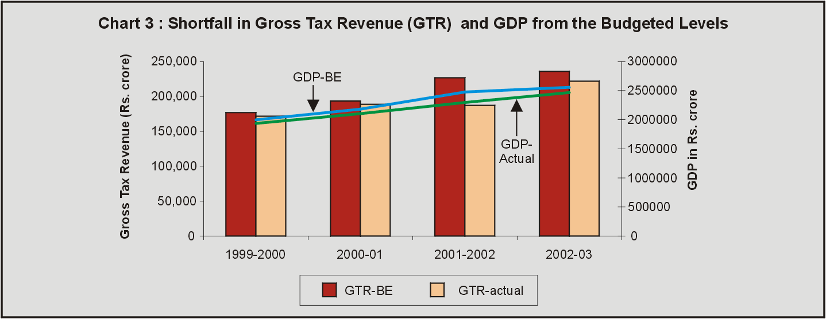

The aggregate expenditure to GDP ratio of the Central Government had declined over the years from 19.1 per cent in 1989-90 to about 15 per cent by the end of 1990s. The reduction in the ratio was, however, observed more in the capital side which declined from about 6 per cent in the beginning of the 1990s to just above 2 per cent by the end of the 1990s reflecting that the current expenditure continues to remain inflexible. The two major components which stimulate the current expenditure are interest payments and subsidies. Interest payments is not only the largest component of revenue expenditure but also the fastest growing non-Plan revenue expenditure. With interest rates on market loans aligned to market rates, the interest payment outgo on market loans has increased in mid-1990s. Interest rates have, however, shown softening trend in recent years (Table 7). Explicit subsidies as percentage of GDP, though declined from 2.1 in 1990-91 to 1.1 per cent in 1996-97, bounced back to 1.8 per cent in 2002-03 and 2003-04. With the dismantling of administered price mechanism (APM) for petroleum products in 2002-03, subsidies provided for domestic LPG, PDS kerosene, and freight subsidy for remote areas have put direct impact on the budget. The growing subsidies, particularly food subsidy mainly emanating from high buffer carrying cost and producers' subsidy, also placed much pressure on the fiscal deficit (Chart 4).

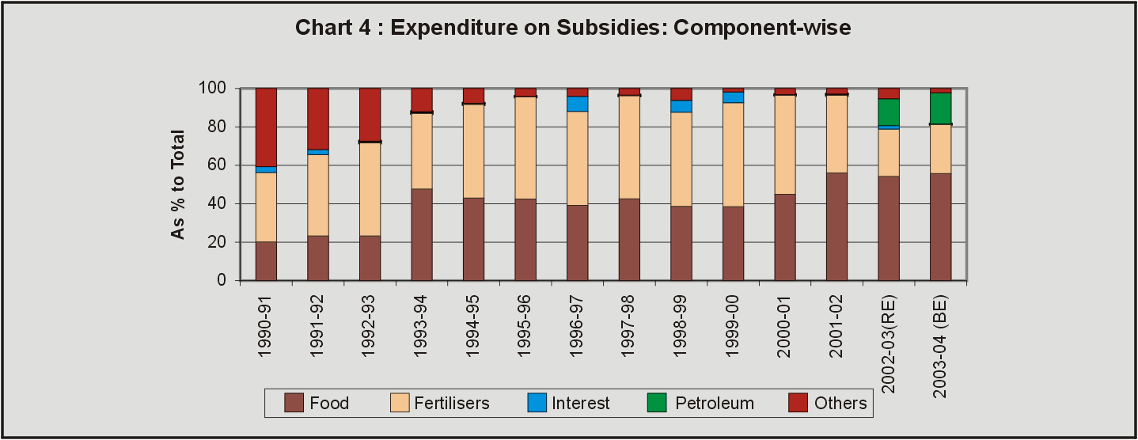

With increasingly larger proportion of resources being pre-empted for current expenditure, the share of capital outlay, which should essentially go for asset creation, in the aggregate expenditure suffered significant decline during the 1990s (Chart 5). Similarly, capital outlay as ratio to GDP, declined from more than 2 per cent during the 1980s to about 1 per cent by the mid of the 1990s and remained at that level throughout the later half of 1990s. In other words, efforts to counter the problem of rising fiscal deficit through compression of capital outlay would affect asset creation adversely which is necessary for enhanced development and social welfare.

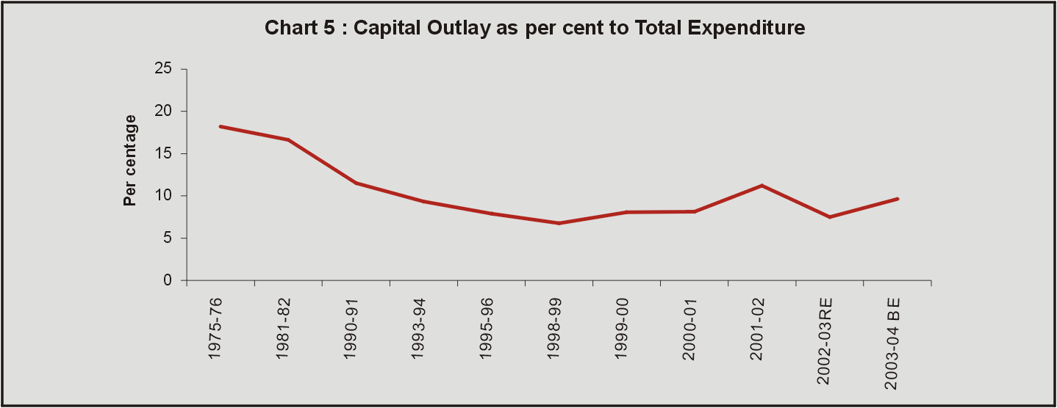

The slippages on revenue and expenditure have widened the resource gap in recent years which led to increased borrowings by the Government. Large deviations in the fiscal deficit from the budget targets have more often placed pressure on the Government to go in for additional market borrowings over the budgeted levels (Chart 6). During the latter half of the 1990s, on an average, deviation in the fiscal deficit of the Centre to the extent of 19 to 65 per cent were absorbed by enlargement of the market borrowing programme. The increasingly larger debt financing of the budget contributed to the rise in debt-GDP ratio to 63.3 per cent in 2002-03 from 55.3 per cent in 1990-91 (Table 8). The persistent rise in the debt stock has not only raised concerns about the sustainability of the public debt but also led to growing asset-liability mismatch, which increased to 28.7 per cent of GDP in 2002-03 from 13.6 per cent in 1990-91.

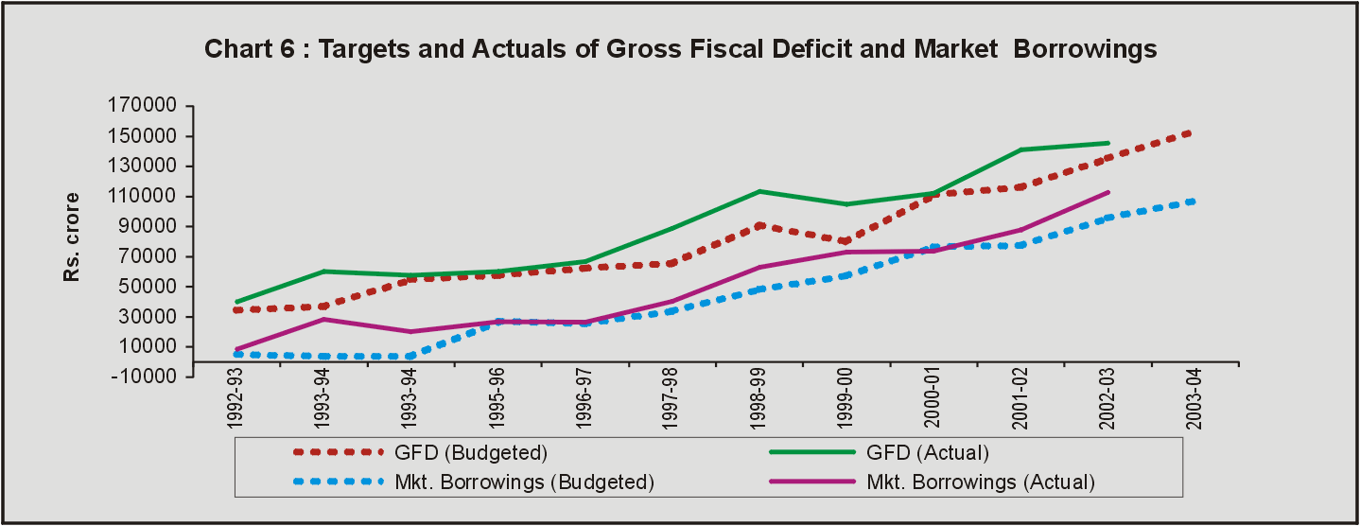

The Union budget for 2003-04, contextually, addresses the issues relating to the structural weaknesses in the Central government finances and accords high priority to fiscal consolidation. The fiscal consolidation is envisaged through revenue enhancement, expenditure rationalisation and restructuring of pubic debt. The budget has projected a modest growth in revenue collection and larger non-debt capital mobilisation through disinvestment. The tax measures proposed in the budget are intended to revive demand, promote investment and accelerate economic growth. The reforms in excise duties and initiatives to launch VAT at States' level are aimed at eliminating the fiscal drag and strengthening the reform process at sub-national level. The rationalisation of expenditure focuses on improved cash management which would not only strengthen public expenditure management, but also enhance productive use of financial resources. The expenditure management also aims at containing the growth of non-plan revenue expenditure while providing higher allocation for capital expenditure. Besides, investments in infrastructure sectors are envisaged to be stepped-up through public-private partnership. The endeavor to restructure public debt by way of prepayment of external debt, buy-back of past high cost loans from the banking system, and debt-swapping with State Governments are expected to strengthen the fiscal consolidation process.

The weak links in the Central Government finances continue to persist, notwithstanding the measures in the budget for strengthening the process of fiscal consolidation. The widening resource gap and pre-emption of a major part of borrowed funds to fill the revenue gap continue to be major areas of concern for sustaining the fiscal consolidation process. The gross fiscal deficit of the Centre which was only Rs. 44,632 crore in 1990-91 has increased to Rs.1,45,466 crore in 2002-03 and it is budgeted to go up to Rs.1,53,637 crore in 2003-04. The proportion of revenue deficit to gross fiscal deficit, which reflects the extent of pre-emption of borrowed funds for consumption expenditure, rose persistently from 41.6 per cent in 1990-91 to 72.0 per cent in 2002-03 and further to 73.1 per cent in 2003-04. As per the budget estimates, the tax-GDP ratio is expected to improve only marginally from 9.0 per cent in 2002-03 to 9.2 per cent. This level of improvement expected mainly through strengthening the tax administration is, nevertheless, inadequate even to achieve the GFD-GDP ratio of 4.3 per cent envisaged for the terminal year of the Tenth Plan (2006-07)¹¹. For the long-term sustainability of the fiscal system, it is critical that the tax revenue achieves sufficient buoyancy and the tax-GDP ratio reaches a higher trajectory. This would require, apart from the widening of tax base by bringing more and more services under the tax net and removing the plethora of fiscal concessions which have outlived its purpose and economic rational, better tax administration. The strengthening of revenue mobilisation would also ensure the sustenance of fiscal consolidation through the restructuring of public debt.

* Prepared in the Division of Central Finances of the Department of Economic Analysis and Policy. This article is based on the Union budget: 2003-04 presented to the Parliament on February 28, 2003.

¹ Economic Survey 2002-03, Government of India, presented to the Parliament on February 27, 2003.
² Implementation of VAT at States’ level has been deferred to a later date, as some of the States were not ready with the necessary enabling legislations as on the scheduled date of April 1, 2003.
³ The proposed revision in the price of urea has subsequently been rolled back to the pre-budget level.
⁴ Consistent with the announcement made by the Finance Minister regarding certain administered interest rates, the interest rate on saving accounts offered by banks has been reduced to 3.5 per cent per annum from 4.0 per cent per annum with effect from March 1, 2003. Simultaneously, the repo rate under the Liquidity Adjustment Facility (LAF) of the Reserve Bank of India to be made available is also reduced to 5.0 per cent from 5.5 per cent from March 3, 2003.
As notified by the Government of India, 8 per cent Relief Bonds, 2002 and 7 per cent Saving Bonds, 2002 were discontinued with effect from February 28, 2003. In their place Government of India has introduced 6.5 per cent Savings Bonds, 2003 (non-taxable) with effect from 24th March 2003 and 8 per cent Savings (Taxable) Bonds, 2003, with effect from 21st April 2003.
⁵ The Reserve Bank of India has issued the necessary operative guidelines to the authorised dealers to this effect. These relaxations are made effective from March 1, 2003.
⁶ The average interest rate on Government of India’s outstanding debt has come down from 11 per cent in 1999-2000 to 9.4 per cent in 2001-02.
⁷ Of the total stock of debt of Rs.2,44,000 crore owed by the States to the Government of India, a little over Rs.1,00,000 crore bear coupon rates in excess of 13 per cent per annum, far in excess of the current market rates.
⁸ As against net external assistance of Rs.770 crore budgeted in 2002-03, the revised estimates show that net external assistance would be negative at Rs.13,496 crore due to higher repayments of Rs.25,210 crore than the budgeted amount of Rs.10,563 crore.
⁹ As per the Reserve Bank of India records.
¹⁰ Economic Survey 2002-03.
¹¹ Draft Tenth Five Year Plan (2002-2007), Planning Commission, Government of India.

