Finances of Large Public Limited Companies, 2001-02*

This article presents the financial performance of selected 990 non-Government, non-financial large public limited companies (each with paid-up capital of Rs.1 crore and above) during 2001-02, based on their audited annual accounts, closed during April 2001 to March 2002¹. These companies accounted for 14.7 per cent of total paid up capital of all non-Government, non-financial public limited companies in terms of their paid-up capital as at the end of March 2002². The data are presented at an aggregate level for all selected companies. In the case of companies, which either extended or shortened their accounting year, their income, expenditure and appropriation account figures have been annualised; the balance sheet data, however, have been retained as presented in the annual accounts of the companies. The analysis of the financial performance of companies over the years is subject to these limitations.

The consolidated results of the selected companies revealed decelerated growth rate in sales, value of production, manufacturing expenses, net profits, etc., in the year 2001-02, (Table 1) while certain profitability ratios indicated marginal betterment in their performance.

Income and Expenditure

Table 1 : Growth Rates of Selected Items
 |  | (Per cent)
Item | 2000-01 | 2001-02
Sales * | 8.5 | 7.4
Value of production | 7.3 | 7.0
Manufacturing expenses | 7.0 | 5.1
Depreciation provision | 7.6 | 15.1
Gross profits | 6.5 | 10.0
Interest | 4.9 | 5.3
Profits before tax | 17.0 | 7.3
Tax provision | 1.4 | 19.9
Profits after tax | 25.4 | 1.8
Dividends | 3.0 | 9.8
Profits retained | 56.4 | -5.6
* Net of ‘Rebates and discounts’ and ‘Excise duty and cess’.

The total sales of the 990 companies amounting to Rs.1,79,085 crore, registered a growth of 7.4 per cent in 2001-02 as against the growth of 8.5 per cent in the previous year (Table 1, also Statement 3). The value of production increased by 7.0 per cent in 2001-02 to reach the level of Rs.1,79,295 crore compared with the increase of 7.3 per cent in 2000-01. On the expenditure side, manufacturing expenses increased by 5.1 per cent in 2001-02 compared to a growth of 7.0 per cent recorded in the previous year. Employees’ remuneration at Rs. 15,433 crore in 2001-02 witnessed a rise of 7.3 per cent lower than the increase of 10.5 per cent recorded in the previous year. Provision for depreciation rose by 15.1 per cent in 2001-02 on top of an increase of 7.6 per cent in 2000-01. The cost of funds, viz., interest payments, was up by 5.3 per cent at Rs.10,217 crore in 2001-02 as compared to an increase of 4.9 percent in the previous year. While the pre-tax profits increased by 7.3 per cent during 2001-02, the post-tax profits increased only by 1.8 per cent perhaps because of a large increase of 19.9 per cent in tax provision during the year. The effective tax rate (tax provision as percentage of profits before tax) rose by 3.6 percentage points to 34.0 per cent in 2001-02. Dividend payments at Rs.2,913 crore, rose by 9.8 per cent in 2001-02 after an increase of 3.0 per cent in the previous year. The profits retained by the selected companies, declined by 5.6 per cent during 2001-02 as against the high growth of 56.4 per cent in the preceding year.

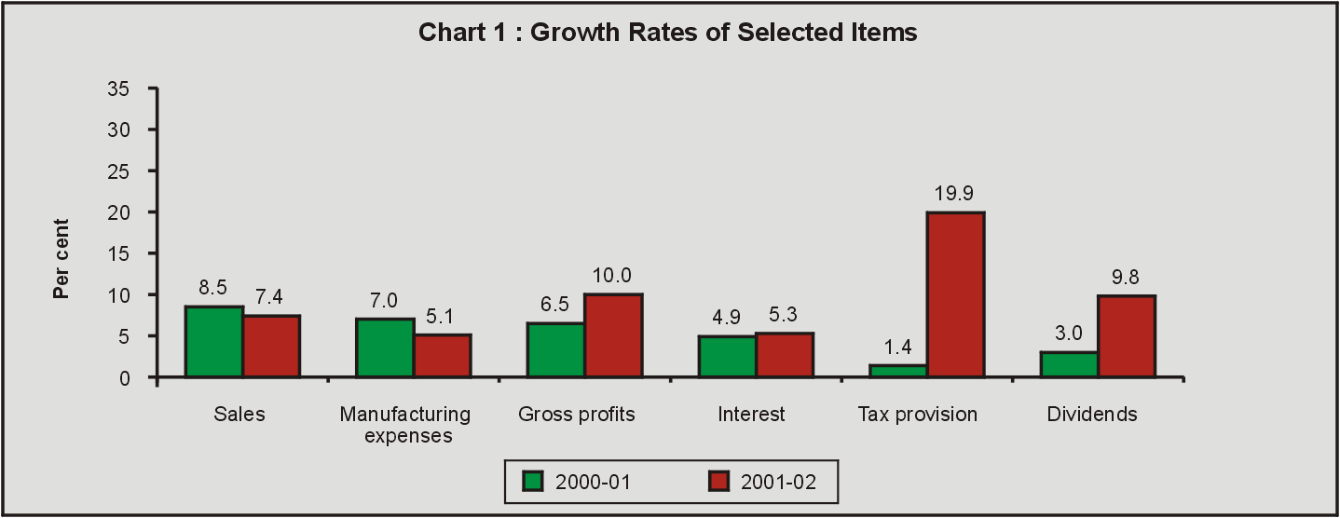

The profit margin of the selected companies (gross profits as percentage of sales) increased marginally from 9.5 per cent in 2000–01 to 9.7 per cent in 2001-02 (Statement 2). The ordinary dividend rate (ordinary dividends as percentage of ordinary paid-up capital) was higher at 13.1 per cent in 2001-02 compared with 12.3 per cent in the preceding year. The retention ratio, viz., profits retained as percentage of profits after tax, decreased to 48.6 per cent in 2001-02 from 52.3 per cent in 2000-01. The return on equity (post tax profits as percentage of net worth) increased fractionally to 6.4 per cent in 2001-02 from 6.3 per cent in 2000-01.

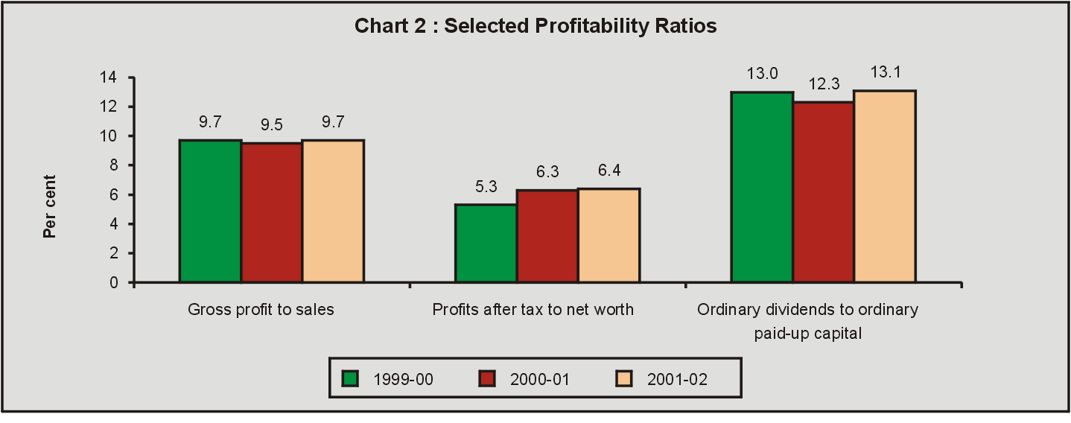

Earnings and Expenditure in Foreign Currencies

The total earnings in foreign currencies of the selected companies grew by 6.4 per cent in 2001-02 as against the growth of 21.5 per cent recorded in 2000-01 (Statements 1 and 6). The merchandise exports, valued at Rs.21,612 crore in 2001-02, grew by 4.0 per cent as compared to the growth of 13.5 per cent recorded in the previous year. The export intensity of sales (exports to sales) was 12.1 per cent in 2001-02 as compared to 12.5 per cent in the previous year. The total expenditure in foreign currencies in 2001-02, dropped by 3.4 per cent in contrast to a rise of 18.5 per cent in 2000-01. The value of merchandise imports amounted to Rs.23,562 crore in 2001-02, registered a fall of 5.5 per cent as against an increase of 16.2 per cent in 2000-01. The imports of raw materials declined by 6.2 per cent in 2001-02 after recording an increase of 28.4 per cent in the previous year. The imports of capital goods decreased further by 5.9 per cent in 2001-02 after a fall of 13.7 per cent recorded in the previous year. The imports of raw materials and capital goods accounted for 75.4 per cent and 6.2 per cent of the total merchandise imports in 2001-02. The net outflow in foreign currencies at Rs.593 crore in 2001-02 was much lower than the outflow of Rs.3,415 crore in the preceding year.

Liabilities and Assets

Total liabilities/assets (unadjusted) of the selected companies increased by 3.8 per cent to Rs.2,38,995 crore in 2001-02 (Statement 4). After adjustment for revaluation, the growth in total net assets worked out to 3.7 per cent in 2001-02 (5.7 per cent in 2000-01) (Statement 1). Gross fixed assets (adjusted for revaluation) grew by 6.0 per cent in 2001-02 as against 6.3 per cent in the previous year. The inventories increased by 0.7 per cent in 2001-02 in contrast to a growth of 5.2 per cent witnessed in 2000-01.

Chart 3 Pattern of Liabilities and Assets, 2001-02
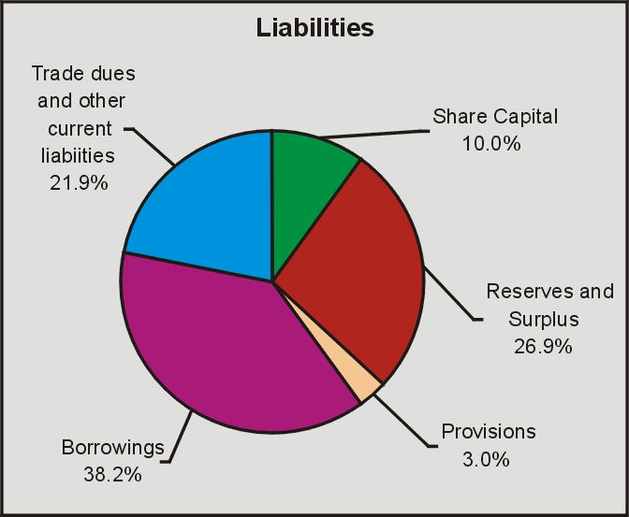 | 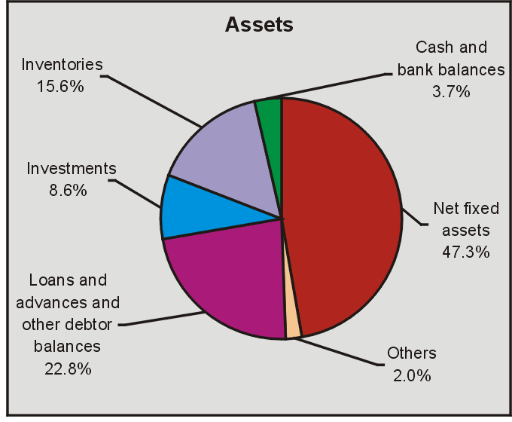

The composition of assets and liabilities remained broadly the same as in the previous year. Among the liabilities, reserves and surplus accounted for 26.9 per cent of total liabilities in 2001-02 (28.3 per cent in the previous year) while the total outstanding borrowings accounted for the major share at 38.2 per cent in 2001-02 (38.9 per cent in the previous year). Borrowings together with reserves and surplus accounted for 65.1 per cent of the total liabilities in 2001-02. Debt-equity ratio increased from 68.0 per cent in 2000-01 to 68.8 per cent in 2001-02. The share of trade dues and other current liabilities in total liabilities increased from 21.1 per cent in 2000-01 to 21.9 per cent in 2001-02. The current ratio (current assets to current liabilities) marginally declined from 1.3 per cent in 2000-01 to 1.2 per cent in 2001-02.

The share of net fixed assets in total assets decreased from 48.0 per cent in 2000-01 to 47.3 per cent in 2001-02. The share of inventories in total assets also decreased marginally from 16.0 per cent in 2000-01 to 15.6 per cent in 2001-02.

The share of loans and advances and other debtor balances declined by 0.6 percentage point to 22.8 per cent in the year under review. The share of investments in total assets moved up from 7.4 per cent in 2000-01 to 8.6 per cent in 2001-02. Of these investments, the quoted investments accounted for 22.0 per cent in 2001-02 as against 24.6 per cent in the previous year.

Sources and Uses of Funds

The total funds raised by the selected companies were of the lower order at Rs.16,380 crore in 2001-02 as against Rs.18,829 crore in the previous year. The share of external funds in total funds mobilised by the selected companies declined from 52.1 per cent in 2000-01 to 40.8 per cent in 2001-02 (Statement 5).

The share of borrowings in total sources of funds declined from 18.6 per cent in 2000-01 to 10.0 per cent in 2001-02. The share of borrowings from banks in total borrowings increased steeply from 52.8 per cent in 2000-01 to 83.0 per cent in 2001-02. The amount raised through net issues sharply declined from Rs.1,588 crore in 2000-01 to Rs.797 crore in 2001-02. Of the total funds raised from capital market, during 2001-02, amounting to Rs.1,275 crore, 37.4 per cent was by way of premium on shares. Depreciation provision which formed the major component of internal sources of funds, contributed Rs.7,277 crore in 2001-02, as against Rs.6,474 crore in 2000-01.

Gross capital formation of the selected companies amounted to Rs.9,947 crore during 2001-02, which accounted for 60.7 per cent of total assets formation during the year compared with 60.9 per cent in the previous year. The gross fixed assets formation, however, increased in terms of magnitude, to Rs.9,702 crore in 2001-02 from Rs.9,644 crore in 2000-01. Inventory build-up registered a rise of Rs.245 crore in 2001-02 as against Rs.1,823 crore in 2000-01. The share of investments in total uses of funds increased to 21.5 per cent in 2001-02 from the previous year’s share of 15.1 per cent.

Performance of Companies by Size of Sales

It is observed that companies with large sales class generally recorded higher rate of growth in sales during the year under review (Statement 7). The growth in sales was the highest at 16.6 per cent in 2001-02 for companies in sales range of ‘Rs.1,000 crore and above’. The gross profits and tax provision recorded high growth rates at 19.3 per cent and 35.8 per cent, respectively, in the year 2001-02 for companies with sales range of ‘Rs.1,000 crore and above’. The growth in borrowings from banks was the highest at 12.2 per cent for the companies in sales range of ‘Rs.50 crore -Rs.100 crore’ in the year 2001-02. The total borrowings recorded the highest growth rate for the companies in sales range of ‘Rs.25 crore -Rs.50 crore’ at 8.6 per cent.

It would appear that the sales size has a bearing on profit margin. The results indicated increasing profit margin with increase in size class of companies measured through sales (Statement 8). The profit margin on sales was 5.1 per cent for the companies with sales range of ‘Rs.25 crore - Rs. 50 crore’ in 2001-02 and it gradually increased to 12.3 per cent for the companies with sales range of ‘Rs.1,000 crore and above’. Exports to sales was the highest at 14.4 per cent for the companies with sales range of ‘Rs.100 crore - Rs.500 crore’ in 2001-02. Inventories to sales was the highest at 32.4 per cent for companies with sales range of ‘Less than Rs.25 crore’ and it gradually declined to 16.1 per cent for companies with increase in sales range up to ‘Rs.500 crore - Rs.1,000 crore’ and increased to 22.5 per cent in the sales range of ‘Rs.1,000 crore and above’ in 2001-02. The debt-equity ratio was 119.9 per cent for the companies in the sales range of ‘Rs.25 crore - Rs.50 crore’ and it was in the range of 62.0 per cent to 68.0 per cent for the companies in the sales range of ‘Rs.50 crore to Rs.100 crore’ and higher sales ranges. The retention ratio (retained profits to profits after tax) was the highest at 73.2 per cent for companies in sales class of ‘Rs.500 crore -Rs.1,000 crore’.

Industry-wise Performance

Performance of the selected companies as reflected by their growth in sales and profits, and selected financial ratios, classified according to their industrial activity are given, for selected industries, in Table 2 (Details are given in Statements 10 and 11). It may be observed that the industries like ‘Transport, storage and communications’ (43.2 per cent), ‘Chemical fertilisers and pesticides’ (22.3 per cent), ‘Paper and paper products’ (22.2 per cent) recorded high growth rates in sales while a few industries like ‘Hotels and restaurants’, ‘Fabricated metal products except machinery and equipments’ and ‘Tea plantations’, ‘Cotton textiles’ recorded negative growth in sales during 2001-02. Turning to gross profits, significant improvement over the previous year was registered by ‘Chemical fertilisers and pesticides’ (87.4 per cent), and ‘Motor vehicles’ (62.3 per cent). On the other hand, gross profits of the industries like ‘Tea plantations’ (-67.2 per cent), ‘Cotton textiles’ (-54.7 per cent) and ‘Hotels and restaurants’ (-53.2 per cent) declined sharply in the year 2001-02.

Table 2 : Industry-wise Performance
A. Growth Rates of Selected Items |  |  |  |  |  | (Per cent)
SelectedIndustry/ |  | Number of | Sales * |  | Gross Profits |  | Profits After Tax
Industry-Group |  | Companies | 2000-01 | 2001-02 | 2000-01 | 2001-02 | 2000-01 | 2001-02
1. | Tea Plantations | 13 | -4.6 | -4.5 | -50.5 | -67.2 | -84.3 | —
2. | Mining and Quarrying | 7 | 9.4 | 16.2 | # | 51.4 | & | &
3. | Food Products and Beverages | 64 | 11.4 | 5.1 | 11.4 | -0.1 | 22.2 | 84.2
 | Of which :
 | Sugar | 17 | -3.2 | 2.6 | 17.3 | -20.2 | 92.1 | -83.1
 | Edible oils and oil cakes | 15 | 19.9 | 6.4 | -14.7 | 15.0 | -55.8 | 241.6
4. | CottonTextiles | 41 | 4.6 | -2.4 | 34.1 | -54.7 | # | —
5. | Man-made Textiles | 62 | 10.9 | -2.6 | 26.6 | 2.6 | & | &
6. | Paper and Paper Products | 28 | 28.3 | 22.2 | 61.3 | 31.6 | # | 37.3
7. | Chemicals and chemical products | 163 | 9.8 | 10.8 | 0.6 | 26.5 | 3.1 | -25.5
 | Of which :
 | Basic Chemicals | 23 | 19.9 | -0.1 | 51.6 | -7.8 | # | —
 | Chemical fertilisers and pesticides | 23 | 3.1 | 22.3 | -25.3 | 87.4 | -30.7 | -97.2
 | Paints and Varnishes | 14 | 15.5 | 9.9 | 13.2 | 14.7 | 25.8 | 9.9
 | Pharmaceuticals and Medicines | 52 | 10.1 | 12.4 | 11.0 | 12.1 | 11.8 | -1.8
8. | Rubber and Plastic Products | 44 | 7.5 | 3.3 | -28.8 | -3.3 | -82.1 | —
 | Of which :
 | Plastic products | 33 | 12.5 | -1.2 | -12.1 | -10.9 | -42.4 | -69.2
9. | Cement and Cement Products | 26 | 10.4 | 12.0 | 46.0 | 32.9 | # | 36.0
10. | Iron and Steel | 33 | 12.3 | 14.2 | 29.3 | -0.5 | & | &
11. | Fabricated Metal Products except
 | machinery and equipments | 43 | -0.4 | -3.0 | -28.0 | 3.2 | — | &
12. | Machinery and Machine Tools | 75 | -2.9 | -1.3 | -52.8 | 12.0 | — | &
13. | Electrical Machinery and Apparatus | 42 | 0.8 | 5.1 | -14.9 | 40.7 | # | 184.1
14. | Radio, Television and Communication
 | equipments & apparatus | 15 | -7.8 | 14.3 | -32.9 | 15.1 | -28.6 | -36.6
15. | Motor Vehicles and other transport equipments | 48 | 4.2 | 0.8 | -35.7 | 62.3 | -50.3 | 99.4
16. | Diversified | 6 | 12.3 | 6.1 | 14.8 | -4.4 | # | 0.1
17. | Electricity Generation and Supply | 9 | 22.2 | 12.9 | 19.8 | 2.5 | 10.9 | 11.5
18. | Construction | 19 | -9.4 | 8.6 | -4.5 | 1.3 | -14.4 | -9.0
19. | Wholesale and Retail Trade | 24 | 7.3 | -2.5 | 0.8 | -14.0 | -9.2 | -50.3
20. | Hotels and Restaurants | 21 | 12.3 | -14.9 | 3.3 | -53.2 | 7.9 | -49.2
21. | Transport, Storage and Communications | 20 | -7.1 | 43.2 | 155.1 | 25.3 | # | 49.5
22. | Computer and Related Activities | 29 | 52.8 | 20.9 | 86.9 | 22.5 | 81.5 | 23.9
All Companies |  | 990 | 8.5 | 7.4 | 6.5 | 10.0 | 25.4 | 1.8
* Net of ‘rebates and discounts’ and ‘excise duty and cess’.
— Numerator is negative or nil or negligible.
# Denominator is negative or nil or negligible.
& Both numerator and denominator are negative or nil or negligible.

B. Selected Financial Ratios |  |  |  |  |  | (Per cent)
SelectedIndustry/ | Number of | Profit Margin |  | Effective Tax Rate |  | Debt to Equity
Industry-Group | Companies | 2000-01 | 2001-02 | 2000-01 | 2001-02 | 2000-01 | 2001-02
1. Tea Plantations | 13 | 9.1 | 3.1 | 61.0 | # | 9.8 | 11.8
2. Mining and Quarrying | 7 | 11.3 | 14.7 | # | # | 106.0 | 176.6
3. Food Products and Beverages | 64 | 6.0 | 5.7 | 37.6 | 28.4 | 55.9 | 51.0
Of which :
Sugar | 17 | 13.6 | 10.6 | 16.2 | 61.9 | 83.0 | 85.8
Edible oils and oil cakes | 15 | 2.3 | 2.4 | 36.2 | 17.5 | 51.0 | 51.2
4. CottonTextiles | 41 | 6.5 | 3.0 | 18.5 | # | 77.2 | 98.5
5. Man-made Textiles | 62 | 3.3 | 3.5 | # | # | 176.6 | 196.6
6. Paper and Paper products | 28 | 9.5 | 10.2 | 25.1 | 20.9 | 106.7 | 165.3
7. Chemicals and chemical products | 163 | 10.4 | 11.9 | 28.9 | 40.2 | 65.0 | 61.7
Of which :
Basic Chemicals | 23 | 10.0 | 9.2 | 87.9 | # | 127.0 | 119.0
Chemical fertilisers and pesticides | 23 | 7.8 | 11.9 | 20.1 | 94.0 | 99.6 | 98.7
Paints and Varnishes | 14 | 11.8 | 12.3 | 29.7 | 30.6 | 46.7 | 47.9
Pharmaceuticals and Medicines | 52 | 15.5 | 15.4 | 25.0 | 26.0 | 19.6 | 17.7
8. Rubber and Plastic products | 44 | 8.7 | 8.1 | 55.3 | 107.6 | 61.0 | 65.0
Of which :
Plastic products | 33 | 12.8 | 11.5 | 28.5 | 55.0 | 61.0 | 62.1
9. Cement and Cement Products | 26 | 9.3 | 11.0 | 32.0 | 25.9 | 138.4 | 159.9
10. Iron and Steel | 33 | 9.6 | 8.4 | 152.4 | # | 218.7 | 264.4
11. Fabricated Metal Products except
machinery and equipments | 43 | 7.2 | 7.6 | 168.9 | 120.5 | 86.7 | 90.1
12. Machinery and Machine Tools | 75 | 4.6 | 5.2 | 143.1 | 121.0 | 46.4 | 42.2
13. Electrical Machinery and Apparatus | 42 | 5.2 | 7.0 | 54.4 | 28.0 | 46.7 | 47.8
14. Radio, Television and Communication
equipments & apparatus. | 15 | 7.0 | 7.0 | 31.0 | 33.0 | 41.4 | 30.7
15. Motor Vehicles and other transport equipments | 48 | 5.5 | 8.9 | 27.5 | 31.0 | 38.0 | 41.6
16. Diversified | 6 | 10.4 | 9.3 | 11.4 | 19.6 | 68.1 | 51.6
17. Electricity Generation and Supply | 9 | 18.1 | 16.5 | 11.1 | 9.6 | 74.4 | 66.2
18. Construction | 19 | 10.9 | 10.1 | 29.5 | 38.8 | 58.2 | 65.1
19. Wholesale and Retail Trade | 24 | 4.4 | 3.9 | 18.0 | 23.9 | 24.1 | 19.0
20. Hotels and Restaurants | 21 | 22.0 | 12.1 | 19.7 | 21.7 | 38.7 | 60.4
21. Transport, Storage and Communications | 20 | 14.7 | 12.9 | 52.0 | 49.0 | 58.8 | 68.0
22. Computer and Related Activities | 29 | 27.9 | 28.2 | 11.4 | 14.3 | 3.1 | 2.9
All Companies | 990 | 9.5 | 9.7 | 30.4 | 34.0 | 68.0 | 68.8

Debt to equity ratio was low in the industries like ‘Tea plantations’ (11.8 per cent), ‘Pharmaceuticals and medicines’ (17.7 per cent) and ‘Computer and related activities’ (2.9 per cent). In respect of a few industries like ‘Iron and Steel’, ‘Man made textiles’, etc. the debt to equity ratio was more than 100 per cent.

* Prepared in the Company Finances Division of the Department of Statistical Analysis and Computer Services.
¹ Reference may be made to the April 2002 issue of the Reserve Bank of India Bulletin for the previous study.
² Based on provisional data as on March 31, 2002 supplied by the Department of Company Affairs, Government of India.

