Composition and Ownership Pattern of Deposits with Scheduled Commercial Banks: March 2002*

Introduction

The sample surveys on composition and ownership pattern of bank deposits with all scheduled commercial banks, including Regional Rural Banks, are conducted by the Reserve Bank of India on annual basis and the results are published regularly in the Reserve Bank of India Bulletin. The results of the latest survey relating to the period March 31, 2002 are analysed in this article.

The survey schedule was designed to capture branch level data on ownership of deposits, classified according to broad institutional sectors and sub-sectors for each type of deposits, including inter-bank deposits. Out of 65,413 branches of scheduled commercial banks, a sample of 10,000 branches was selected for the purpose as per the following sampling design.

Top 3,500 bank branches, in terms of quantum of deposits, were selected with certainty. All bank branches of the States / Union Territories which were having less than 10 branches each, were also selected with certainty, in order to ensure proper representation in the sample. Under this category, all the 9 branches in Lakshadweep were selected. Out of the remaining 61,904 bank branches, 6,491 branches were selected using circular systematic sampling after arranging the branches in the descending order of their deposits. Of the 10,000 bank branches selected, filled-in schedules were received from 9,313 branches resulting in the response rate at 93.1 per cent. Using the estimation procedure associated with the sampling design, the estimates of different classificatory characteristics have been obtained and presented in this article.

2. Composition of Deposits

The composition of aggregate deposits by type of account, viz., current, savings and term deposits is presented in Chart 1. The current deposits accounted for 11.6 per cent of total deposits as on March 31, 2002, which witnessed a fall from 12.7 per cent as on March 31, 2001. The share of term deposits, on the other hand, registered an increase from 63.5 per cent as on March 31, 2001 to 64.4 per cent as on March 31, 2002. The share of savings deposits increased fractionally between the two reference dates.

3. Ownership Pattern of Bank Deposits

Classification of bank deposits by type and institutional sectors as on 31st March 2001 and 2002 is presented in Statement 1. The total outstanding deposits of scheduled commercial banks was Rs.11,24,372 crore as on March 31, 2002, recording an increase from Rs.9,76,460 crore as on March 31, 2001¹.

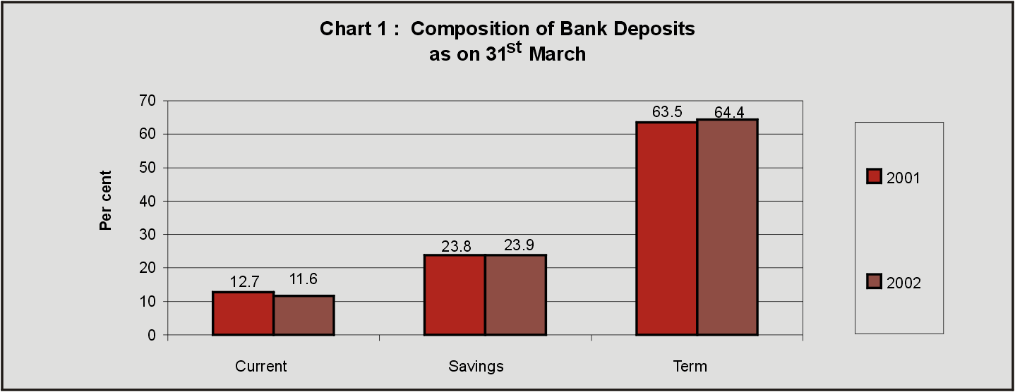

Although the share of 'Household Sector', in the deposits of scheduled commercial banks, reduced from 67.2 per cent as on March 31, 2001 to 66.7 per cent as on March 31, 2002, it remained the largest constituent of the deposits held with banks. Further, the share of the 'Financial Sector' declined marginally from 7.3 per cent as on March 31, 2001 to 6.9 per cent as on March 31, 2002 and that of the 'Foreign Sector' decreased from 11.0 per cent to 10.2 per cent. On the other hand, the shares of 'Government Sector' and 'Private Corporate Sector (Non-Financial)' increased from 10.0 per cent and 4.6 per cent in 2001 to 10.6 per cent and 5.7 per cent in 2002, respectively.

It is observed that ownership pattern of deposits in 2002 remained similar to that of 2001 for each type of deposits. In respect of current deposits, 'Household Sector' had the highest share of 46.3 per cent as on March 31, 2002, although the share decreased from 47.3 per cent as on March 31, 2001.

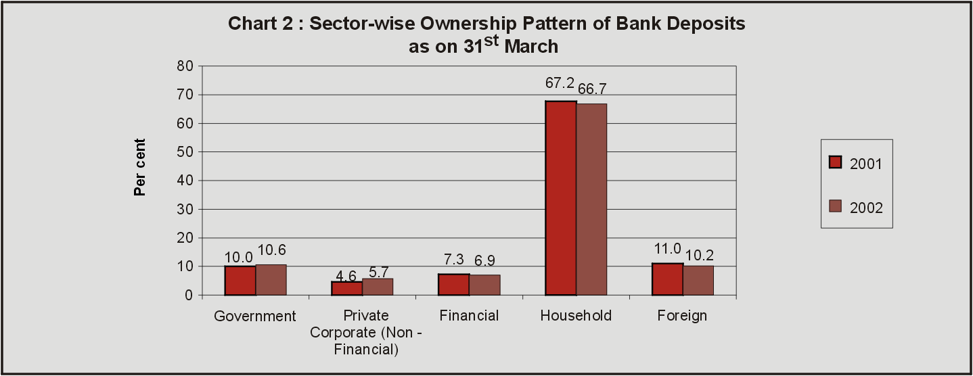

The shares of 'Government Sector', 'Private Corporate Sector (Non-Financial)' and 'Financial Sector' in current deposits were in the range of 16.1 per cent to 17.8 per cent in 2002, as against the range of 14.2 per cent to 18.1 per cent in 2001. The share of 'Government Sector' in savings deposits remained the same (6.4 per cent) in 2002 as that in 2001. Deposits from 'Foreign Sector' constituted 5.3 per cent of savings deposits in 2002, marginally higher as compared to 5.1 per cent in 2001. Household deposits accounted for larger share of 87.3 per cent in savings deposits in 2002 as compared to 86.9 per cent in 2001. 'Private Corporate Sector (Non-Financial)' and 'Financial Sector' had negligible shares in savings deposits in 2002. In respect of term deposits, 'Household Sector' had the highest share, even though the share declined from 63.8 per cent in 2001 to 62.8 per cent in 2002.

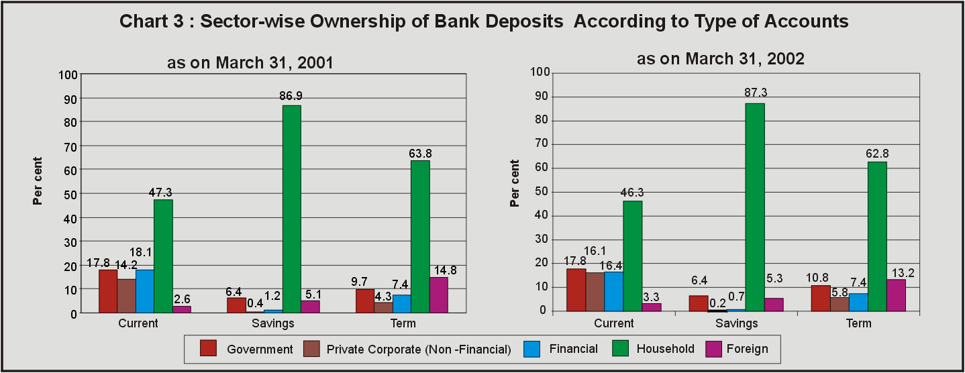

The share of 'Foreign Sector' in term deposits decreased from 14.8 per cent as on March 31, 2001 to 13.2 per cent as on March 31, 2002. On the other hand, the shares of 'Government Sector' and 'Private Corporate Sector (Non-Financial)' increased by more than 1 per cent.

4. Ownership Pattern of Deposits according to Population Groups

The ownership of deposits classified according to population groups is presented in Statement 2. The metropolitan areas accounted for the major share (43.2 per cent) in total deposits, while the deposits of rural, semi-urban and urban areas accounted for 15.0 per cent, 18.6 per cent and 23.2 per cent, respectively as on March 31, 2002. The shares had relatively increased in respect of metropolitan and urban groups over those in 2001 as depicted in chart 4.

The 'Household Sector' accounted for the highest share in total deposits in each of the population groups. The share of 'Household Sector' was 87.7 per cent in rural areas, 74.8 per cent in semi-urban areas, 72.3 per cent in urban areas and 53.1 per cent in metropolitan areas as on March 31, 2002. 'Individuals (including Hindu Undivided Families)' was the major constituent of the 'Household Sector' in all the population groups.

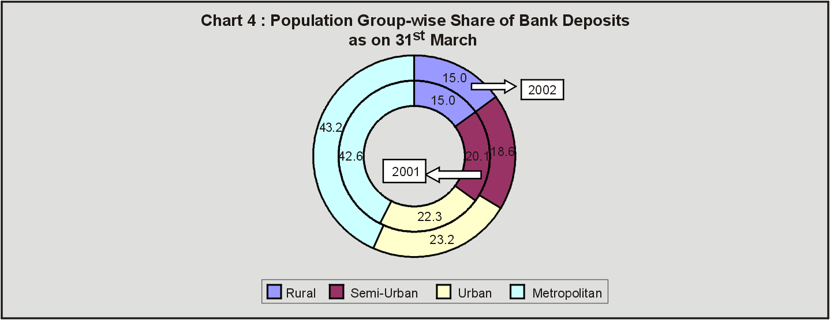

Further, 'Farmers' held a significant portion (37.4 per cent) of bank deposits in the rural areas. Shares of 'Businessmen, Traders, Professionals and Self-employed Persons' in the rural, semi-urban, urban and metropolitan areas were 12.0 per cent, 13.6 per cent, 14.5 per cent and 10.6 per cent, respectively. The share of 'Wage and Salary Earners' in the category of 'Individuals' of the 'Household Sector' was the highest for the urban branches (17.3 per cent) among different population groups. The share of 'Trusts, Associations and Clubs, etc.' in total deposits was found to be the highest in the metropolitan areas (2.3 per cent) among different population groups. The ownership of 'Proprietary and Partnership Concerns, etc.' in bank deposits was the highest in metropolitan centres (4.3 per cent). While the share of 'Educational Institutions' in different population groups was in the range of 0.9 per cent to 2.2 per cent, the share of 'Religious Institutions' was below 1 per cent in all the population groups.

The 'Government Sector' comprises Central and State Governments, local bodies, quasi-government bodies (like State Electricity Boards) and public sector corporations and companies. Deposits from the 'Government Sector' constituted 4.5 per cent of the total deposits in rural areas as on March 31, 2002. The share of deposits held by the 'Government Sector' in the semi-urban areas was 6.7 per cent, while in respect of urban branches, the share of deposits was 10.5 per cent. In the case of metropolitan branches, the 'Government Sector' held higher share at 14.3 per cent compared to its share in other population groups.

The share of 'Private Corporate Sector (Non-Financial)' in total deposits of the metropolitan areas was at 11.9 per cent as on March 31, 2002. This sector, however, held very small shares of 1.8 per cent or less in deposits of the branches in other population groups. The share of 'Financial Sector' was 10.5 per cent of the total deposits in metropolitan areas. The 'Financial Sector' accounted for lower shares at 6.7 per cent in urban areas, 3.4 per cent in semi-urban areas and 0.8 per cent in rural areas. 'Banks' accounted for major portion in the share of 'Financial Sector' in all population groups. The 'Insurance Corporations and Companies', another constituent of 'Financial Sector', held a share of 1.5 per cent of the total deposits in metropolitan areas; while their shares in other population groups were below 0.5 per cent. The 'Foreign Sector', comprising non-residents and foreign embassies, etc., accounted for 14.6 per cent of deposits in semi-urban areas and around 6.7 per cent to 10.2 per cent in other areas. Deposits from 'Non-Residents' accounted for 13.4 per cent and 8.4 per cent of total deposits in semi-urban and metropolitan areas, respectively.

Considering the deposits by their type, the survey indicated that metropolitan areas accounted for the highest share and rural areas accounted for the lowest share in all the types of deposits. Further, savings deposits were almost evenly distributed among the three population groups, viz., rural, semi-urban and urban, with their respective shares being 21.0 per cent, 22.9 per cent and 24.4 per cent, while the metropolitan areas had a higher share at 31.6 per cent. In respect of current deposits, the metropolitan areas accounted for the largest share at 56.3 per cent, followed by urban areas at 25.0 per cent while the shares of rural and semi-urban areas were low at 5.9 per cent and 12.7 per cent, respectively.

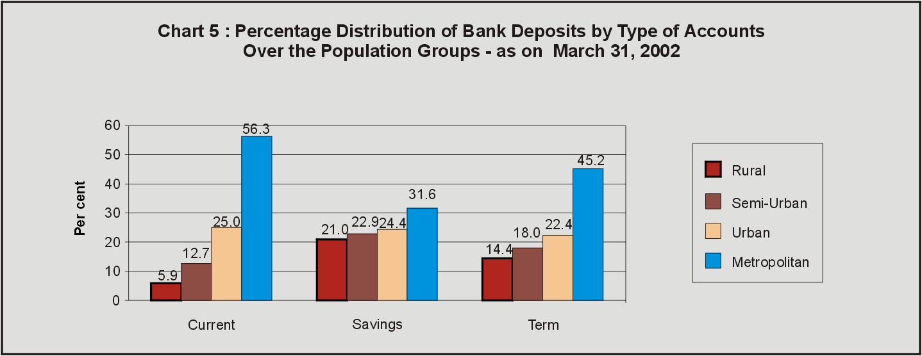

5. Ownership Pattern of Deposits in States and Union Territories

The ownership pattern of deposits classified according to States/ Union Territories is presented in Statement 3. The bank deposits have been primarily mobilised from the 'Household Sector' in all the States and Union Territories. Predominance of 'Household Sector' can be adjudged from the fact that for ten States / Union Territories, the contribution of this sector was 80 per cent and above of total deposits mobilised as on March 31, 2002 and there were thirteen other States / Union Territories in which the 'Household Sector' accounted for 70 to 80 per cent of deposits. Among the States and Union Territories, the contribution of the 'Household Sector' was the highest in the state of Haryana (88.3 per cent), followed by Manipur (86.7 per cent) and Tripura (86.3 per cent). The contribution of the 'Household Sector' was less than 50 per cent in Kerala, Lakshadweep and Maharashtra.

The share of the 'Government Sector' in the total deposits mobilised in a State/ Union Territory was 10 per cent or below in sixteen States/ Union Territories as on March 31, 2002. This sector had significant contribution in the total deposits mobilised in the States/ Union Territories of Lakshadweep (38.5 per cent), Dadra and Nagar Haveli (26.7 per cent), Delhi (24.2 per cent), Meghalaya (23.8 per cent), Chandigarh (23.5 per cent) and Andaman and Nicobar Islands (23.0 per cent).

The contribution of 'Foreign Sector' in deposits mobilisation was below 5 per cent as on March 31, 2002 in majority of the States and Union Territories. 'Foreign Sector' accounted for more than 15 per cent of total deposits in the States/ Union Territories of Kerala, Daman and Diu, Goa, Punjab and Gujarat. The share of 'Private Corporate Sector (Non-Financial)' in total deposits was more than 9 per cent in Maharashtra and Delhi. Deposits from 'Banks' accounted for more than 7 per cent of total deposits in Chhattisgarh, Madhya Pradesh and Maharashtra.

6. Ownership Pattern of Deposits in Metropolitan Centres

The ownership pattern of deposits of the four major metropolitan centres is presented in Statement 4. Among these metropolitan centres, the share of 'Household Sector' in total deposits as on March 31, 2002 was the highest in Kolkata (63.9 per cent) and the lowest in Mumbai (40.0 per cent). The highest share of `Government Sector' was recorded in Delhi (24.5 per cent). The share of 'Government Sector' was less than 10.5 per cent in other centres. The share of 'Private Corporate Sector (Non-Financial)' was the highest in Mumbai (17.9 per cent). The 'Foreign Sector' accounted for more than 13 per cent of total deposits in Mumbai and Chennai. Inter-bank deposits constituted 9.6 per cent of total deposits in Mumbai.

7. Ownership Pattern of Deposits according to Bank Groups

The bank group-wise composition of deposits is presented in Statement 5. Of the total deposits of Rs.11,24,372 crore as on March 31, 2002, Nationalised Banks accounted for the largest share of 53.5 per cent, followed by State Bank of India and its Associates (21.0 per cent), Other Scheduled Commercial Banks (15.2 per cent), Foreign Banks (6.0 per cent) and Regional Rural Banks (4.2 per cent).

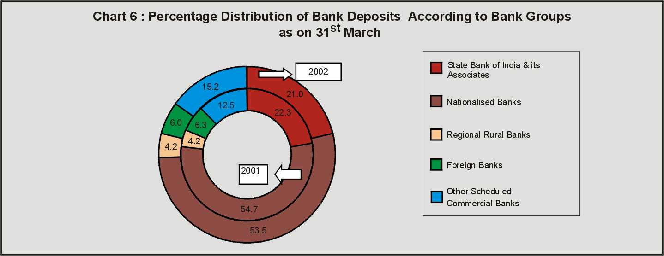

Current, savings and term deposits accounted for 15.1 per cent, 26.4 per cent and 58.5 per cent, respectively, in the total deposits held by State Bank of India and its Associates. In the case of Nationalised Banks, current deposits accounted for 9.8 per cent, savings deposits at 26.3 per cent and term deposits at 63.9£ per cent of their total deposits. Regional Rural Banks had 41.2 per cent of their deposits in savings deposits category, which was the highest among the bank groups.

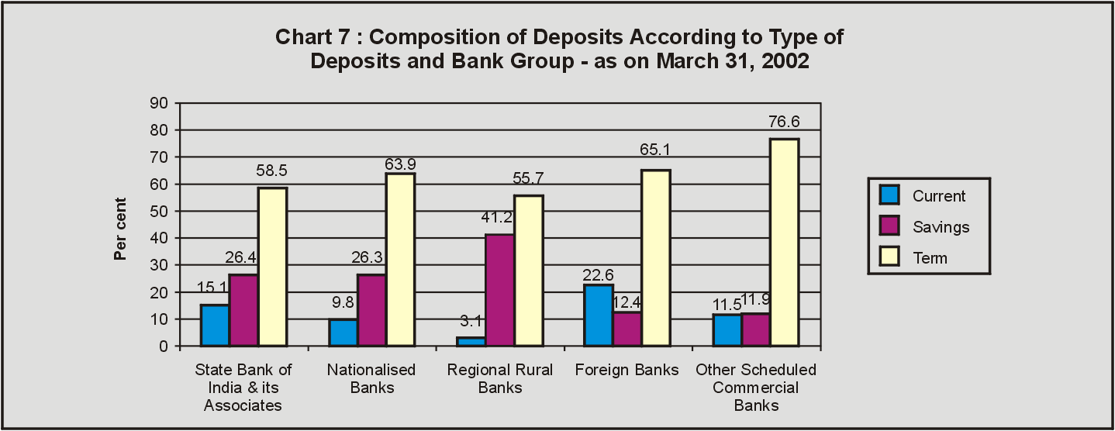

8. Ownership Pattern of Deposits according to Sector and Bank Groups

The ownership pattern of deposits according to the institutional sectors and bank groups as on March 31, 2002 is presented in Statement 6. The 'Household Sector' accounted for the highest share of the total deposits in all the bank groups, although the share in Foreign Banks was low. The share of the households in total deposits was 63.2 per cent for State Bank of India and its Associates, 72.5 per cent for Nationalised Banks, 90.3 per cent for Regional Rural Banks, 35.7 per cent for Foreign Banks and 57.1 per cent for Other Scheduled Commercial Banks. 'Individuals (including Hindu Undivided Families)' was the major constituent of the 'Household Sector' in all the bank groups. 'Farmers', included in 'Individuals', had a share of 43.1 per cent of the total deposits of Regional Rural Banks, which was the highest among all the bank groups. Further, 'Businessmen, Traders, Professionals and Self-employed Persons' had a share of 17.2 per cent of deposits held with Regional Rural Banks. The share of 'Wage and Salary Earners' in the total deposits, was found to be the highest in the case of State Bank of India and its Associates.

The share of the 'Government Sector' was the highest in respect of deposits held with State Bank of India and its Associates (13.9 per cent). This share for Nationalised Banks was at 11.1 per cent, Regional Rural Banks at 8.2 per cent, Foreign Banks at 0.2 per cent and Other Scheduled Commercial Banks at 8.6 per cent. In the case of State Bank of India and its Associates, within the 'Government Sector', 5.3 per cent of the total deposits was held by 'Central and State Governments' and 3.9 per cent by 'Quasi-Government Bodies'. Such deposits of Regional Rural Banks were largely contributed by 'State Governments' (5.0 per cent). 'Central and State Governments' in the 'Government Sector' accounted for 4.4 per cent of the total deposits held with Nationalised Banks.

The share of 'Private Corporate Sector (Non-Financial)' in the total deposits of various bank groups was the highest in the case of Foreign Banks (32.3 per cent). The corresponding shares of State Bank of India and its Associates, Nationalised Banks and Regional Rural Banks were very low at 2.7 per cent, 2.1 per cent and 0.2 per cent, respectively.

The contribution of 'Financial Sector' in the total deposits of different bank groups was the highest in the case of deposits held with Foreign Banks (15.4 per cent). The corresponding shares in other bank groups were 8.4 per cent for State Bank of India and its Associates, 4.1 per cent for Nationalised Banks, 0.8 per cent for Regional Rural Banks and 12.9 per cent for Other Scheduled Commercial Banks. Foreign Banks had mobilised about 9.8 per cent of their total deposits from 'Banks', which was higher as compared to other bank groups.

The non-residents accounted for the highest deposits with Foreign Banks (14.5 per cent), followed by State Bank of India and its Associates (9.9 per cent) and Nationalised Banks (8.4 per cent).

* Prepared in the Banking Statistics Division of the Department of Statistical Analysis and Computer Services. The previous article on 'Composition and Ownership Pattern of Scheduled Commercial Bank Deposits: March 2001' was published in May 2002 issue of the Reserve Bank of India Bulletin.
¹ Total outstanding deposits presented in the article may differ from those given in other sources as these data relate to March 31 and are estimated based on the data of a sample of 10,000 bank branches.

