प्रेस प्रकाशनी PRESS RELEASE
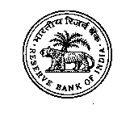 | 
भारतीय रिज़र्व बैंक
RESERVE BANK OF INDIA
वेबसाइट : www.rbi.org.in/hindi | संचार विभाग, केंद्रीय कार्यालय, शहीद भगत सिंह मार्ग, फोर्ट, मुंबई - 400 001
Website : www.rbi.org.in | Department of Communication, Central Office, Shahid Bhagat Singh Marg, Fort,
ई-मेल/email : helpdoc@rbi.org.in | Mumbai - 400 001 फोन/Phone: 022 - 2266 0502
May 30, 2025

Deposits with Scheduled Commercial Banks - March 2025 (Annual BSR-2)

Today, the Reserve Bank released the web publication ‘Deposits with Scheduled Commercial Banks – March 2025’ on its ‘Database on Indian Economy’ portal (https://data.rbi.org.in Homepage > Publications).

Scheduled commercial banks (SCBs) (including regional rural banks) report branch-wise data on type of deposits (current, savings and term), its institutional sector wise ownership, age wise distribution of deposits pertaining to individuals, maturity pattern of term deposits as well as number of employees in the annual ‘Basic Statistical Return’ (BSR) - 2 return. These data are released at disaggregated level (viz., type of deposits, population groups, bank groups, states, districts, centres, interest rate ranges, size, original and residual maturity).

Highlights:

- Bank deposits grew (y-o-y) by 10.6 per cent during FY 2024-25 as compared to 13.0 per cent, net of merger, in the previous year (Chart I).

- Household sector accounted for the largest share of SCB’s deposits at 60.2 per cent; the share of female depositors was 20.7 per cent in March 2025 (Chart II).
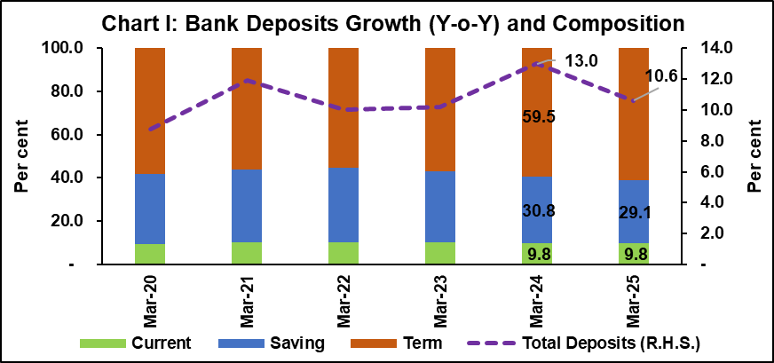

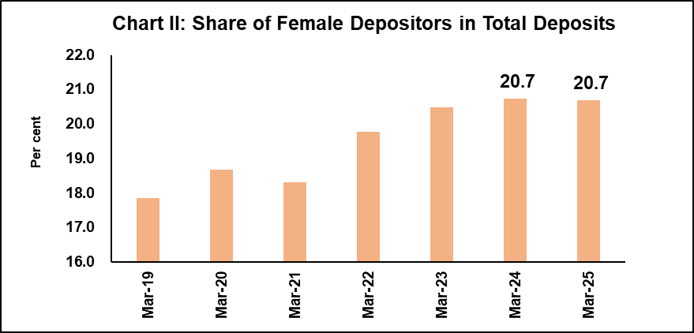

- Branches in metropolitan areas, which constituted the dominant share in deposits, recorded 11.7 per cent annual growth in March 2025; whereas rural, semi-urban and urban centres registered 10.1 per cent, 8.9 per cent, and 9.3 per cent annual growth, respectively.

- The higher returns on term deposits led to higher accretion in such deposits as compared to other type of deposits; the share of saving deposits declined to 29.1 per cent in March 2025 as compared to 30.8 per cent a year ago and 33.0 per cent two years ago.

- Nearly 68.4 per cent of term deposits were having the original maturity of one to three as on March 2025.

- The share of term deposits bearing interest rate of ‘7 per cent and above’ increased and stood at 72.7 per cent in March 2025 as compared to 64.2 per cent a year ago and 33.5 per cent two years ago.

- The share of term deposits of size ‘Rs. one crore and above’ increased to 45.1 per cent in March 2025 from 43.7 per cent in March 2024.

- The share of senior citizens’ deposits was 20.2 per cent of total deposits as on March 2025.

Ajit Prasad
Press Release: 2025-2026/448 Deputy General Manager
(Communications)

Quarterly publication for March 2025 encompassing all SCBs excluding RRBs is also released with this annual BSR-2 March 2025 (https://data.rbi.org.in>Homepage>Publications).
Aggregate data on bank deposits based on fortnightly Form-A Return (collected under Section 42(2) of the RBI Act, 1934) for the last reporting Friday of March 2025 have been published earlier at our website (https://website.rbi.org.in/en/web/rbi>Home>Statistics>Data Release>Fortnightly>Scheduled Bank's Statement of Position in India).
Reference date for BSR-2 is last day of the quarter. These data include the impact of merger of a non-bank with a bank with effect from July 1, 2023.
Previous data release in the annual series, covering end-March 2024 position, was published on June 4, 2024, on RBI website.
Population group criteria used for BSR is based on population size of respective revenue centre, as per census 2011, where branches of SCBs are operating and classified as: a) 'Rural' (population less than 10,000), b) 'Semi-urban' (population of 10,000 to less than 1 lakh), c) 'Urban' (population of 1 lakh to less than 10 lakhs), d) 'Metropolitan' (population of 10 lakhs and above).
Household sector includes individuals, proprietary concerns, Hindu undivided families (HUFs), partnership firms and others.

