प्रेस प्रकाशनी PRESS RELEASE
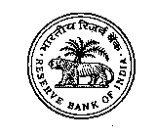 | 
भारतीय रिज़र्व बैंक
RESERVE BANK OF INDIA
वेबसाइट : www.rbi.org.in/hindi | संचार विभाग, केंद्रीय कार्यालय, शहीद भगत सिंह मार्ग, फोर्ट, मुंबई - 400 001
Website : www.rbi.org.in | Department of Communication, Central Office, Shahid Bhagat Singh Marg, Fort,
ई-मेल/email : helpdoc@rbi.org.in | Mumbai - 400 001 फोन/Phone: 022 - 2266 0502
May 30, 2025

Credit by Scheduled Commercial Banks – March 2025 (Annual BSR-1)

Today, the Reserve Bank released the web publication ‘Basic Statistical Return on Credit by Scheduled Commercial Banks (SCBs) in India – March 2025’ on its ‘Database on Indian Economy’ (DBIE) portal (https://data.rbi.org.in Homepage > Publications). The publication provides information on various characteristics of bank credit in India, based on data submitted by SCBs {including Regional Rural Banks (RRBs)} under the annual ‘Basic Statistical Return (BSR) – 1’ system, which collects information on type of account, organisation, occupation/activity and category of the borrower, district and population group of the place of utilisation of credit, rate of interest, credit limit and amount outstanding.

Highlights:

- Bank credit growth (y-o-y) decelerated to 11.1 per cent in March 2025 from 15.3 (net of merger ) per cent in the previous financial year.

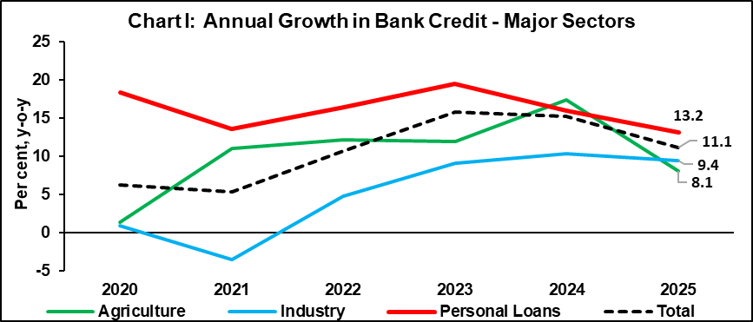
- The deceleration in credit growth (y-o-y) was observed across all bank groups during FY 2024-25. Private sector banks witnessed the steepest decline to 9.5 per cent in March 2025 after a sustained credit growth above 15 per cent for the preceding three years.

- With higher credit growth in rural, semi-urban and urban areas compared to metropolitan area, the share of metropolitan branches in total credit declined to 58.7 per cent in March 2025 from 63.5 per cent five years ago.

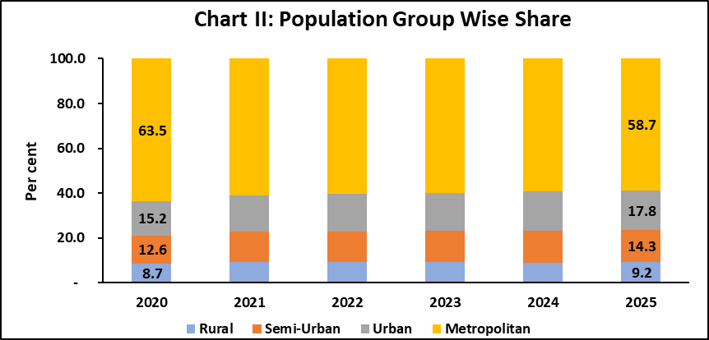

- The growth in personal loans, though moderated sharply to 13.2 per cent, continued to outpace headline credit growth, which has led to an increase in their share to 31.0 per cent (24.1 per cent five years ago).

- Share of housing loans bearing interest rate 9 per cent and above came down to 36.8 per cent in March 2025 from 54.5 per cent a year ago which signifies decline in cost of housing loans.

- Consumer durables and other personal loans accounted for nearly one third of total personal loans; the share of these loans bearing interest rate 11 per cent and above has declined to 47.4 per cent in March 2025 from 50.3 per cent in the previous year.

- Loans to industry accounted for nearly one fourth of total bank credit and increased at a (y-o-y) rate of 9.4 per cent in March 2025, down from 10.4 per cent a year earlier.

- The share of Individuals in total credit maintained its increasing momentum and stood at 47.8 per cent in March 2025 as compared to 41.5 per cent in March 2020. Within individuals, the share of female borrowers also gradually rose to 23.8 per cent from 22.0 per cent in the said period.

Ajit Prasad
Press Release: 2025-2026/449 Deputy General Manager
(Communications)

The previous annual BSR-1 series results on credit by SCBs (including RRBs) for March 2024 were released on the RBI website on June 4, 2024; the aggregates from quarterly BSR-1 for SCBs (other than RRBs) are being released regularly since December 2014. Accordingly, quarterly publication for March 2025 is also released (web-link: - https://data.rbi.org.in >Homepage > Publications>Basic Statistical Return (BSR)-1 - (Quarterly) - Outstanding Credit of Scheduled Commercial Banks) along with the annual BSR-1 March 2025.
Banking aggregates based on fortnightly Form-A Return (collected under Section 42(2) of the RBI Act, 1934) for the last reporting Friday of March 2025 were published earlier at our website (https://website.rbi.org.in/web/rbi >Home>Statistics>Data Release>Fortnightly>Scheduled Bank's Statement of Position in India) and aggregate level monthly data on sectoral deployment of bank credit for March 2025, reported by select major banks, were also released on the website (Home>Statistics>Data Releases>Monthly> Data on Sectoral Deployment of Bank Credit).
Population group criteria used for BSR is based on population size of respective revenue centre, as per census 2011, where branches of SCBs are operating and classified as: a) 'Rural' (population less than 10,000), b) 'Semi-urban' (population of 10,000 to less than 1 lakh), c) 'Urban' (population of 1 lakh to less than 10 lakhs), d) 'Metropolitan' (population of 10 lakhs and above).
Reference date for BSR-1 is last day of the quarter. The growth figures used for comparison pertaining to March 2024 are adjusted of impact of merger of a non-bank with a bank with effect from July 1, 2023.
Personal loans include housing, education, vehicle, personal credit cards, consumer durables and other personal loans.

