Monthly Payment System Indicators - MAY 2023

Digital Payments – Volume and Value
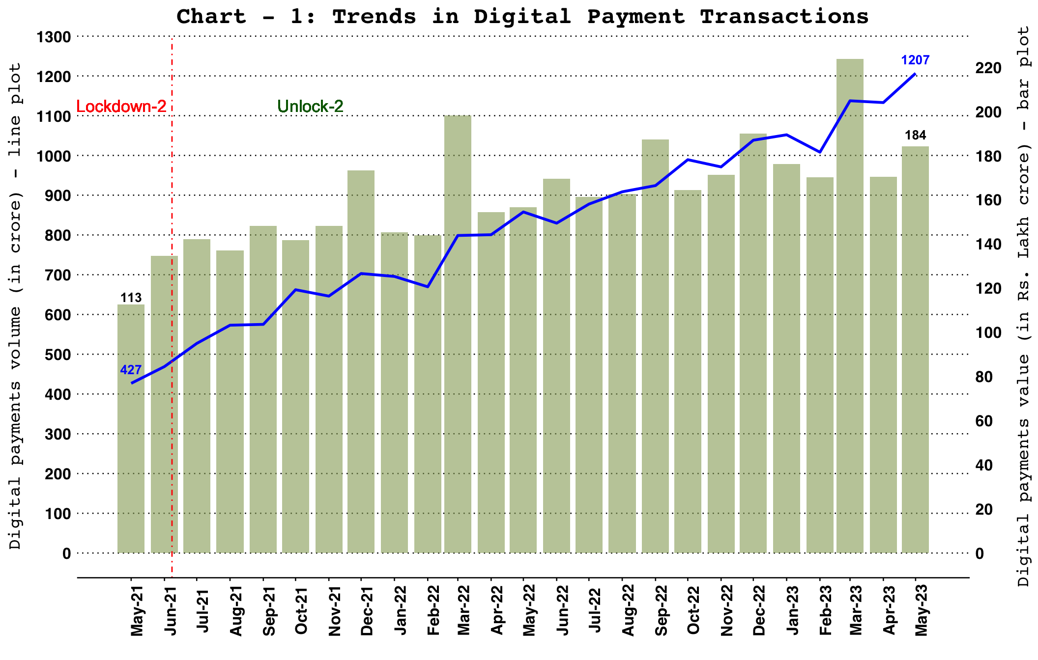Note: Digital payments include RTGS (customer and inter-bank transactions), retail electronic clearing – NEFT, IMPS, NACH (credit, debit and APBS), card payment transactions (excl. cash withdrawal), PPI payment transactions (excl. cash withdrawal), UPI (including BHIM & USSD), BHIM Aadhaar Pay, AePS fund transfer and NETC (linked to bank accounts).

Total Payments – Volume and Value
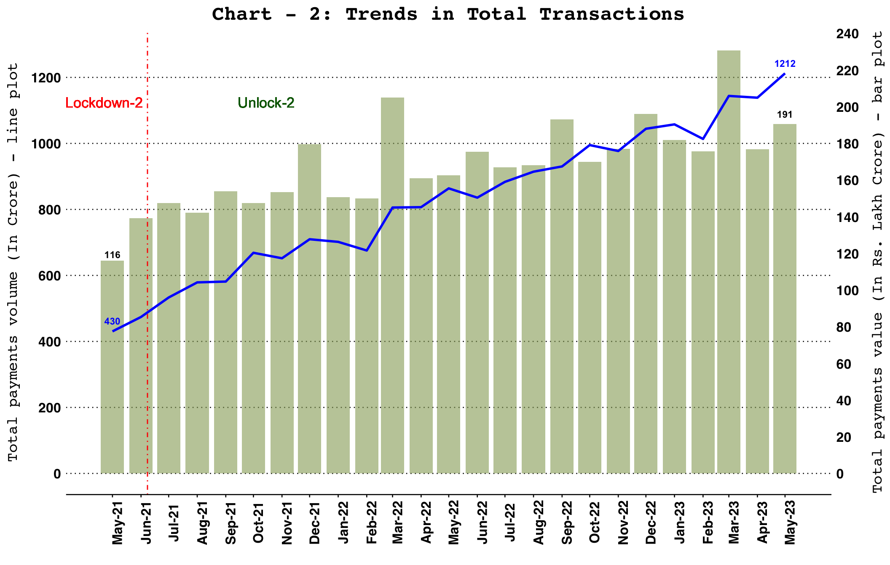
Note: Total payments include RTGS, NEFT, IMPS, NACH (credit, debit and APBS), card payment transactions (excl. cash withdrawal), PPI payment transactions (excl. cash withdrawal), UPI (including BHIM & USSD), BHIM Aadhaar Pay, AePS fund transfer, NETC (linked to bank accounts) and paper clearing.

Total Retail Payments – Volume and Value
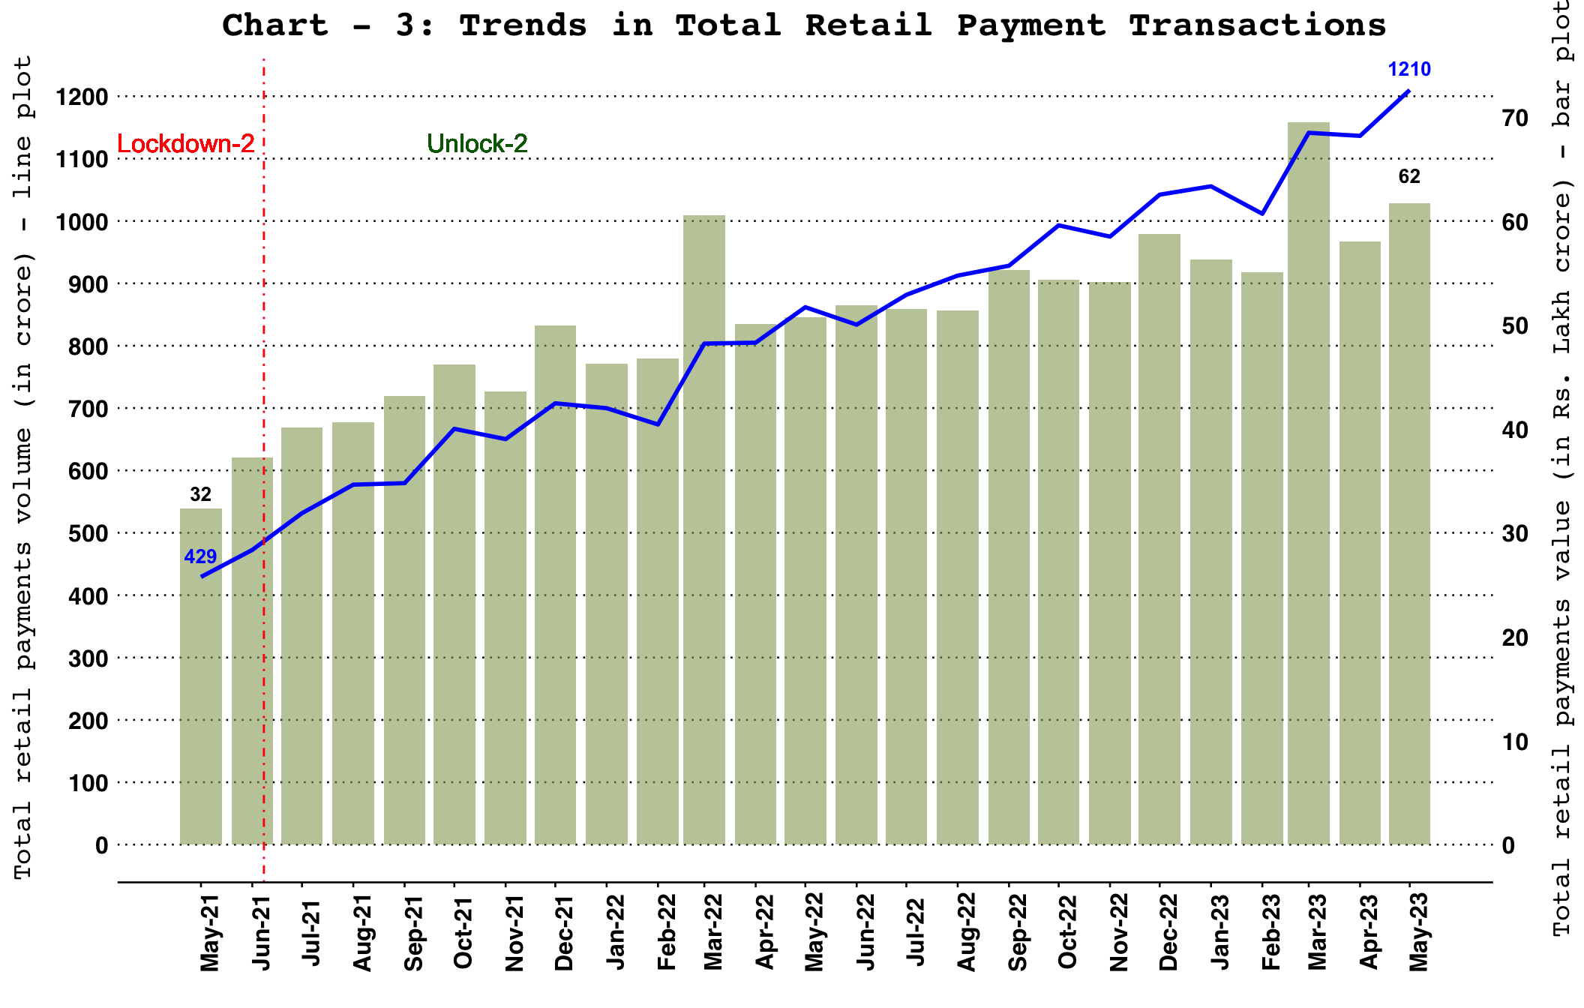
Note: Total retail payments include NEFT, IMPS, NACH (credit, debit and APBS), card payment transactions (excl. cash withdrawal), PPI payment transactions (excl. cash withdrawal), UPI (including BHIM & USSD), BHIM Aadhaar Pay, AePS fund transfer, NETC (linked to bank accounts) and paper clearing.

Digital Retail Payments – Volume and Value
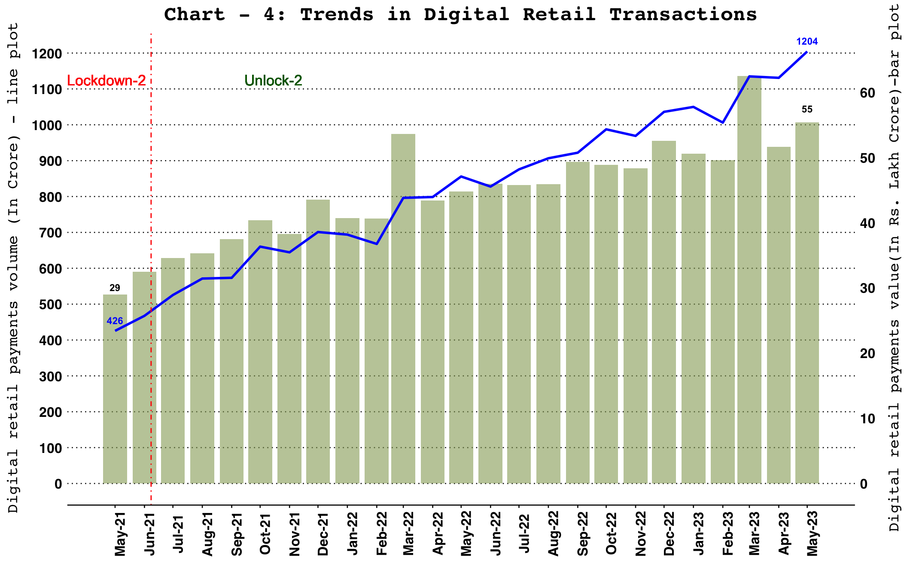
Note: Digital retail payments include NEFT, IMPS, NACH (credit, debit and APBS), card payment transactions (excl. cash withdrawal), PPI payment transactions (excl. cash withdrawal), UPI (including BHIM & USSD), BHIM Aadhaar Pay, AePS fund transfer and NETC (linked to bank accounts).

Comparison of WHOLESALE and RETAIL Payment Systems

Comparison of Payments Volume
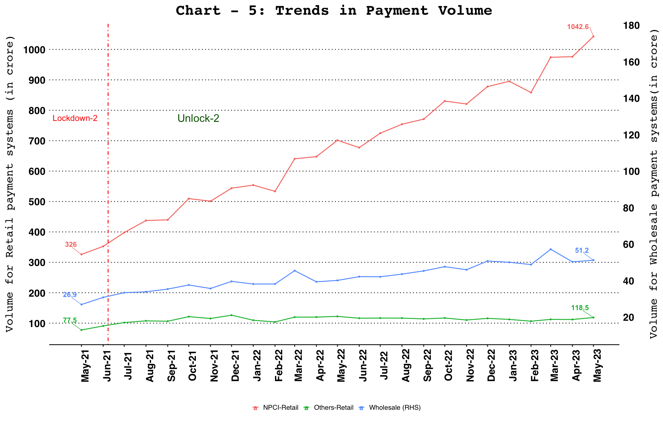

Comparison of Payments Value
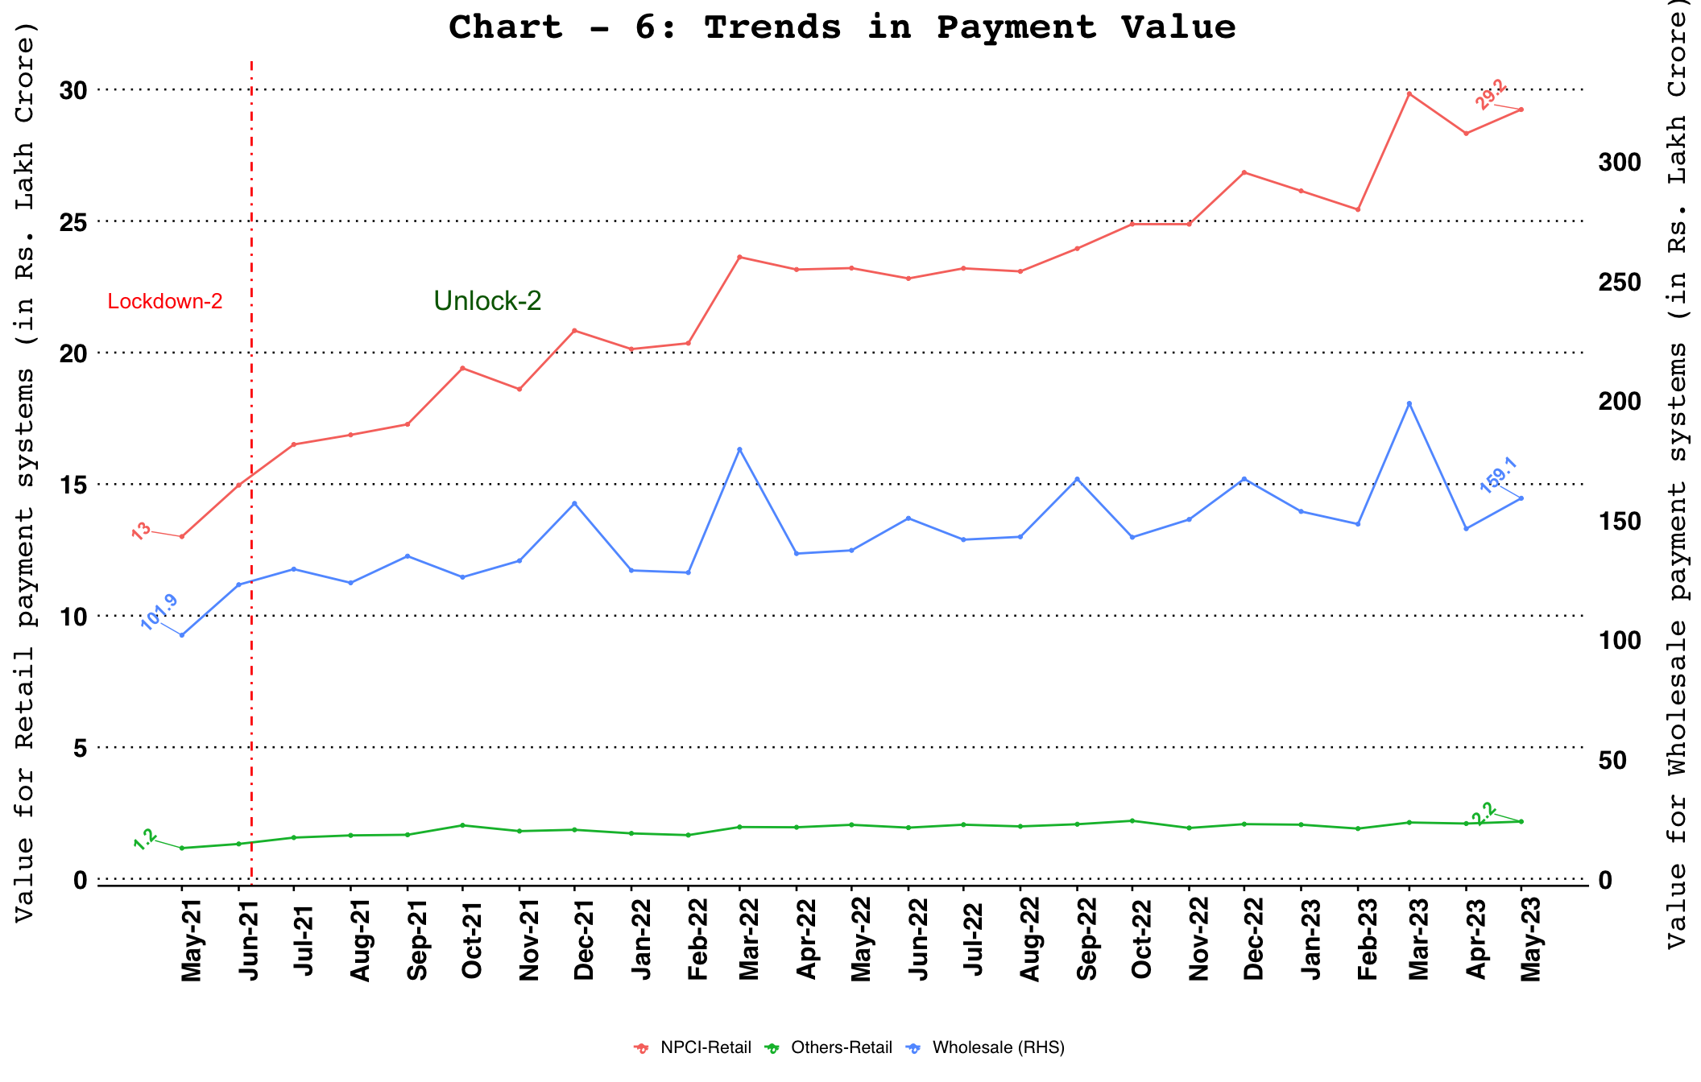
Note: Wholesale payment systems include RTGS (customer and inter-bank transactions) and NEFT.
NPCI-retail payment systems include IMPS, NACH, UPI (including BHIM & USSD), BHIM Aadhaar Pay, AePS fund transfer, NETC (linked to bank account) and paper clearing.
Other-retail payment systems include debit and credit card payment transactions (excl. cash withdrawal) and wallet and PPI card payment transactions (excl. cash withdrawal).

RBI Operated Payment Systems

Real Time Gross Settlement (RTGS)
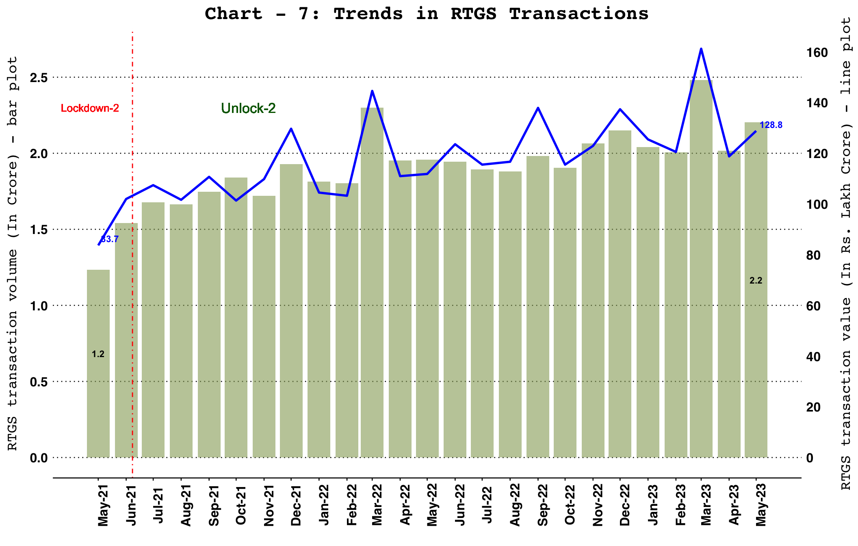

National Electronic Funds Transfer (NEFT)
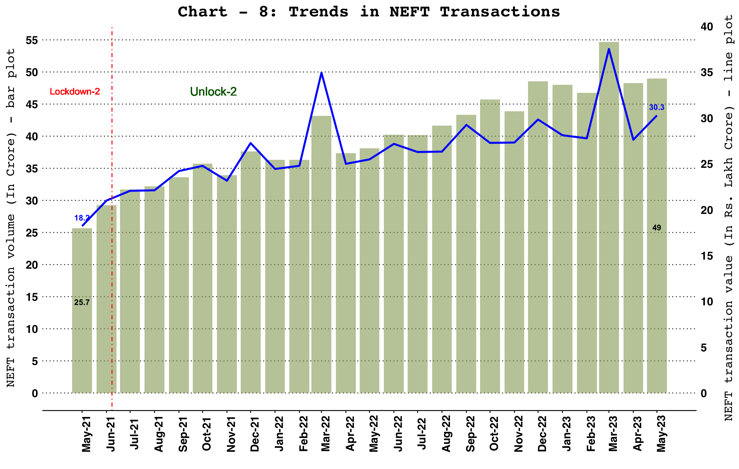

NPCI Operated Fast Payment Systems - Unified Payments Interface (UPI) and Immediate Payment System (IMPS)
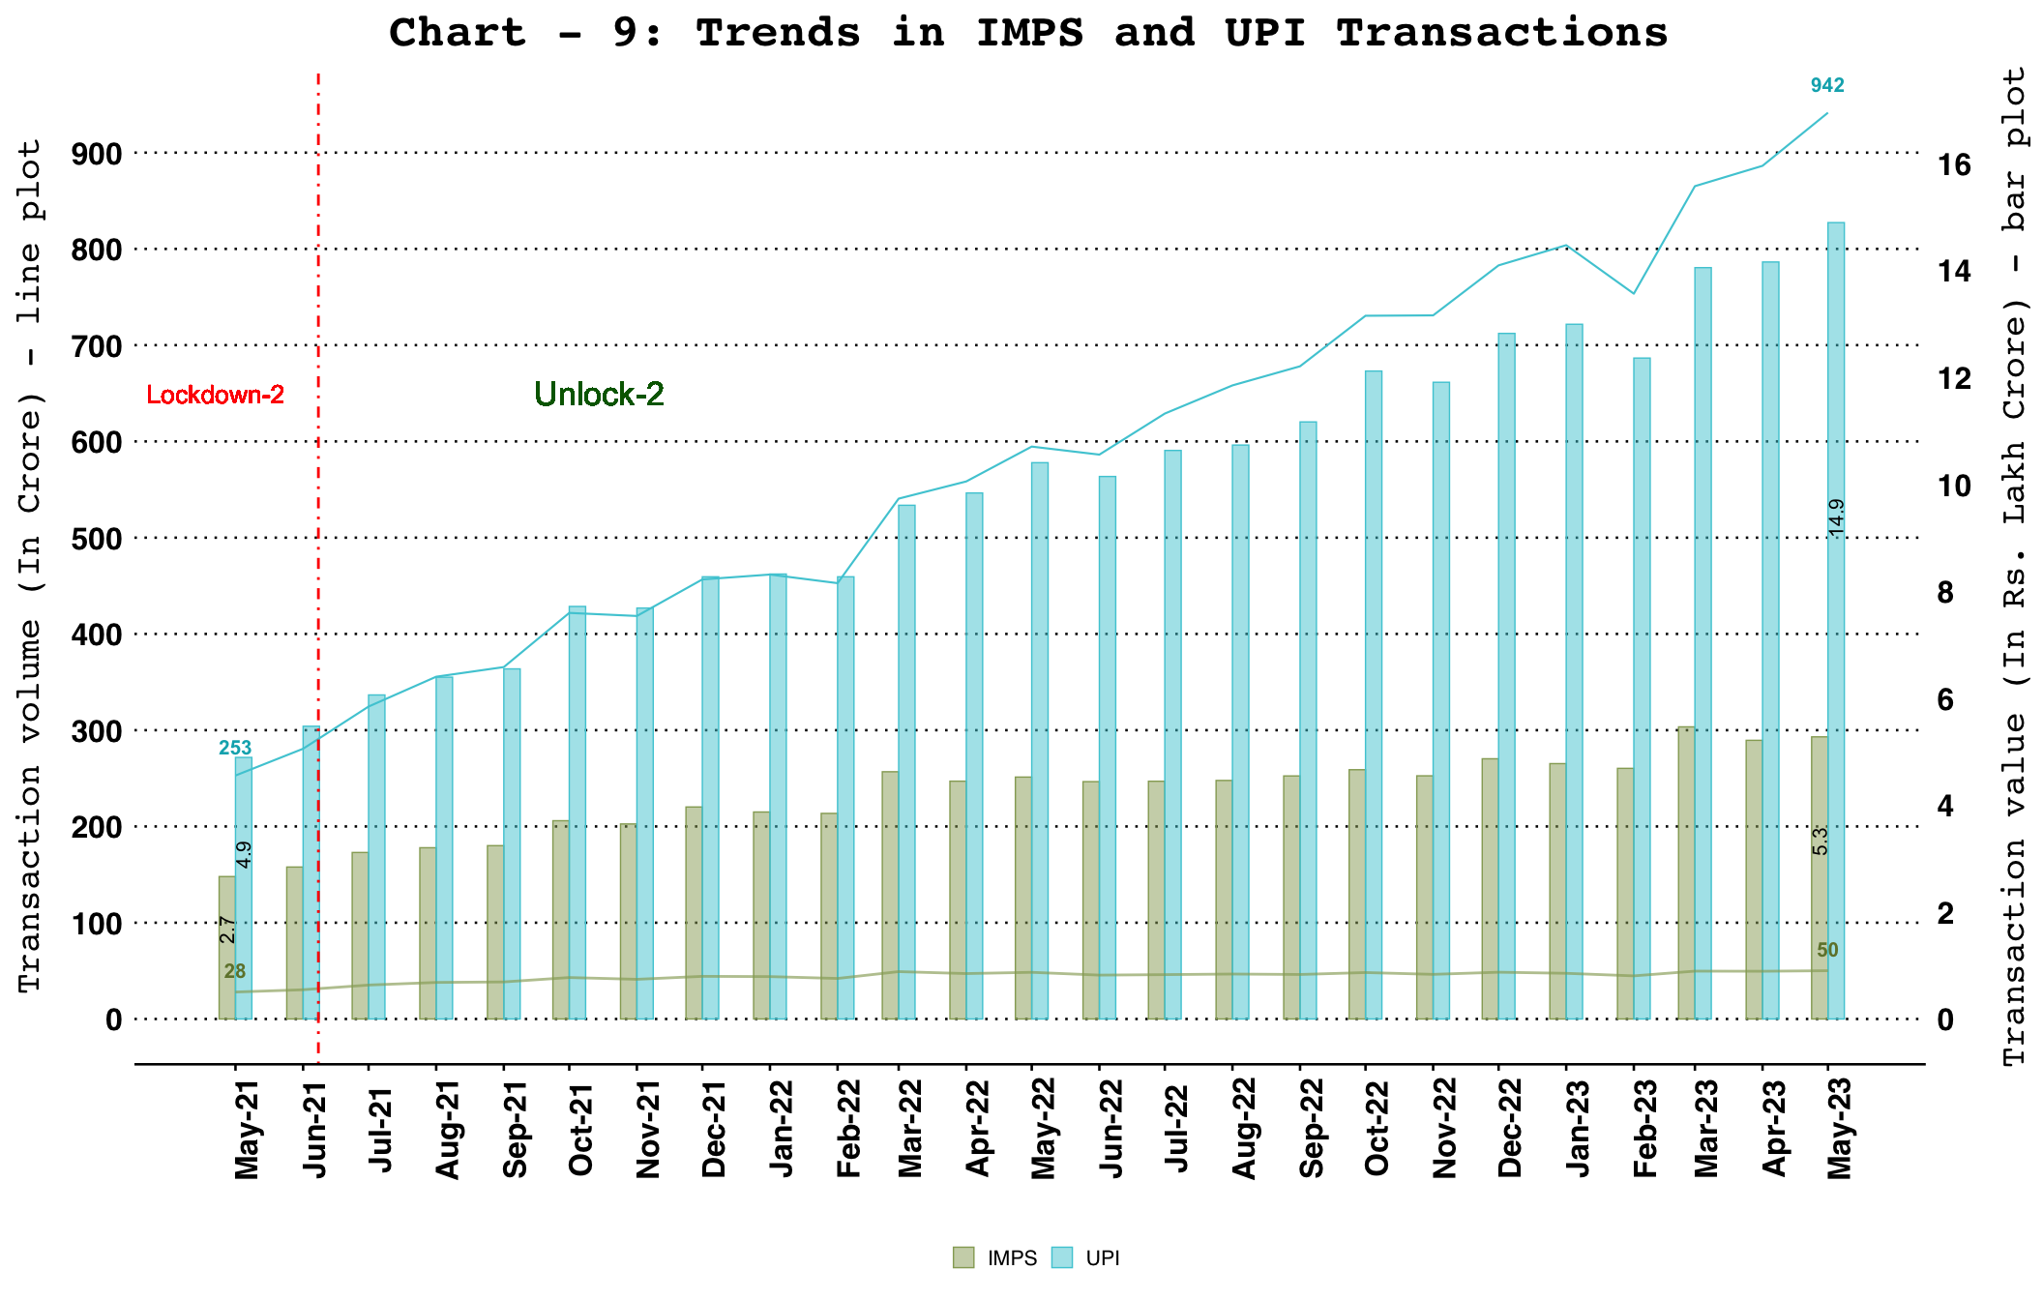

Other NPCI Operated Payment Systems

Bharat Interface for Money (BHIM) Aadhar Pay
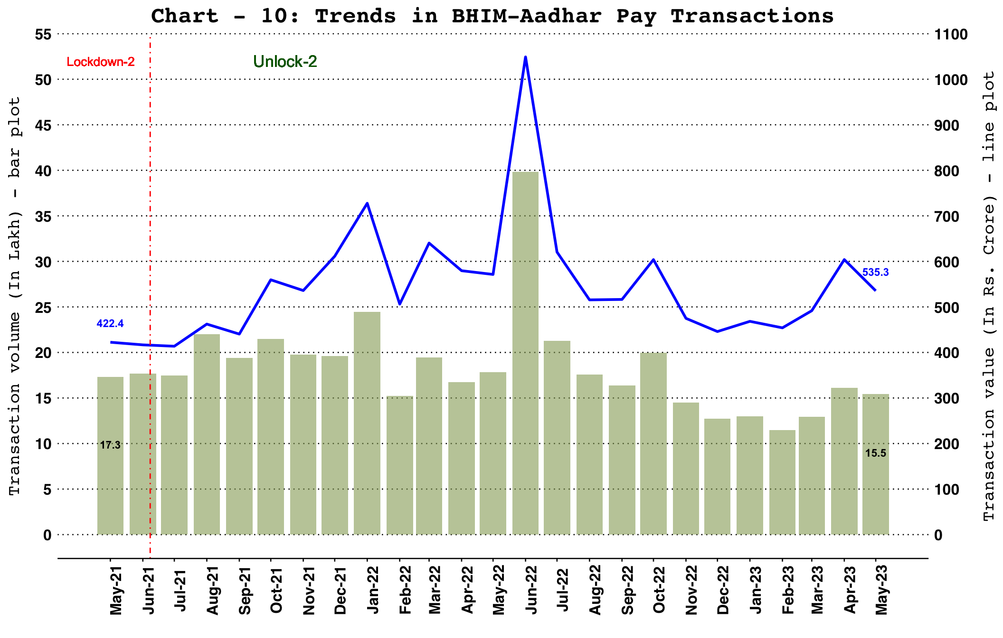

National Electronic Toll Collection (NETC) (Linked to Bank Account)
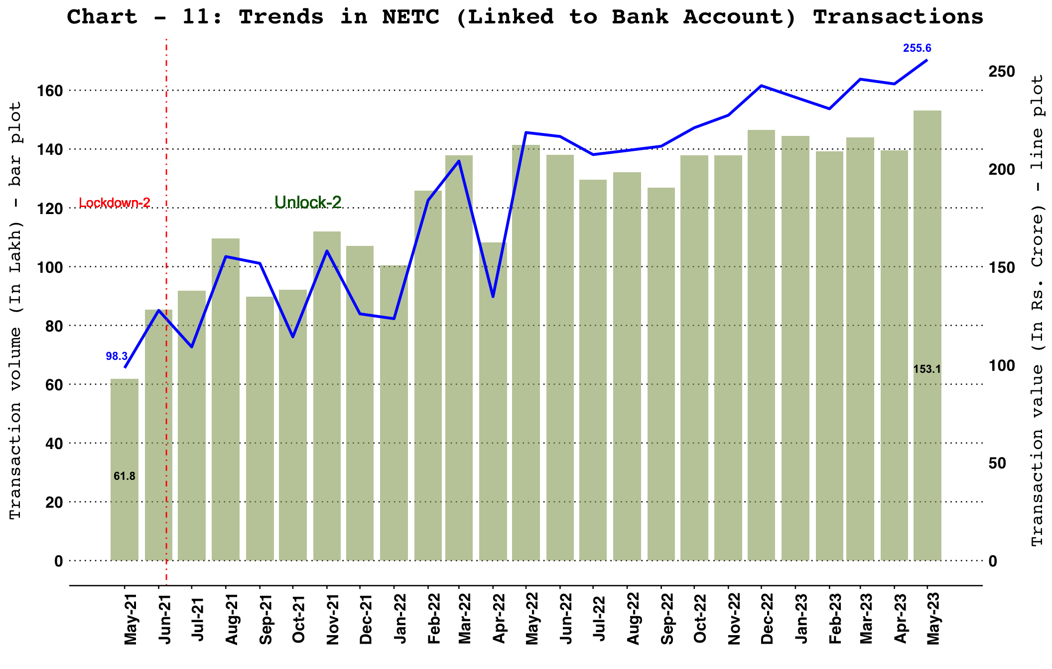

National Automated Clearing House (NACH) - Credit and Debit
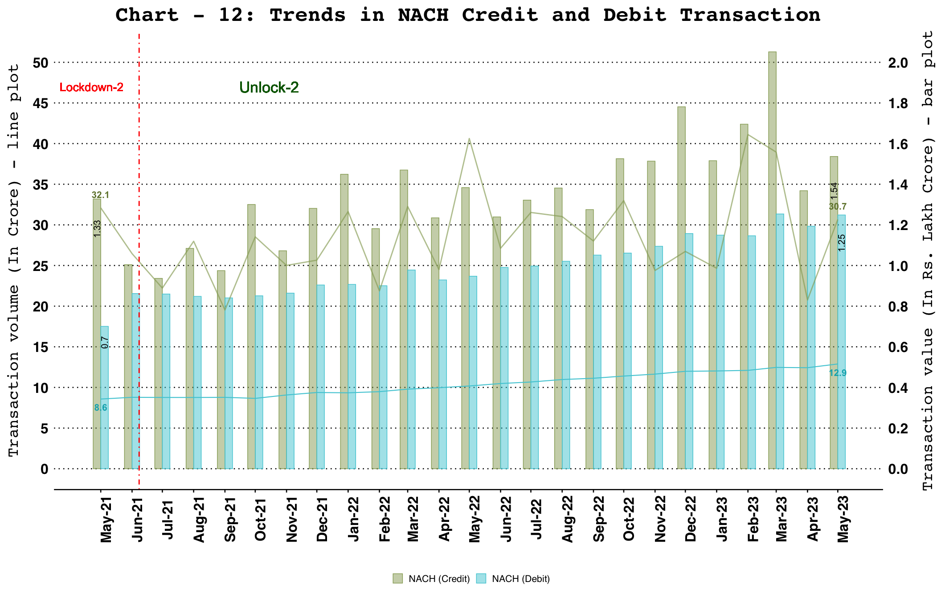

Cards and Prepaid Payment Instruments (PPIs)

Debit and Credit Cards
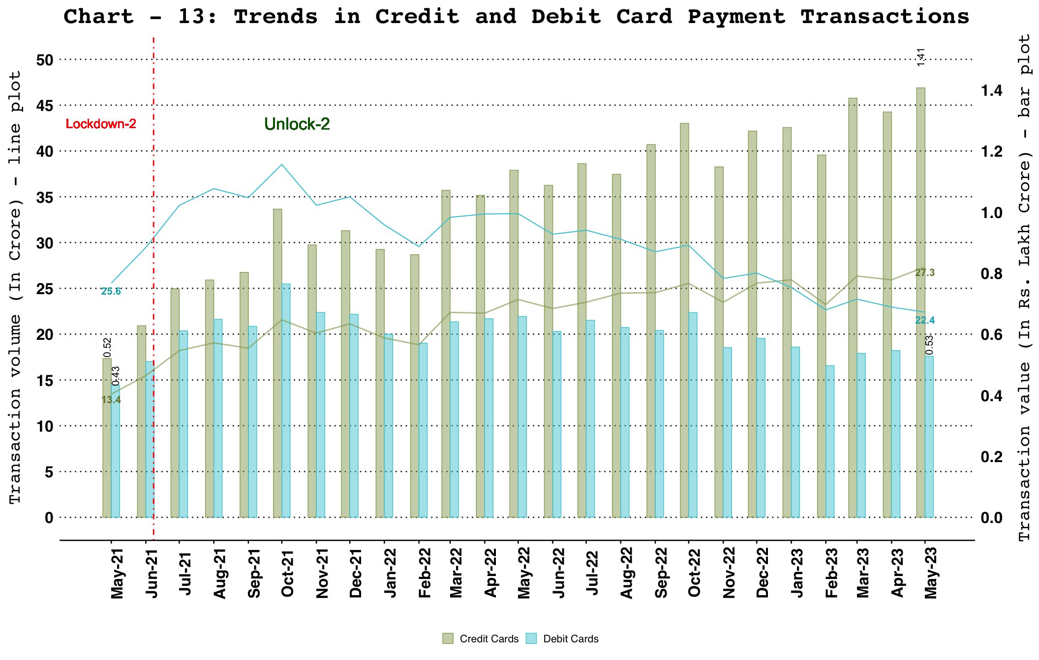
Note: Cards include debit and credit card payment transactions (excl. cash withdrawal).

PPI Wallets and Cards Usage
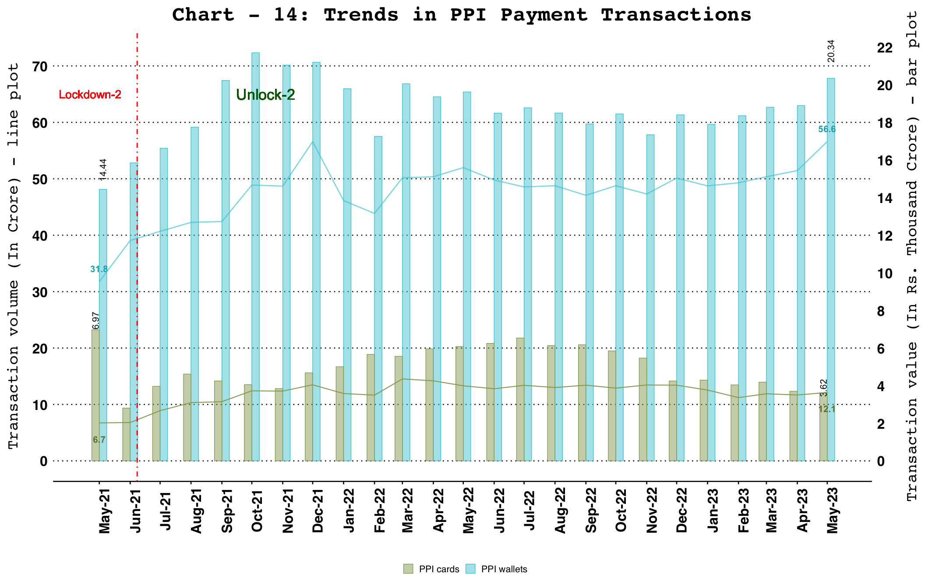
Note: PPIs include wallet and PPI card payment transactions (excl. cash withdrawal).

Paper Operated Payment System - Cheque Truncation System (CTS)

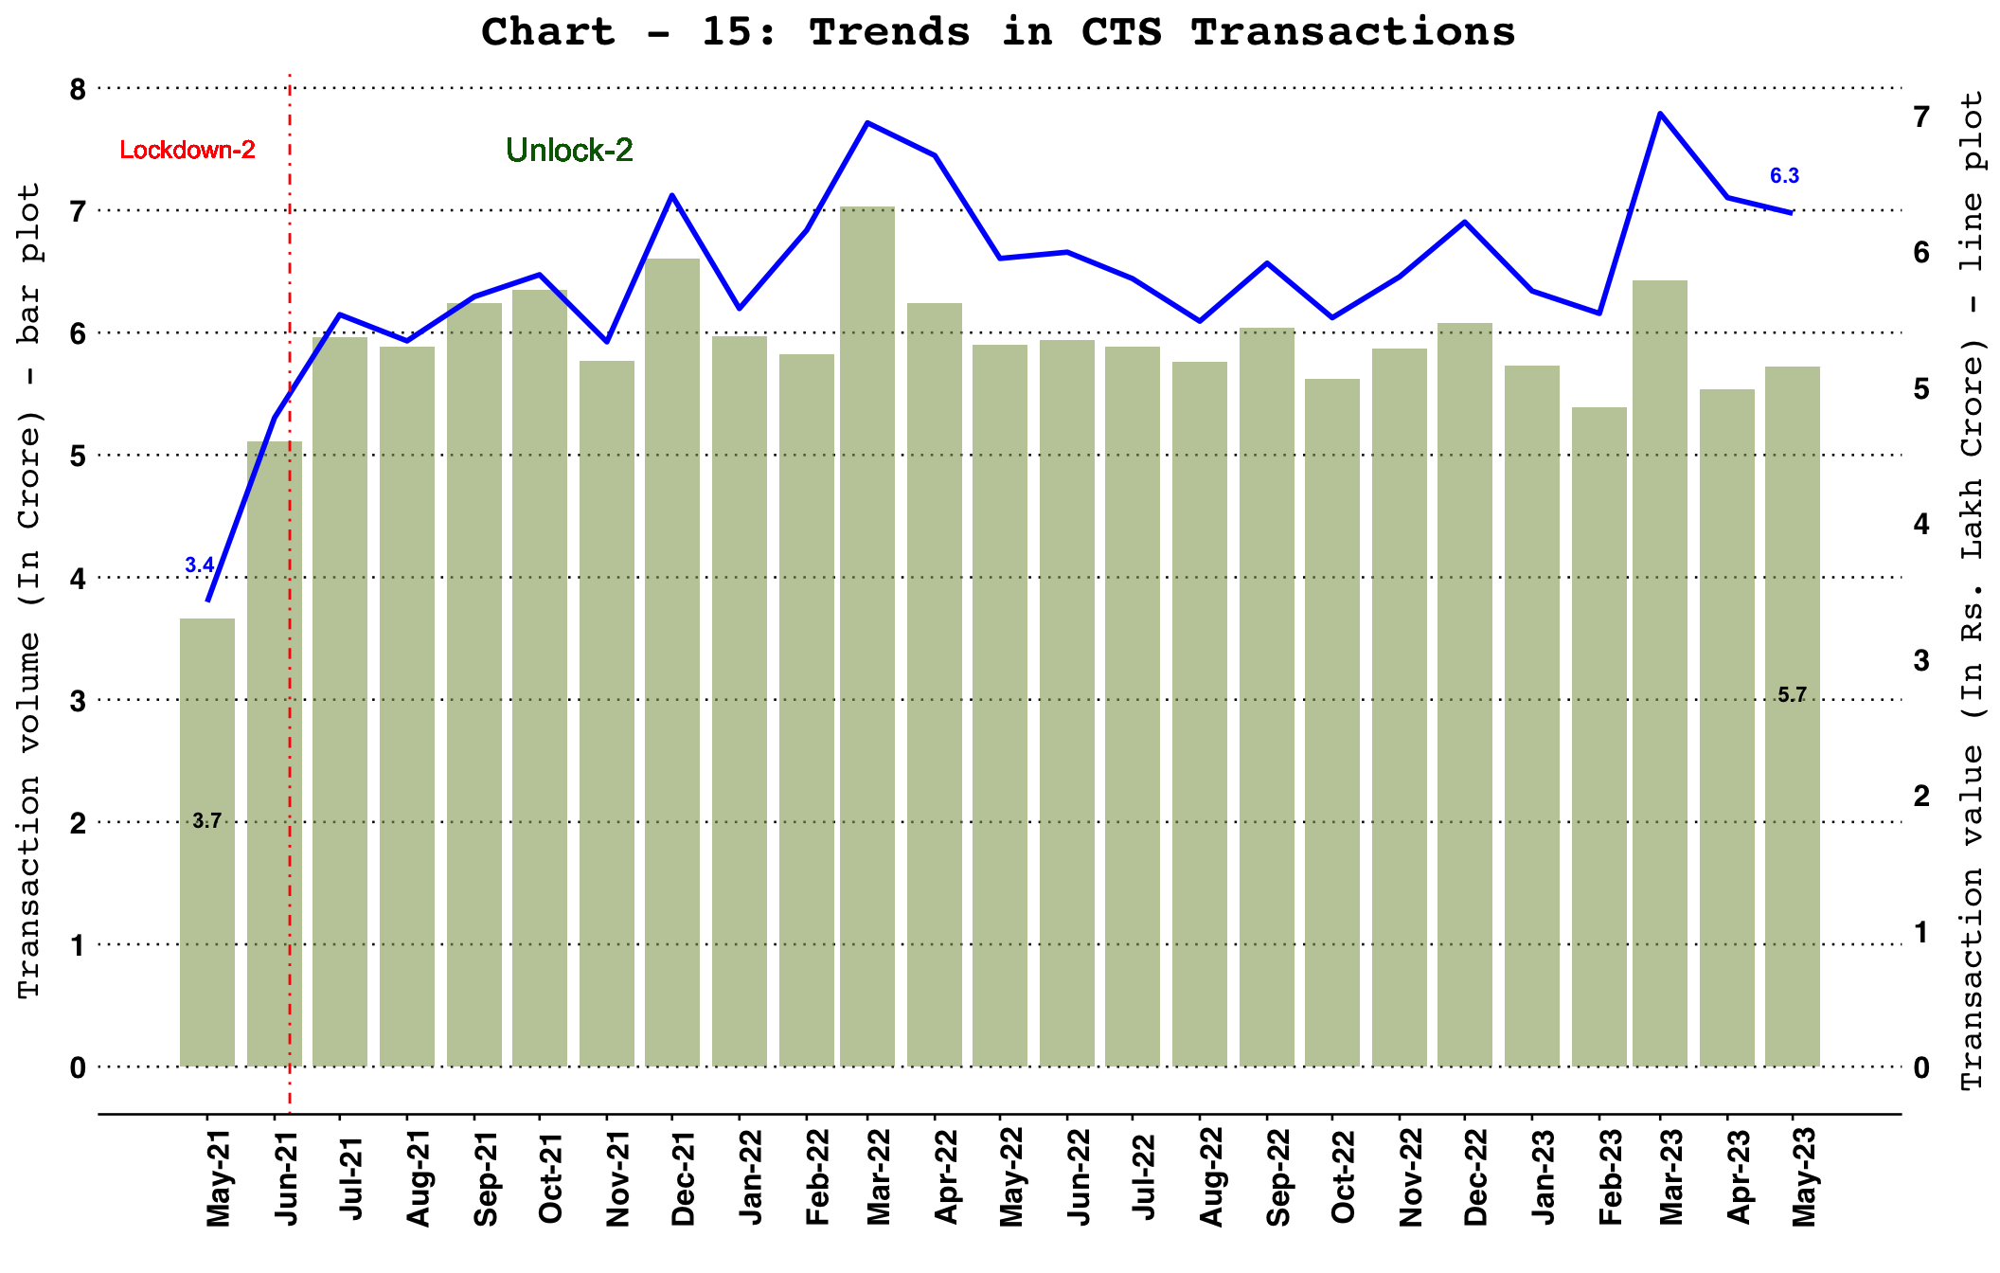

Card Acceptance Infrastructure and QR Codes

Card Acceptance Infrastructure
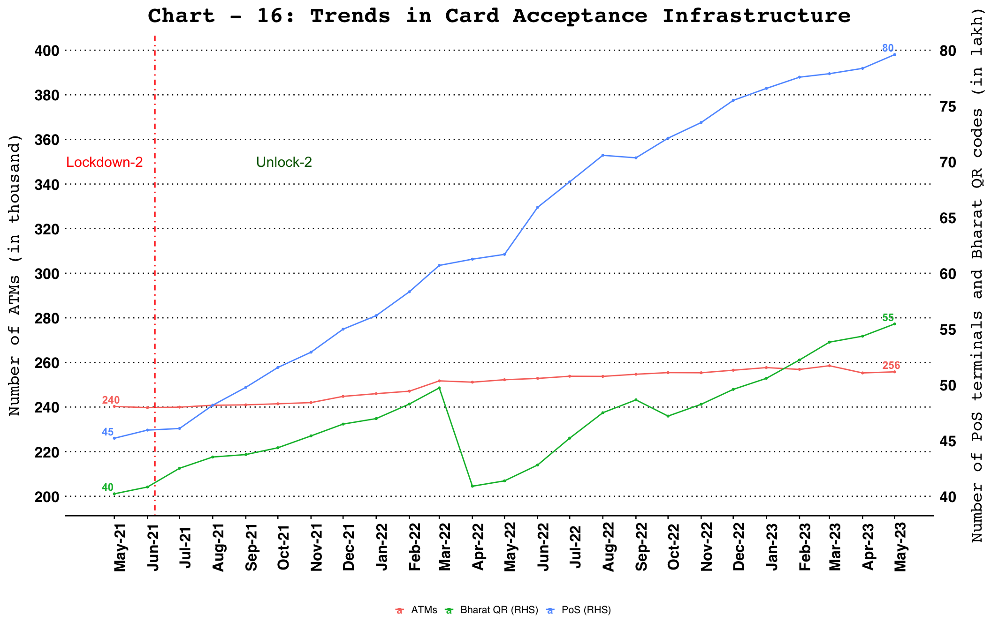

UPI QR Codes
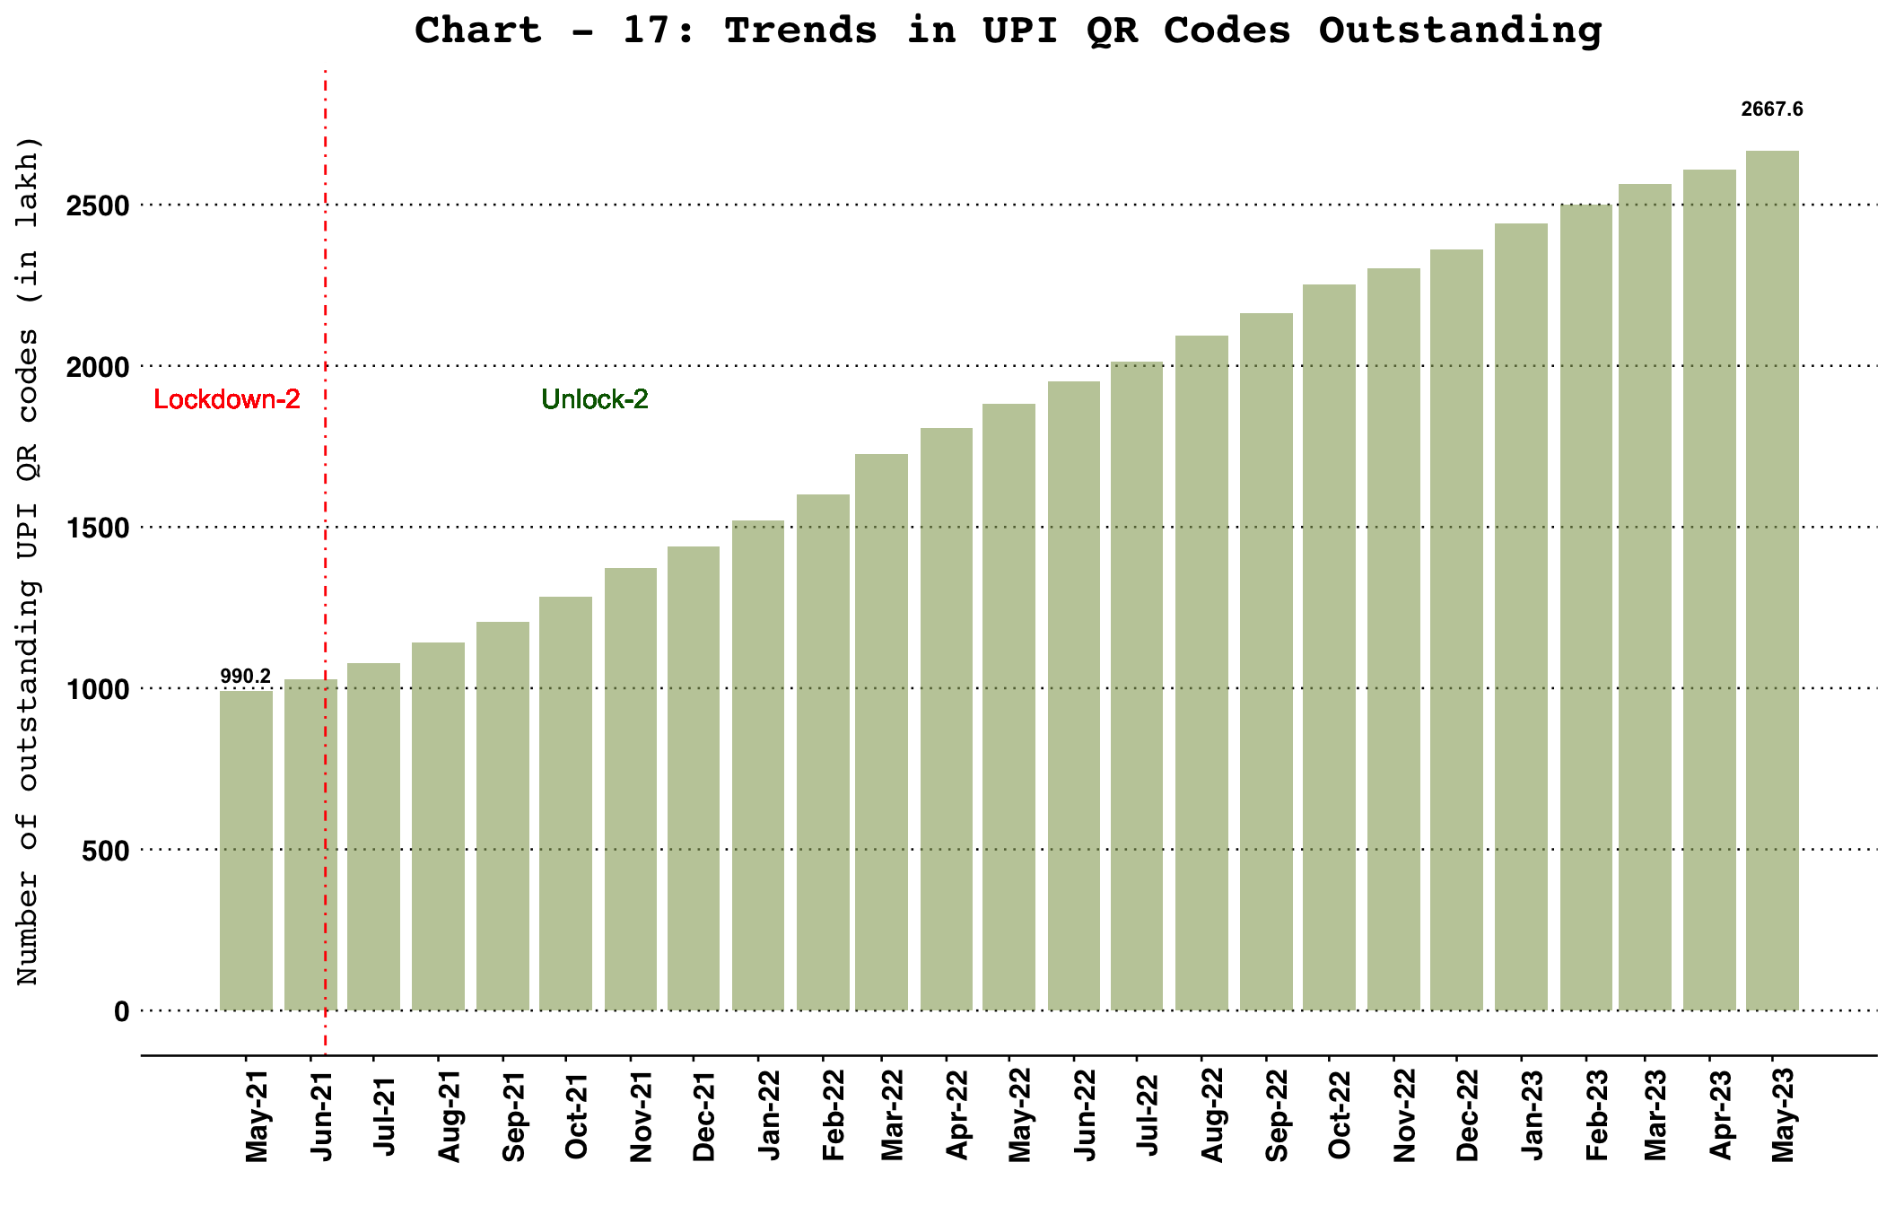

Payment System Wise Volume and Value Share

Digital Payment Volume Share
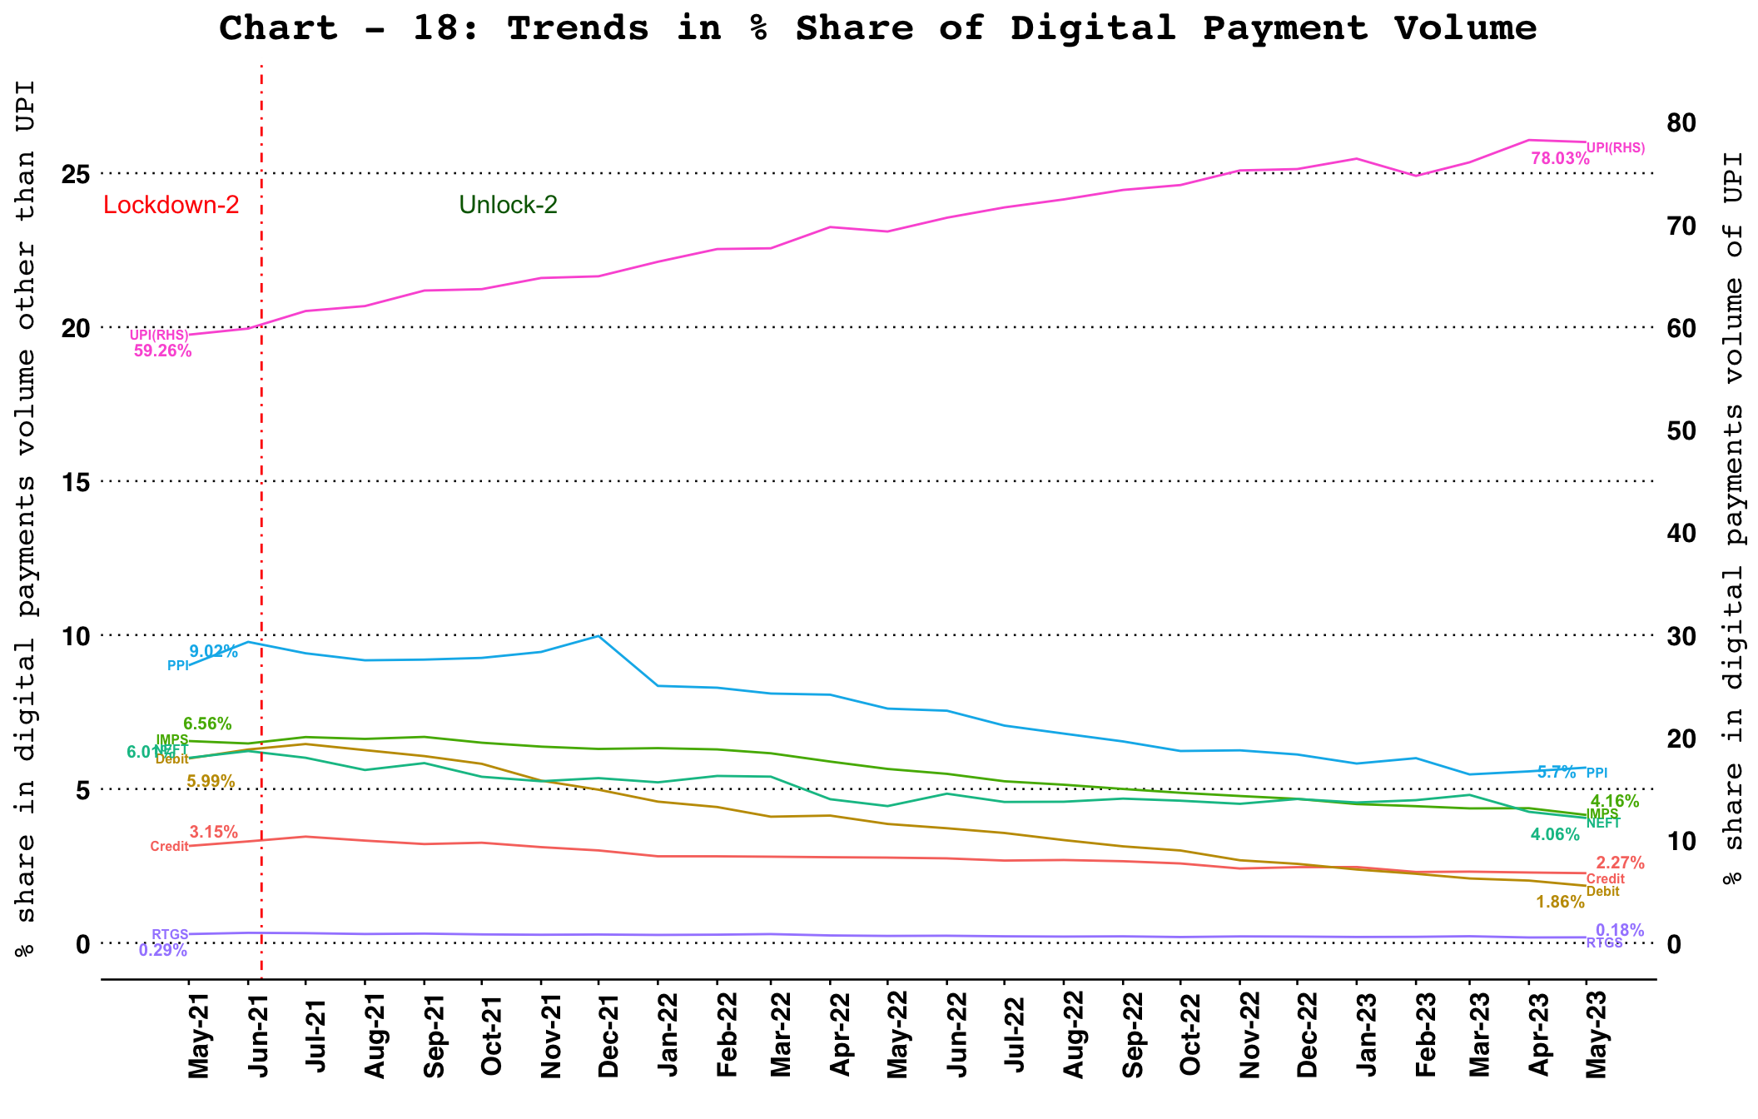

Digital Payment Value Share
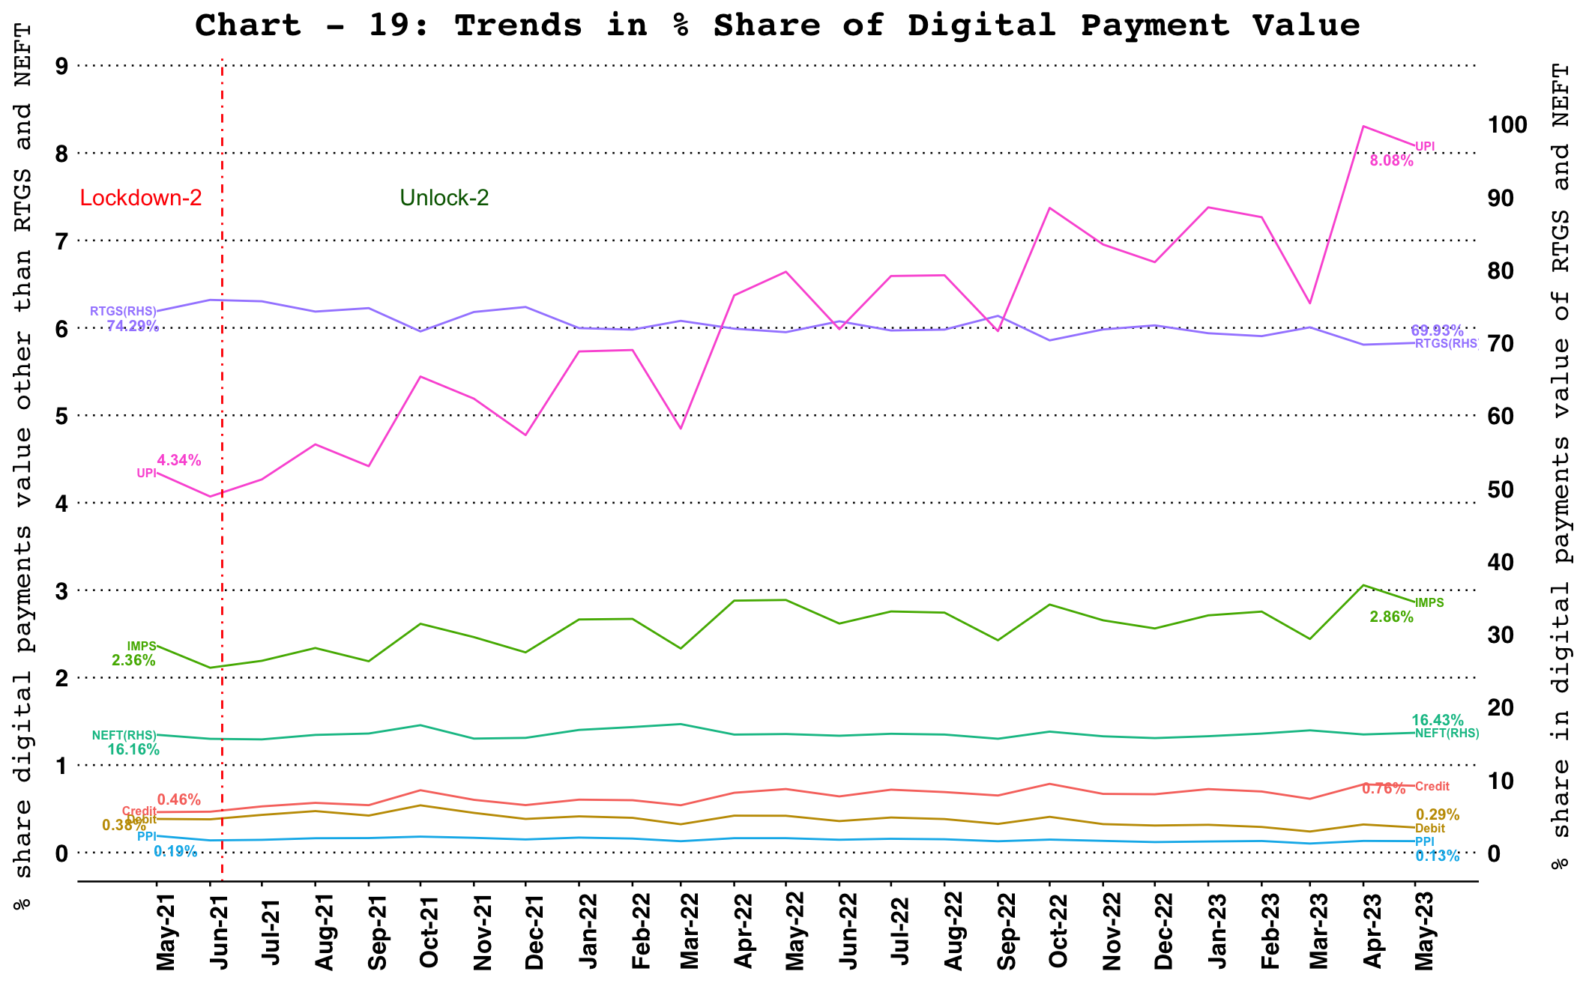

Ticket size

Ticket Size of Retail Payment Systems
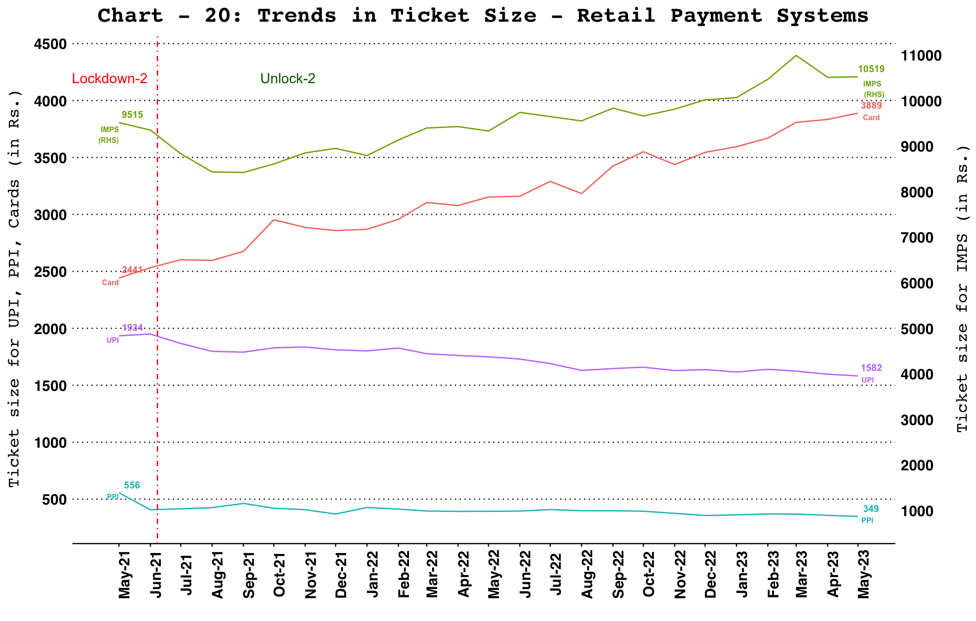
Note: Ticket size (Average Value Per Transaction) is calculated by dividing the transaction value of a payment system for a given period by its transaction volume during the same period.
Cards include debit and credit card payment transactions (excl. cash withdrawal).

Ticket Size of NEFT and RTGS Payment Systems
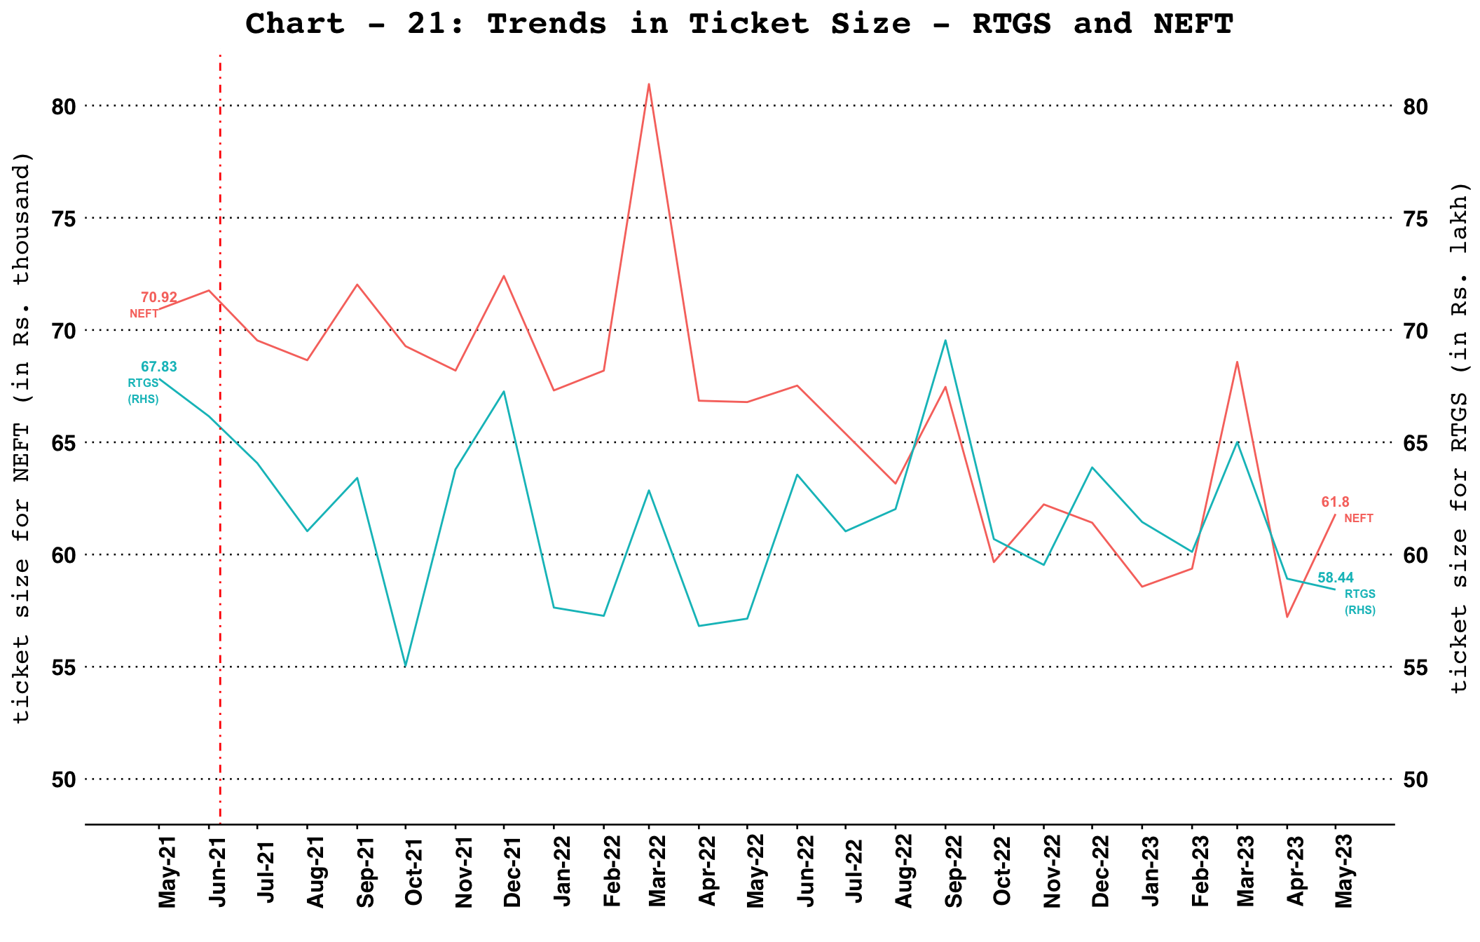
Note: Ticket size (Average Value Per Transaction) is calculated by dividing the transaction value of a payment system for a given period by its transaction volume during the same period

Trade Receivables Discounting System (TReDS)

TReDS - Invoices Uploaded and Financed
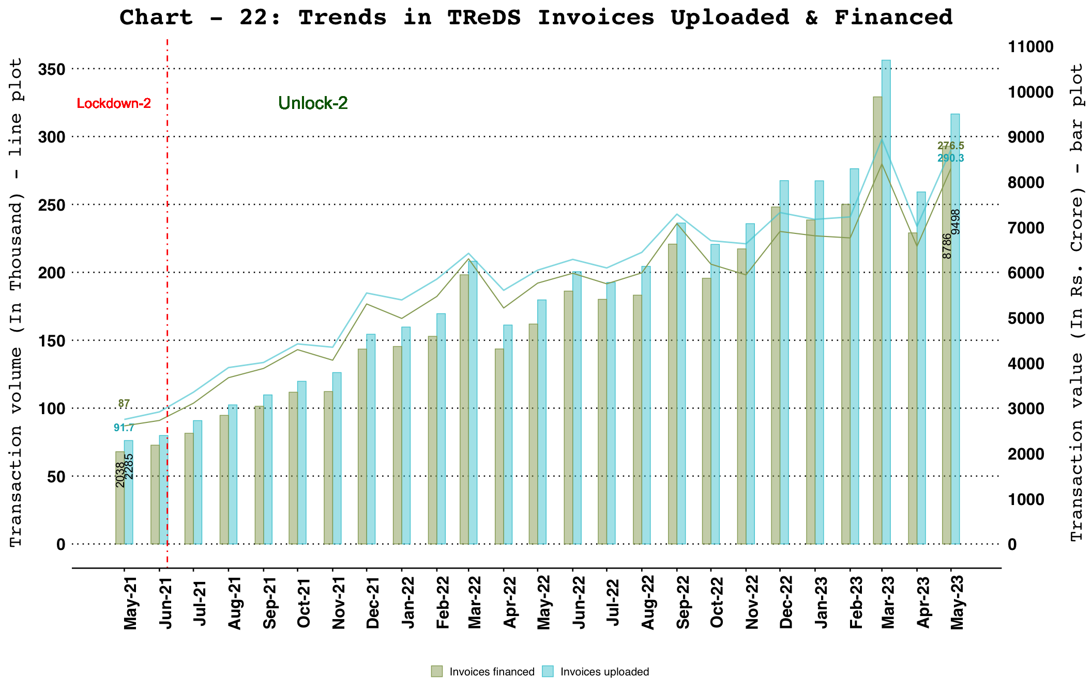

TReDS - Buyers and Sellers Onboarded
